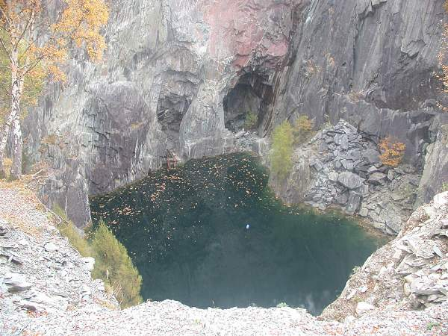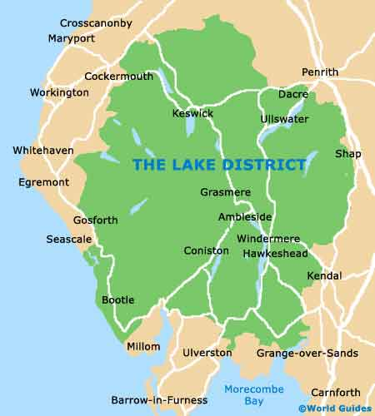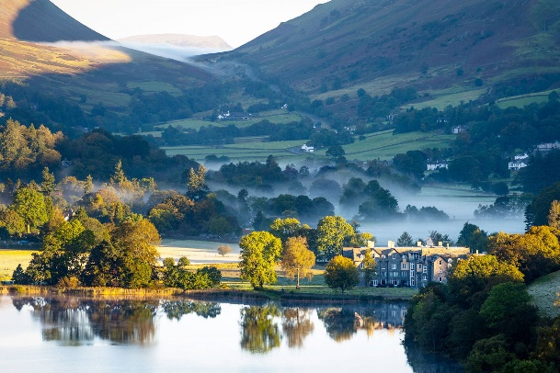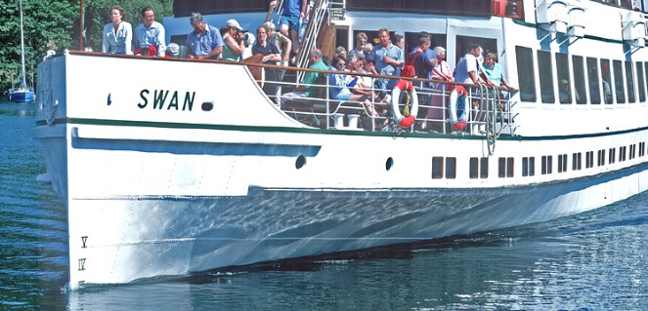

**Lake** **District**

**Farming/agriculture**

**Mining**

**Quarrying**

**Tourism**

**Transport**

**Region**

**Locality**

**Human characteristics**

**Physical characteristics**

**National Park**

**Coastline**

**Keswick**

**Lake District**

**Lake**

**Mountain**

**Climate**

**River**

**Vegetation**

**Volcanic**

**Glaciations**

**Settlement**