|  |  |
| --- | --- |
| Astronaut |  |
| Planet |  |
| Gravity |  |
| Space shuttle |  |
| Rocket |  |
| Moon |  |

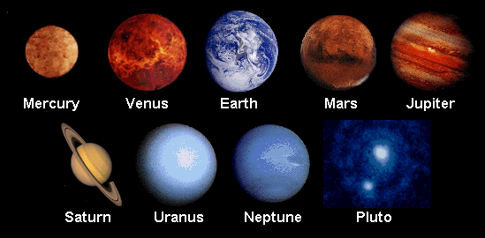

Mae Jemison

Neil Armstrong

Tim Peake

Tim

