English
Read and analyse a written account of Caractacus’ Last Battle.
Write own account of a Roman vs Celt battle.
Kennings poetry about Boudicca

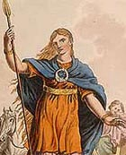
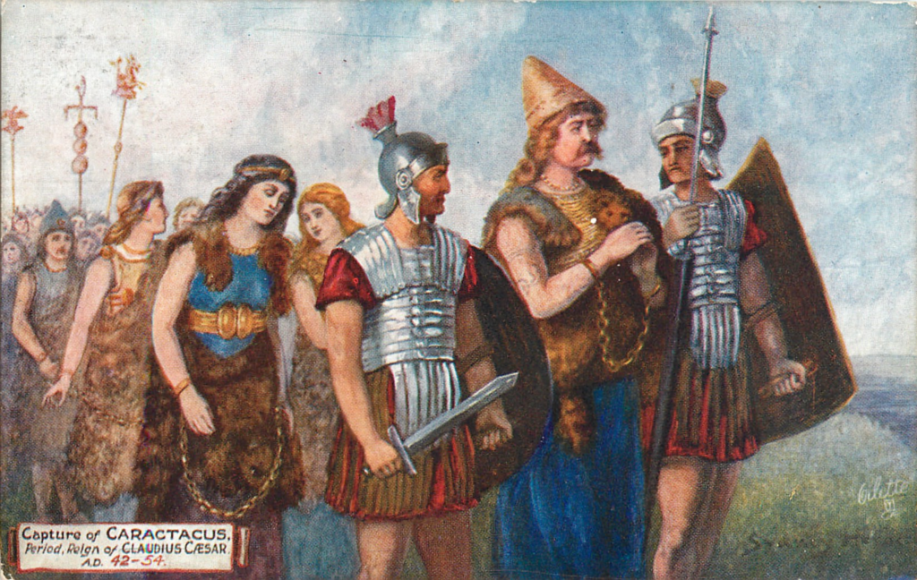
‘How were the Romans able to conquer Britain?’
Spring 1
Class 4
History
To develop an understanding of chronology
Find out about the lives of Iron Age Celts living in Britain.
Roman invasions of Britain – Julius Caesar and Claudius
Roman Soldiers – armour and weapons
Roman Forts and defences
Hadrian’s Wall
Celtic resistance – Boudicca
The fall of the Roman Empire
What did the Romans do for Britain?
Visit to Ribchester Roman Museum

