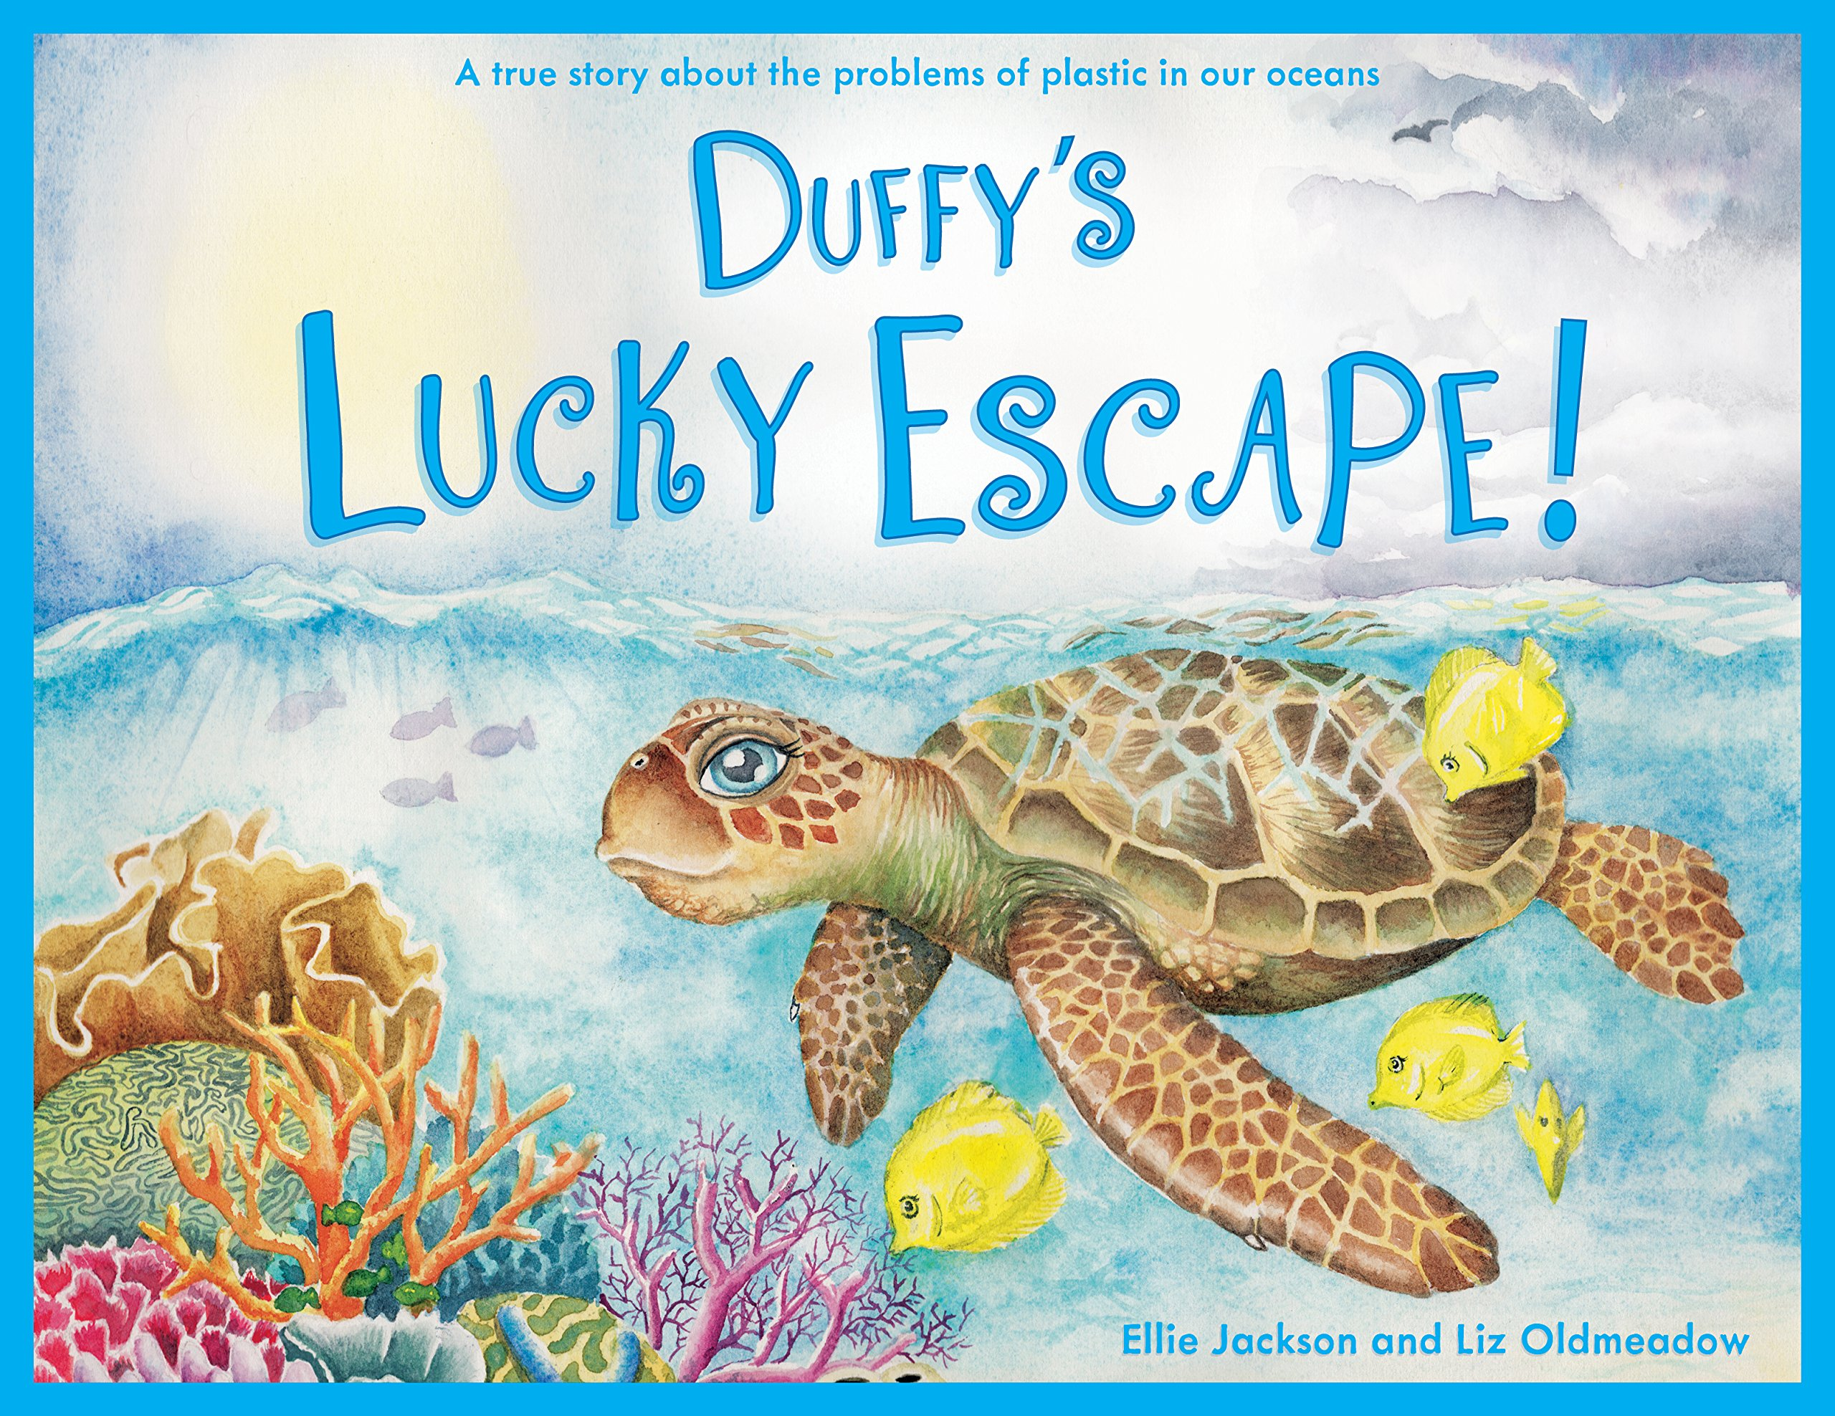
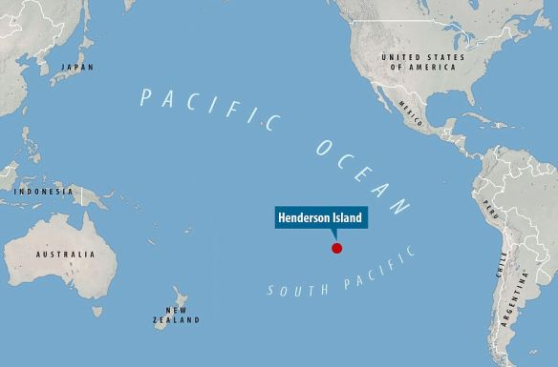
English
Read and analyse stories with an environmental message
Duffy’s Lucky Escape by Ellie Jackson
One Plastic Bag by Isatou Ceesay
Write our own stories with an environmental message.
Read and analyse diamante poems
Write diamante poem about plastic pollution.

Geography
Name and locate the world’s 5 oceans
Finding out why the oceans are so important
Plastic pollution and its impact on wildlife
Henderson Island – ‘the most polluted place on the planet’
How does plastic end up in our oceans?
Ways to reduce use of plastic by individuals, communities and the wider world

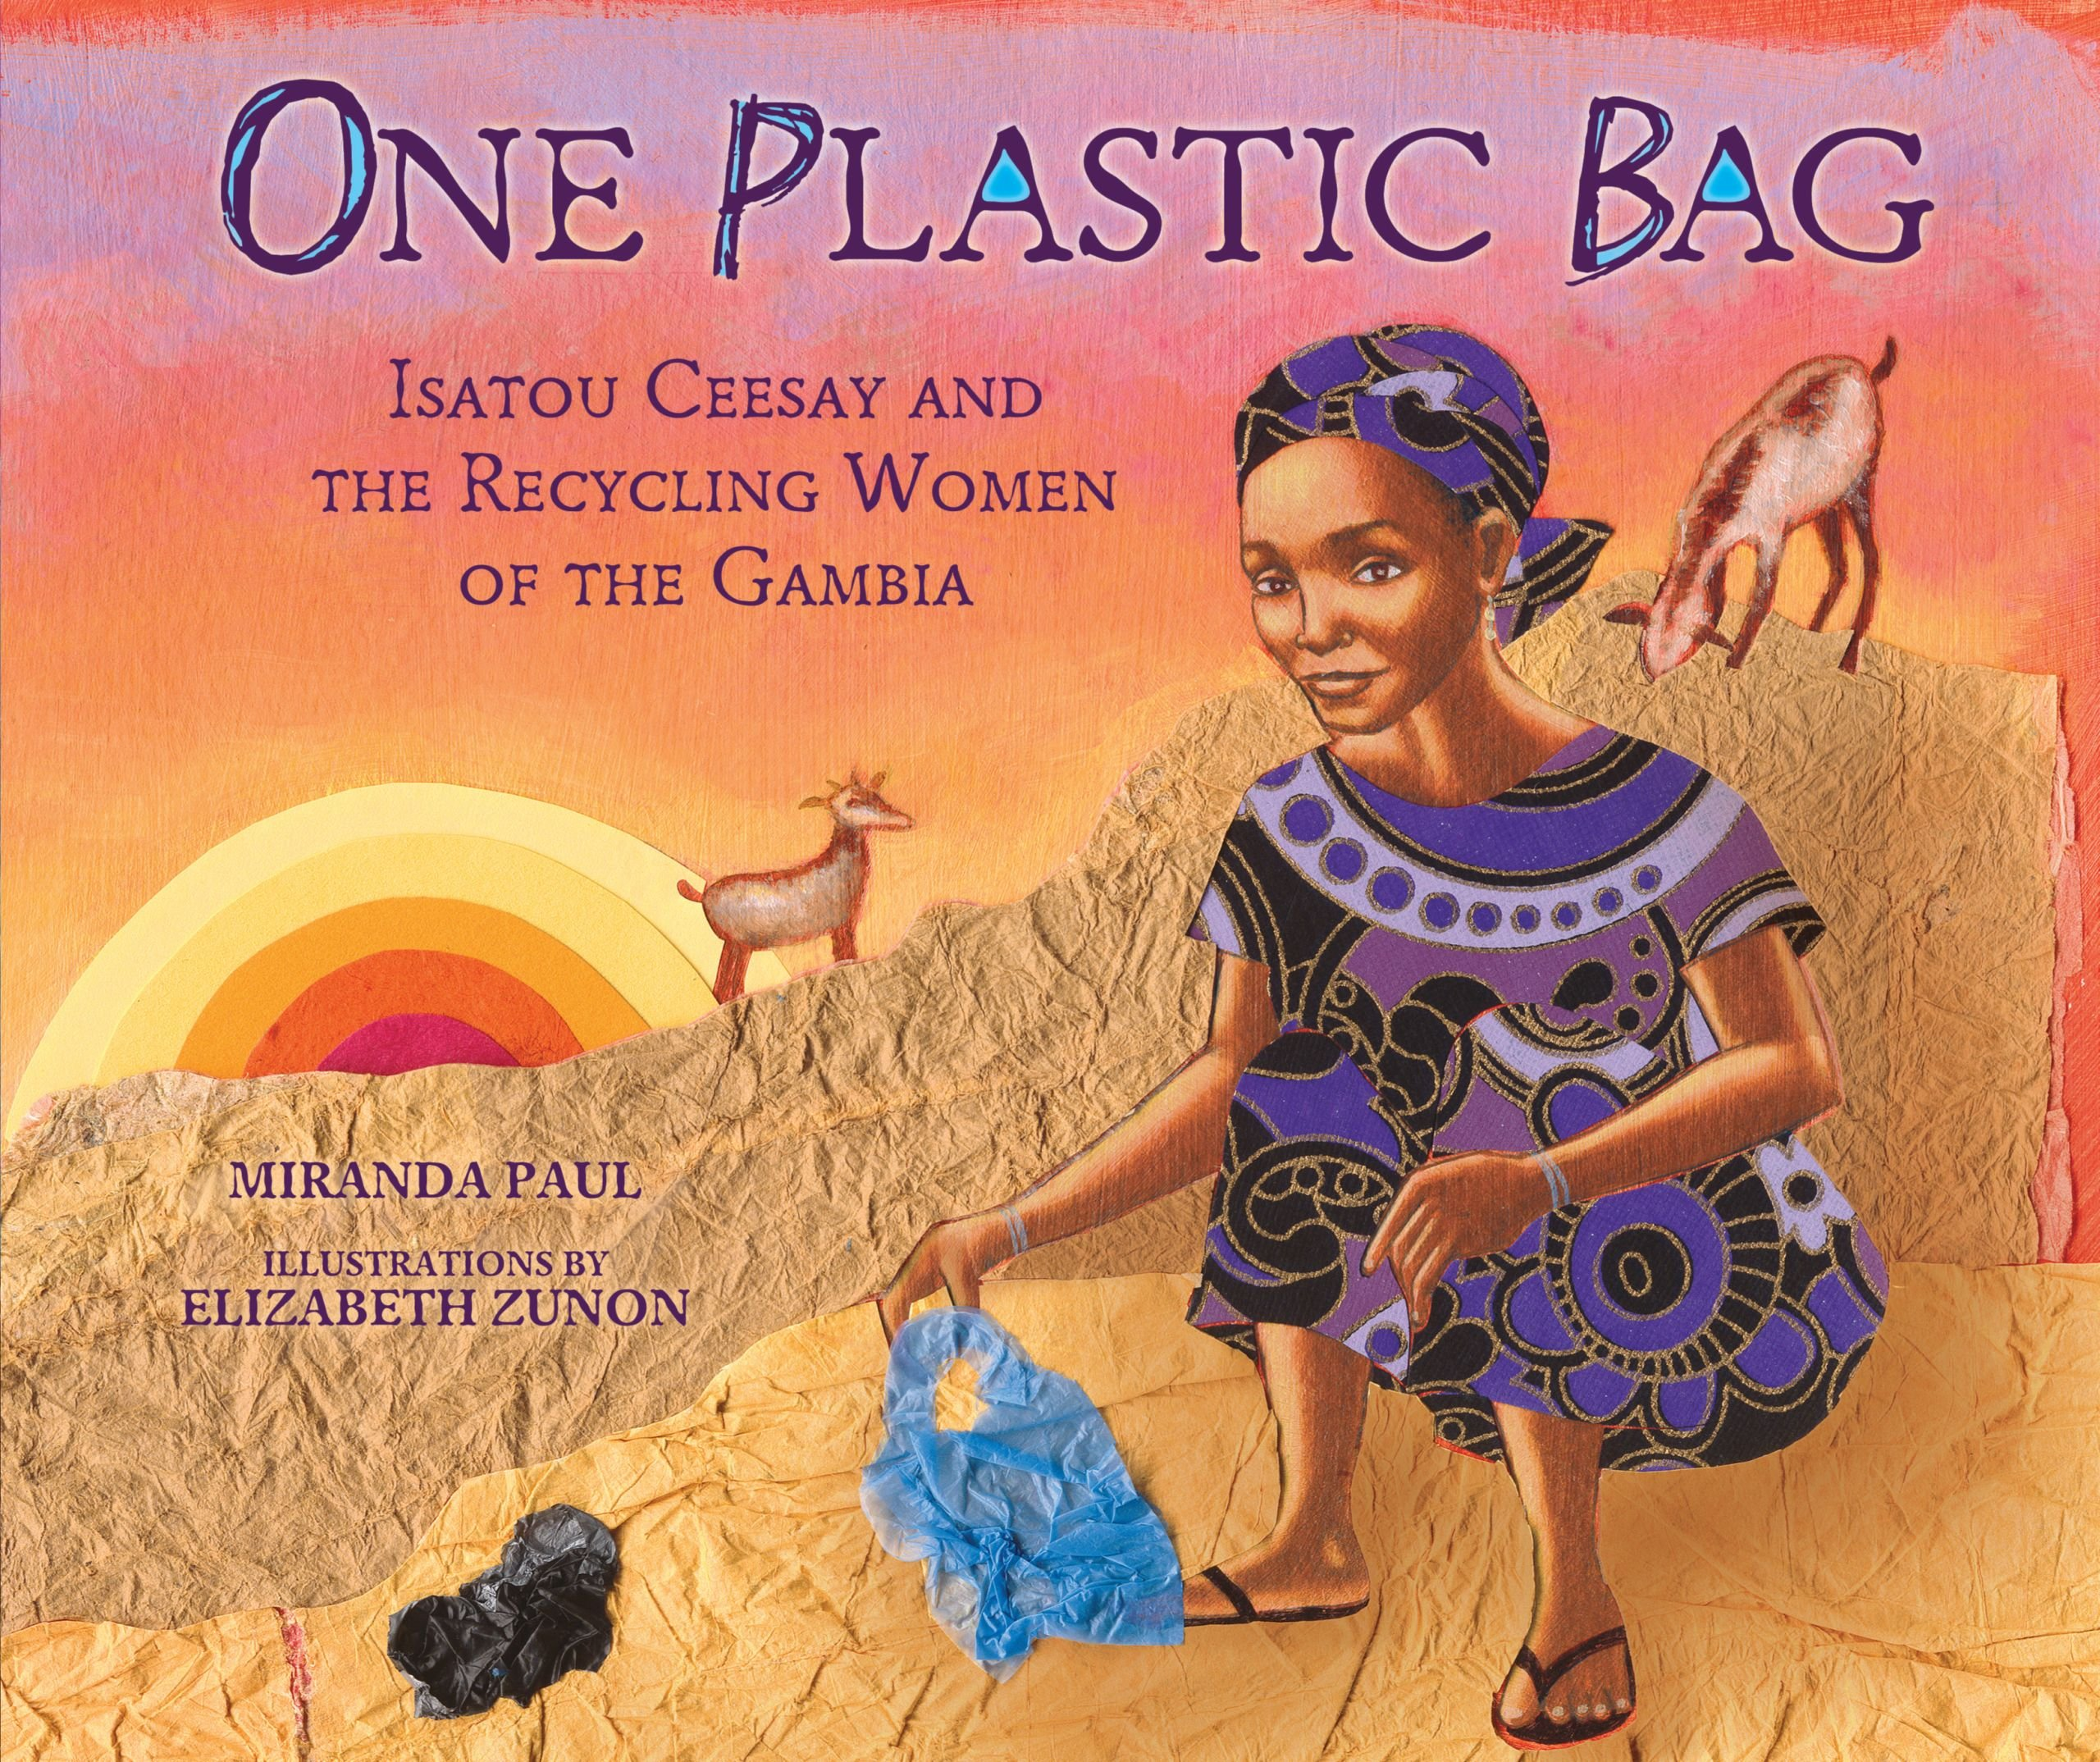
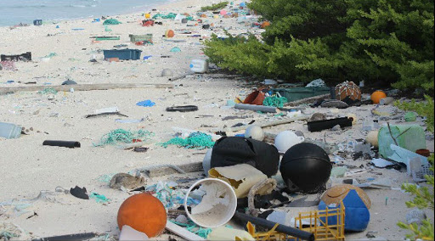

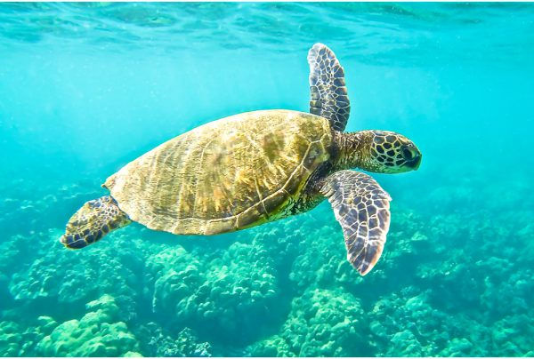
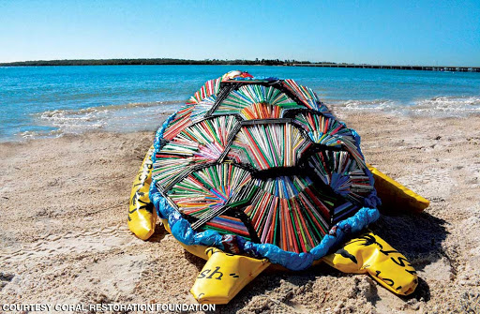
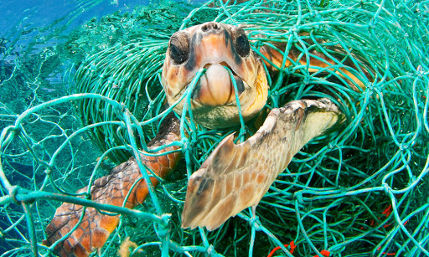
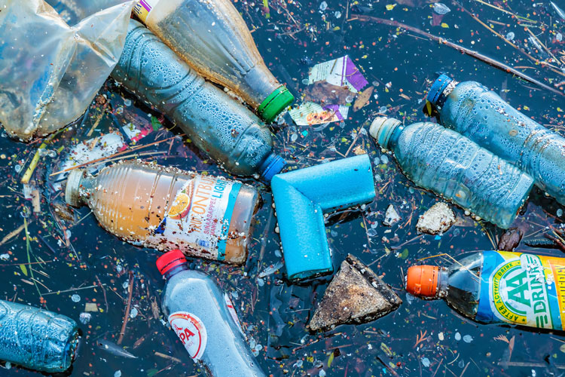
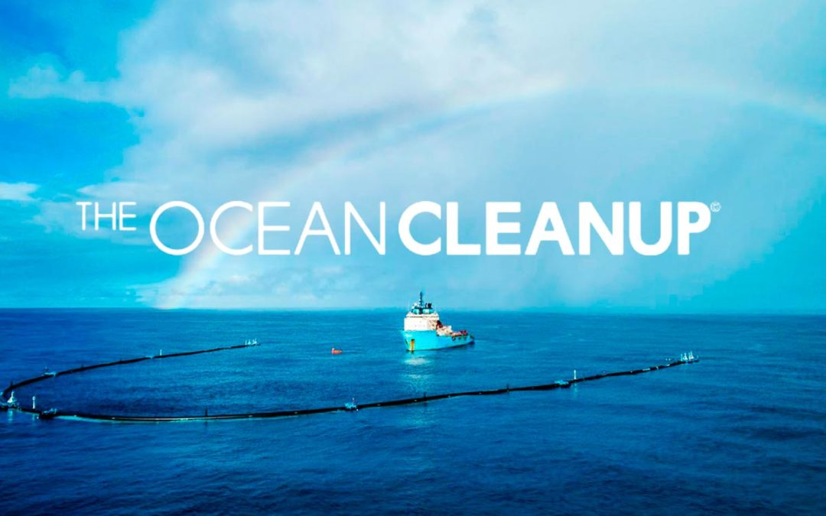

What impact does plastic have on our oceans?
Spring 2
Class 4

Art and Design
Green Sea Turtles
Drawing – line, form, shape, pattern, tone, shading
Artist – Adam Long, Victoria Cassar
Printing with plastic – sea turtles

