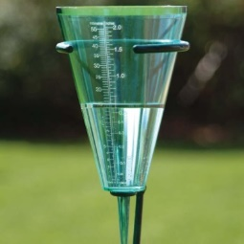C:\Users\Kelly\Pictures\Microsoft Clip Organizer\00232180.wmfC:\Users\Kelly\Pictures\Microsoft Clip Organizer\00117999.wmfC:\Users\Kelly\AppData\Local\Microsoft\Windows\Temporary Internet Files\Content.IE5\KMETZ76R\MC900235377[1].wmfC:\Users\Kelly\Pictures\Microsoft Clip Organizer\00022708.wmf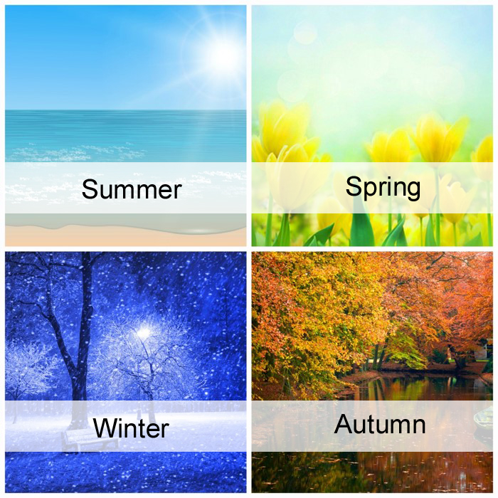 

Thermometer

Rain Gauge

Weather Vain

**Wonderful Weather**

Winter

Autumn

Summer

Spring

sunny

cloudy

snowing

windy

raining

stormy