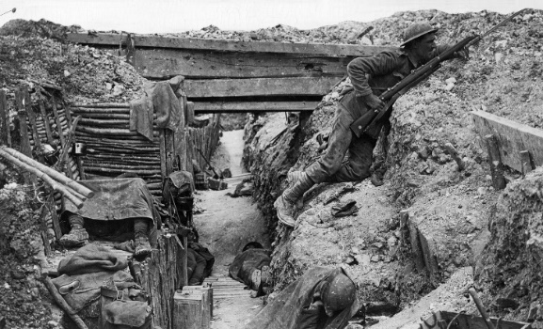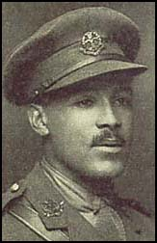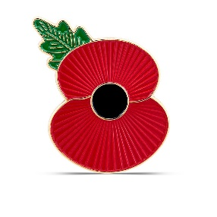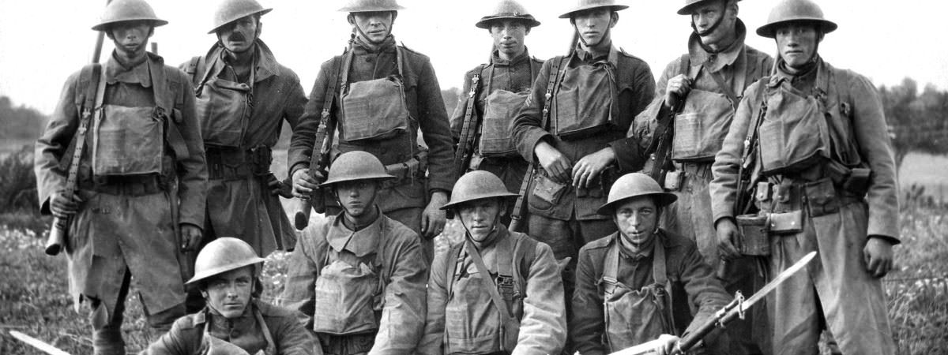

poppy

remembrance

fought

enemy

destroyed

victory

truce

troops

solider

pilot

nurse

Great Britain

Europe

Germany

Russia

Walter Tull

Private Billingham

Archduke Franz Ferdinand

trenches

gas mask

transmitter

horse

plane

zeppelin

bayonet

artillery

sandbags

grenade

**World War One**