**English**

**World Book Day**

One World Many Colours

By Ben Lewill

**Reading**

The Magic Finger

by Roald Dahl

The Egyptian Cinderella

by Shirley Climo

Pyramids of Secrets

By Jim Eldridge

**Writing**

Comprehension Responses

Linked to

‘The Magic Finger’

Historical Fairytale

Linked to the fable of

‘Egyptian Cinderella’

Instructions

How to make a ‘mummy’

**Class 3 – Spring Term 1**

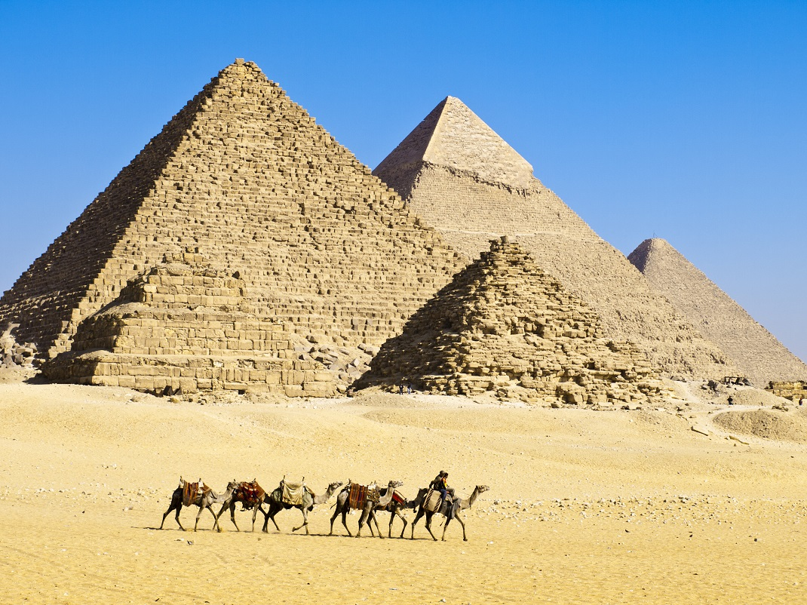

**Ancient Egyptians**

Learning Question

**Why was the River Nile so important for Ancient Egyptian civilization?**

**History**

**Ancient Egyptians**

To find out about one of the earliest civilizations

To find out where and when the Ancient Egyptians lived

To discover why the River Nile was so important to farming

To find out why else the River Nile was so important to Ancient Egyptians

To explore how the pyramids were built

To learn about mummification

To find out what might have caused the fall of the Ancient Egyptians

**Science**

**Light**

Children will recognise that they need light in order to see things and that dark is the absence of light.

They will notice that light is reflected from surfaces.

The children will recognise that light from the sun can be dangerous and that there are ways to protect their eyes.

The class will recognise that shadows are formed when the light from a light source is blocked by a solid object.

They will find patterns in the way that the size of shadows change.

**RE**

**Exploring the Sadness and Joy of Easter**

Explore the Easter Story by focusing on the feelings during events in Holy Week.

**DT**

**Designing, making and evaluating**

How to make an Egyptian Shaduf