
St. John's C of E (VA) Primary, Cliviger.

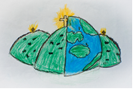

23/09/2026

Dear Parents and Carers,

As we begin the new academic year, we would like to take this opportunity to share some information about our Personal, Social, Health and Economic (PSHE) education programme.

PSHE education plays an important role in supporting pupils’ personal development, wellbeing and preparation for life now and in the future. It is the curriculum subject that gives children the knowledge, understanding, strategies and practical skills to live safe, healthy and productive lives to meet their full potential.

As part of PSHE education, we deliver Relationships, Sex and Health Education (RSHE) in line with the DfE statutory requirements. RSHE is designed to be age-appropriate, inclusive and respectful, and teaching takes place in a safe and supportive learning environment, underpinned by our school ethos and values.

Our RSHE policy
We encourage all parents and carers to read our draft RSHE policy, which is available on the school website in the curriculum section. This policy includes:
• our definitions for Relationships and Sex Education, how it is taught and who is responsible for teaching it
• how pupils’ questions are handled in the classroom
• how parents can view curriculum materials
• the process for parents to request withdrawal from all or some elements of sex education, in line with statutory guidance
• how content is made accessible to all pupils, including those with special educational needs or disabilities (SEND).

This year we are going to be using the Lancashire scheme of work to deliver our PSHE lessons. In due course, examples of teaching materials used in lessons, will be found on our website in the curriculum PSHE section. This will provide further details about what pupils will learn in each year group.

As we are reviewing our PSHE policy, we invite you to share your feedback by following the QR code below. This will open from the date of this letter for a two-week period, ending on Wednesday 7th October.
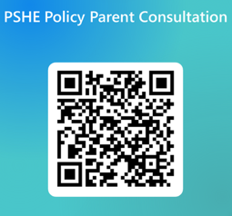
Yours sincerely,
Mrs Kenny
PSHE Lead



