Year 3
Art – Autumn 1
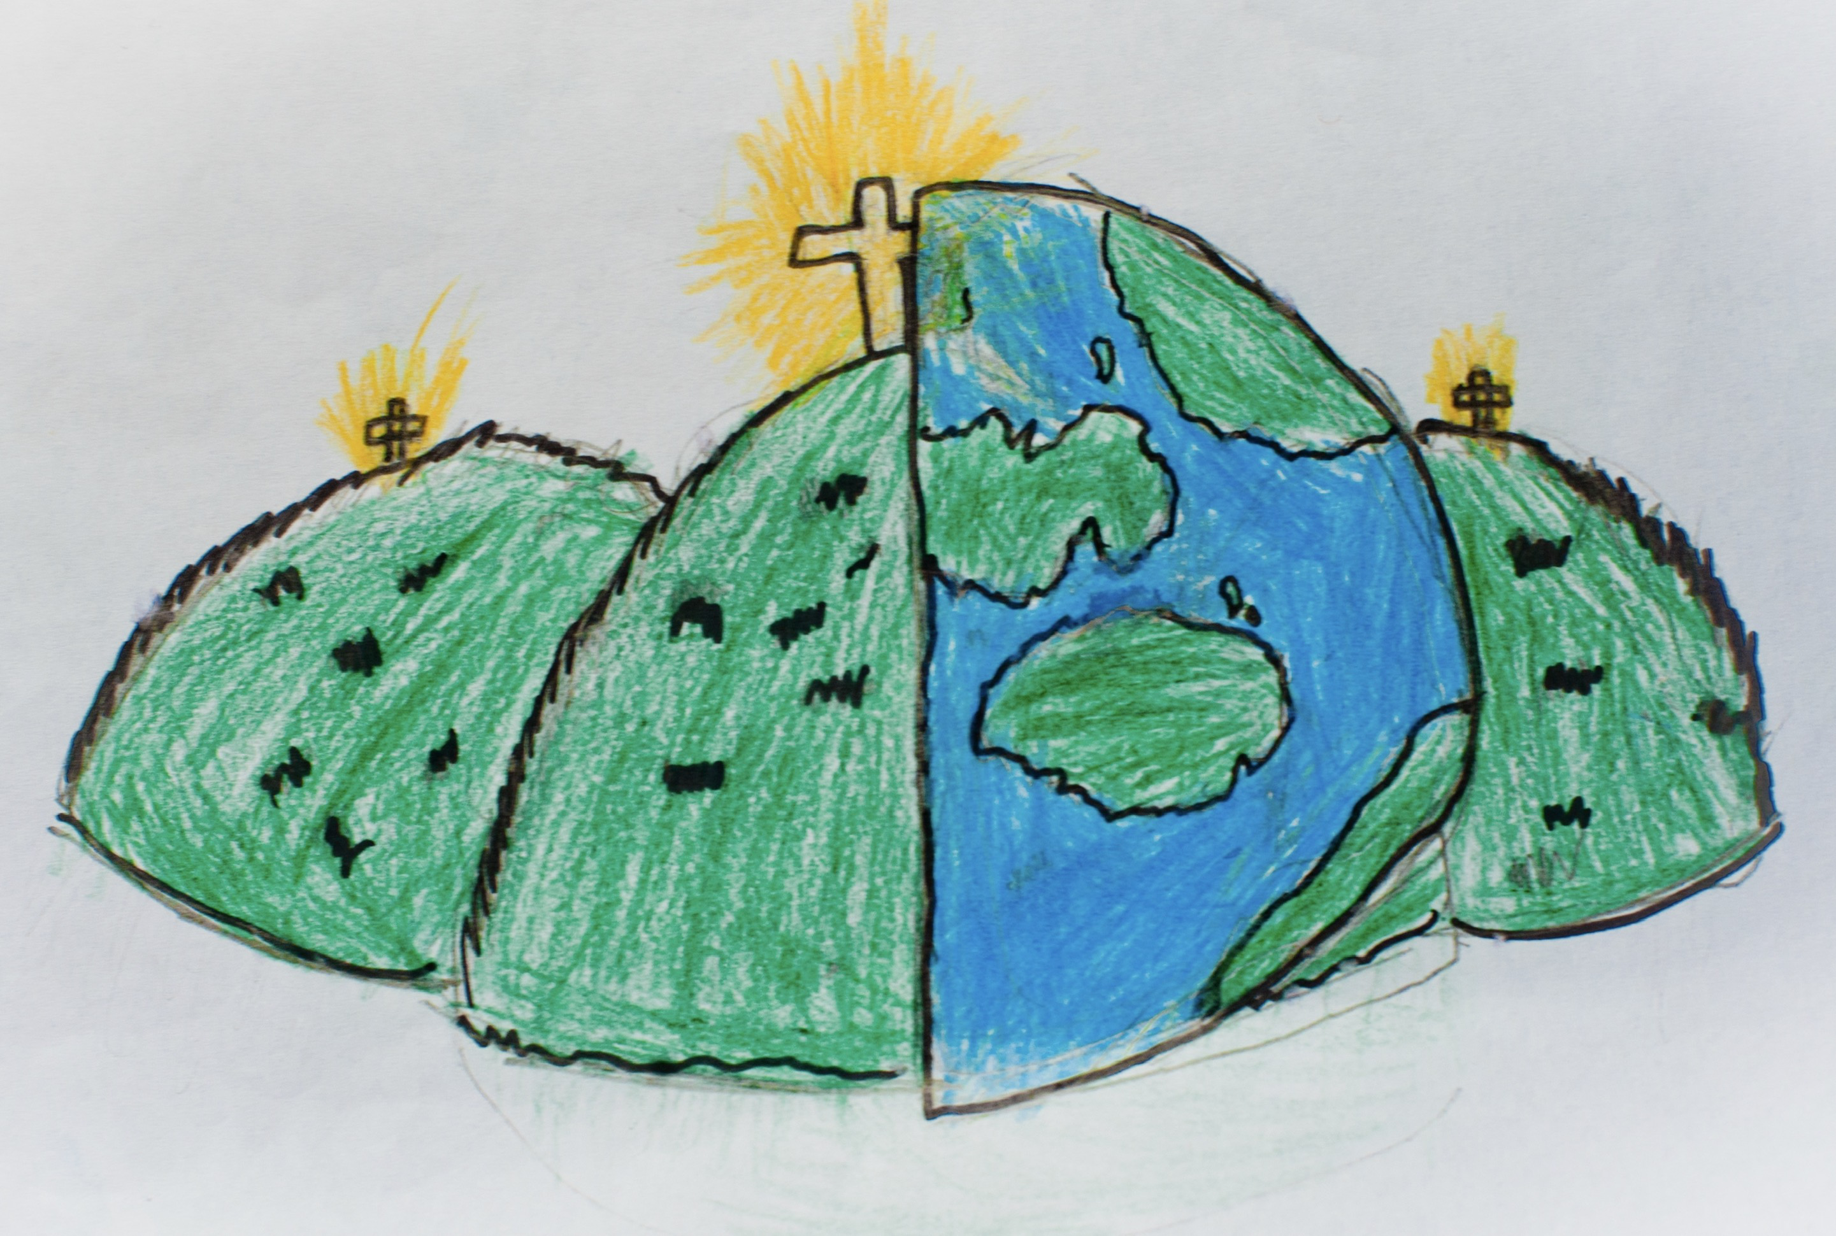

cartoonist  An artist who makes a series of drawings or illustrations. | character  A description of a person. | minimal  A very simple design without many colours.
opaque  A solid surface which you cannot see through. | puppet  A doll moved by your hand or strings. | sketching  A fast, light drawing which is often made as a plan for a drawing or painting.
style  The way in which something has been drawn. | three dimensional (3d)  A solid object, with height, length and width. | tint  The adding of white to make a colour lighter.
tone  The lightness and darkness of a colour. | 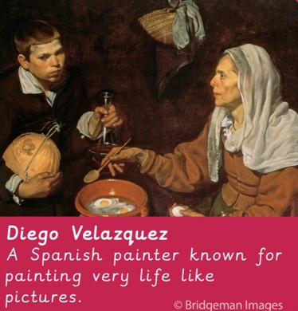  Diego Velazquez  A Spanish painter known for painting very life like pictures. | 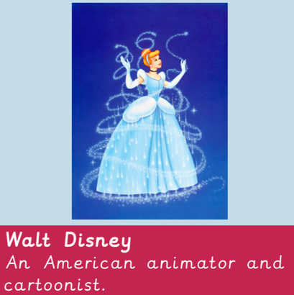  Walt Disney  An American animator and cartoonist.
Carl Giles  A British cartoonist. | shadows  Formed by shining a light at an object. | silhouette  The dark solid shape you can see when there is a bright light behind an object.

