Year 3
DT – Digital World: Electronic Charm


control  To command something to change, such as the direction in which something moves. | electronic  Devices that have some decision-making capabilities that require a processor. | function  How an object or product operates or works.
initiate  To start. | programming loop  A piece of code that repeats until instructed to stop. | monitor  To observe and record something over time.
program  A series of code which instructs an electronic device to perform specific tasks. | sensor  A tool or device that is designed to monitor, detect and respond to changes. | simulator  Computer generated imitation of something such as a program test or product prototype.
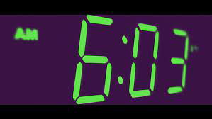  digital | user  A person that uses something. | 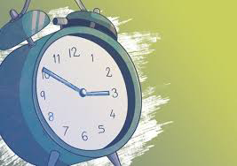  analogue

