Year 3
Science - Light
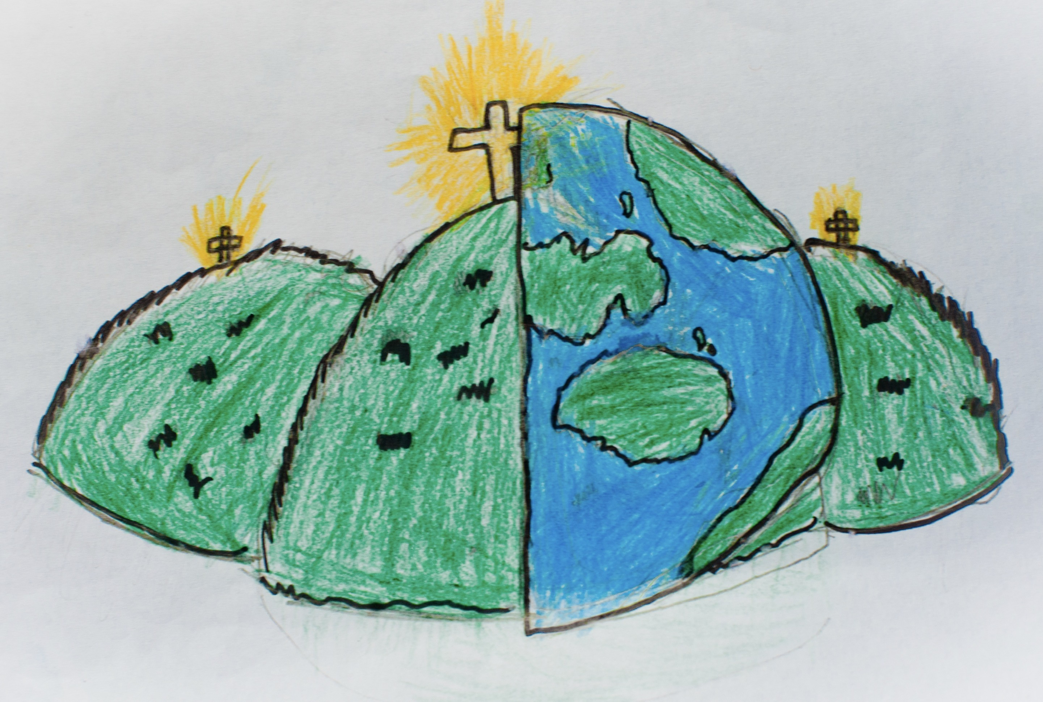

light source  Something which provides light. | absence of light  When there is darkness. | transparent  When you can see straight through.
translucent  Some light passes through but images are blurry. | opaque  You cannot see through it. | shiny  A surface which light reflects off.
matt  A dull, textured surface. | surface  The top of something. | shadow  It forms when something blocks the light.
reflect  When light or an image bounces back. | mirror  An object which provides reflection. | 