Key Vocab  Name | Definition
light source  absence of light  transparent  translucent  opaque  shiny  matt  surface  shadow  reflect  mirror | Something which provides light.  When there is darkness.  When you can see straight through  Some light passes through but images are blurry.  You cannot see through it.  A surface which light reflects off.  A dull, textured surface.  The top of something.  It forms when something blocks the light.  When light or an image bounces back.  An object which provides reflection.
Topic facts & figures
- We see objects because our eyes can sense light. We see objects when the light from a light source reflects from an object into our eyes.
- Some objects are sources of light e.g. the sun, light bulbs and candles.
- Dark is the absence of light. We cannot see anything in complete darkness.
- Shadows are formed on a surface when an opaque or translucent object is between the light source and the surface, blocking some of the light.
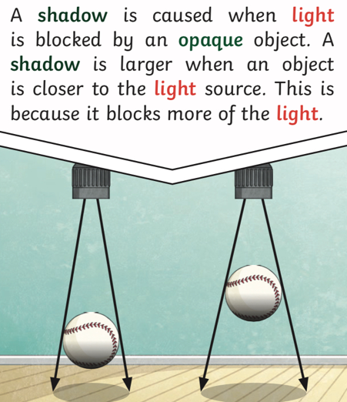
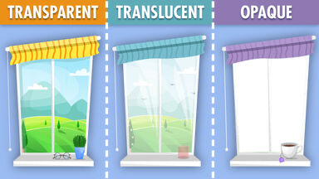
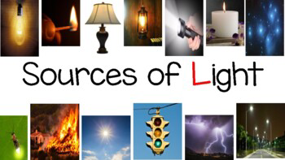
- The size of a shadow depends on the position of the source, object and surface. If the light source and object move closer to each other, the shadow becomes larger.
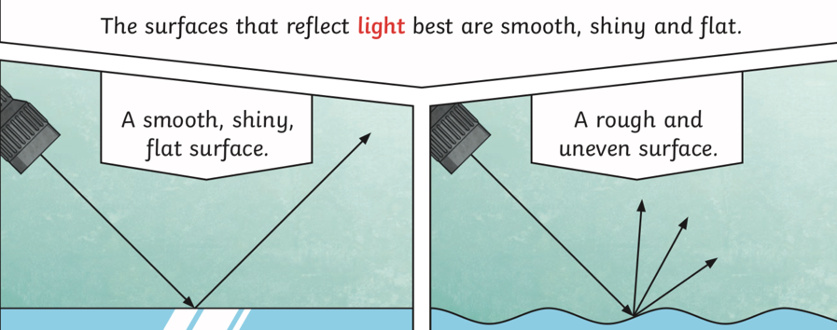
Knowledge Organiser – Orion and the Dark

