

‘Learn, Pray, Care & Play’

**St. John's C.E. (VA) School Cliviger**

Our church school through its Christian values and caring community seeks to inspire each individual to achieve and grow.

## **Able and Talented Policy**

## Aims and Rationale

Our school aims to make the education of more able learners a whole-school endeavour to be embraced by all school and subject leaders. We believe that addressing the needs of more able learners will raise achievement for a much wider group of learners in school. Providing for more able learners is not about labelling, but about creating a curriculum and learning opportunities which allow all children to flourish. We know that ability can be revealed across a range of subjects, not only in traditional academic ones. Our ethos is to set high expectations and aspirations for all learners. We provide a challenging and enriching education and as practitioners, we undertake continuous professional development to ensure that we are meeting the needs of our most able learners. We believe that ability is a fluid concept; it can be developed through challenge, opportunity and self-belief. We celebrate the achievements of all our children and encourage them to strive for excellence.

Definitions

“More Able pupils” are learners who:

* Have the potential or capacity for high achievement;
* Demonstrate high levels of performance in an academic area;
* Are more able relative to their peers in their own year group, class or school;
* Have ability in all areas of the curriculum or in a specific subject/curriculum area.

“Higher attaining” is purely a term used to distinguish between the more able and those that attain the highest standards.

“Exceptionally able” children show exceptional ability in one or more areas. These children exceed the needs of the more able and these need to be accommodated for. Their exceptional ability is in comparison with peers from all schools across the entire population. We understand that there may be learners that have, as yet, unrealised potential for exceptional ability. Exceptionally able children’s needs go beyond the needs of students already deemed to require opportunities and extensions within the normal curriculum.

“Underachieving more able learners”are those that have previously demonstrated high levels of ability, but whose current performance fails to demonstrate this. Underachievement may be the result of barriers to pupils’ learning, including socio-economic factors, SEMH and language and communication issues. Underachieving more able learners may be those whose contributions, responses and learning behaviours suggest that they are more able, although this is not reflected in their written work or assessments.

“Dual and multiple exceptionality learners” describe learners who are more or exceptionally able and who also have additional learning needs e.g. dyslexia, autistic spectrum disorders, developmental coordination disorder, developmental language disorder, emotional and behavioural difficulties, physical and sensory differences. These additional learning needs or a disability can make it difficult to identify their high intellectual ability.

**Attainment**refers to the level or standard of a learner’s work as demonstrated by some kind of test, examination or in relation to a predetermined expected level. In our school, common measures for attainment include Standard Attainment Tests (SATs) and NFER assessments. The emphasis here is on how learners perform when tested.

**Achievement** also refers to the success of a learner, but also takes into account the progress made and improvements demonstrated across time. The notion of added value over a term, year or key stage is part of the equation here, not merely the summative test scores.

Identification

More able learners can be identified in many ways at our school. These include:

* Nomination by staff, parents or peers;
* Self-nomination;
* Transition information;
* Teacher observation and assessment;
* Data and pupil tracking processes;
* Checklists of criteria;
* Identification through classroom provision

Each term the More Able Lead and SENDCo meet to identify learners who are at risk of, or are currently underachieving and interventions are put into place to help to raise attainment or performance. Underrepresented pupils, for example Pupil Premium children in our school, are also tracked on a Virtual Class and attainment is monitored through this.

Tracking and Assessment

Children are tracked and assessed using various means including:

* Teacher assessment;
* Use of NFER assessments in reading, grammar, spelling and maths;
* KS1 and KS2 SATS;
* Early Learning Goals (Development Matters);
* The Lancashire Tracker;
* Termly review of attainment and progress by and T&L lead and SENDCo;
* Pupil Progress Meetings between SLT and teachers;
* Pupil Premium Virtual Class;
* Comparison with local and national outcomes;
* Arrangements made for receiving information and passing it on at transfer and transition;
* Phonics tracker;
* Foundation subjects half-term assessments.

Leadership

Miss Leanna Moran is the Teaching and Learning Lead and is the designated More Able Co-ordinator. Miss Moran’s role is to offer support to colleagues in ensuring effective learning of the children. She also tracks more able children’s progress and keeps a record of the children that are more able in any given area.

The Governor responsible for overseeing More Able Children is Stuart Jackson (Chair of Governors).

Subject Leaders also have responsibility for providing a challenging curriculum within their specialisms and facilitating learners in meeting their full potential in a given subject.

Curriculum, teaching and Learning

At our school, we provide sufficient challenge for all children through the design of our lessons and curriculum. A learning pit is used in which children are encouraged to build their resilience to learn new concepts and take responsibility for their success.

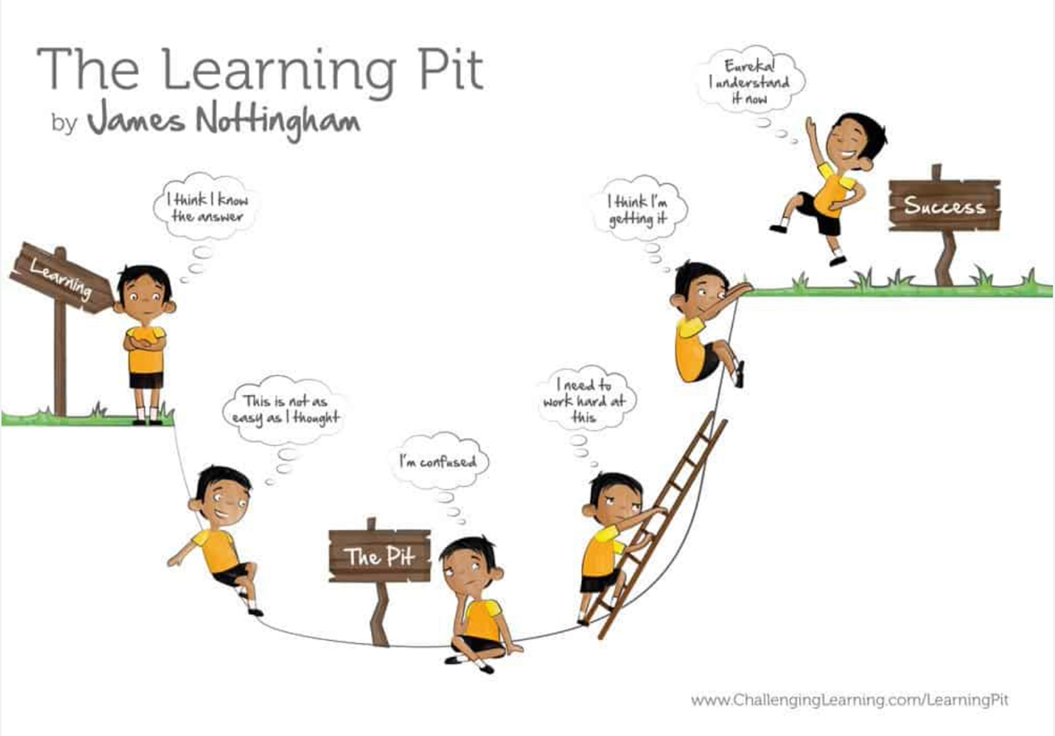

High expectations are outlined in every lesson and the use of the chilli challenge provides learners with three options to choose from: tricky, trickier or trickiest challenges. The curriculum is designed to provide opportunities for deeper learning by exploring relationships and problems in depth. Learners are encouraged to embrace challenge and aim high for themselves.

More able learners are provided with opportunities to work with other more able learners on cognitively challenging learning opportunities and dialogue is encouraged so that children can problem solve together. Children are encouraged to self-regulate their learning and explore their meta-cognition in order to achieve optimal learning.

The curriculum allows for extended talk and opportunities to reason in full sentences. Children are provided with opportunities to question and follow lines of enquiry. Dialogic teaching is used to engage children in developing their ideas and helping them to overcome misunderstandings.

Support staff are used effectively to challenge the more able learners through questioning and group work.

A range of resources are utilised including digital resources to enhance the curriculum and provide opportunities for learners to thrive.

Exceptionally able learners

When an exceptionally able child is at our school, the following measures will be put into place:

* A Pupil Overview of Provision (POP) will be put into place focussing on the needs of the individual and how they will be met;
* Extra provision, enrichment and approaches will be explored;
* Establish targets for the next half term;
* Liaison with parents or carers about the child’s targets and work;
* Consideration of social, emotional and learning mindset needs;
* Explore and develop responses to failure;
* Allow time and space for exploration and creation to pursue their passion.

Enrichment

Enrichment activities are provided for more able learners. These include:

* Opportunities for problem-solving;
* Chances to make decisions, for example in the role of a subject ambassador/leader working alongside subject leaders;
* Time to synthesise knowledge;
* Opportunities to think creatively;
* Follow their own lines of enquiry;
* Research their interests;
* Evaluate their learning or outcomes;
* Where possible, children are invited to masterclasses in specific subjects to delve deeper;
* More able children attend sports competitions;
* Collaborative tasks with other schools across Lancashire for more able learners, such as Spelling Bees and Times Table Championships;
* Opportunities for learners to engage with real-life scenarios, for example the use of the Daily Rigour (real world news) in KS2 Maths;
* Use of local external specialists such as gym and dance instructors and theatre groups;
* Opportunities to participate in performances, such as Burnley Youth Theatre productions.

Partnership with Parents and Carers

Our school works with parents and carers to meet the needs of the more able learners. Parents evenings are held termly between teachers and parents. Termly reports are issued so that parents can track the progress of their child they are invited to contact class teachers via email or telephone if they have any queries.

Personal, social and emotional support

We understand that there are specific challenges experienced by more able learners, such as pressure to perform. The learners are at the centre of everything we do, therefore the following strategies are in place:

* Our ethos is ‘learn, play, care and pray’ with a balance of each to develop every individual child to be the best version of themselves;
* PSHE lessons explore feelings of anxiety and stress and ways of managing these;
* A range of external visitors signpost children to ways of managing mental health, such as a Yoga instructor and PawsB facilitator (upper KS2 exploring mindfulness and meditation);
* Termly PSHE and Christian Value reports are sent home emphasising the importance of spiritual, moral, social and cultural development in our learners;
* Pastoral support is provided by teachers and teaching assistants;
* Pupil Voice interviews are conducted with more able learners to check how they feel towards school and learning;
* Open communication between school and home and incidents noted on CPOMS allowing common trends to be identified and addressed.

Professional Development

Our team at St John’s Cliviger undertake continuous professional development. This includes the Headteacher, the Senior Leadership Team, Subject Leaders, teachers and teaching assistants. Our CPD includes:

* Membership of the NACE website to keep abreast of the latest developments in challenging the more able and effective teaching and learning;
* Attendance on courses or webinars for development in subject knowledge or good practice;
* Guidance from external specialists, such as ECM for Maths Mastery approaches;
* Enrolment in SCHOOT for remote CPD which is tailored to each teacher or subject leader;
* Opportunities to liaise with other teachers in our school cluster.

Policy review and development

The quality of provision for more able learners will be monitored termly when pupil progress sheets are submitted and reviewed. Support will be given where needed. The challenge for more able learners is part of our School Improvement Plan (Priority 3 Teaching and Learning). There will be ongoing focussed monitoring of the quality of teaching and learning for more able learners. The impact of this policy will be assessed by the outcomes of monitoring and the progress of the more able children. The person who holds responsibility for policy development, review and evaluation is Miss Leanna Moran, Teaching and Learning Lead.

Appendix:

From NACE Website ‘Identifying more able learners’:

