Questioning  Questioning is asking yourself questions about things which puzzle you.  What does that word mean?  Why is that important?  How does this compare with…? | Reviewing  Reviewing is stopping once in a while to think about what you know, what you think you know, and what has changed about what you thought you knew.  Oh I get it! This is about…  Before I read this, I thought…Now I think…  I could tell from the beginning, this is about…
Connecting  Connecting is when what you are reading reminds you of something that has happened to you, something you have read, something you have seen or something you have heard about.  This makes me think of…  This reminds me of…  This is very similar to… | Evaluating  Evaluating is when you make judgements about what you are reading.  I like the way the author…  This is hard to understand because the author…  The part about…was easy to understand because the author…  It was helpful when the author…
Predicting  Predicting is when you stop occasionally and make a guess about what is going to happen or about what you might find.  This is going to tell about…  I think the story will end with…  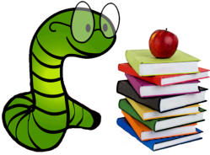  The next section will probably be about… | Visualising  Visualising is when you can picture in your mind what you are reading about.  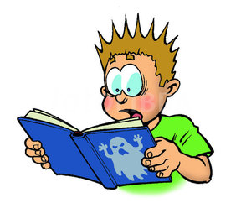  When I close my eyes, I can picture…  I can imagine…  When I read the part about…I imagined…

