

‘Learn, Pray, Care & Play’

Our church school through its Christian values and caring community seeks to inspire each individual to achieve and grow.

# Art and Design Policy

The National Curriculum states that:

*Art, craft and design embody some of the highest forms of human creativity. A high-quality art and design education should engage, inspire and challenge pupils, equipping them with the knowledge and skills to experiment, invent and create their own works of art, craft and design. As pupils progress, they should be able to think critically and develop a more rigorous understanding of art and design. They should also know how art and design both reflect and shape our history, and contribute to the culture, creativity and wealth of our nation.*

This policy will reflect the Anti-Bullying Policy of this school and will be reviewed as appropriate.

The Purpose of studying Art and Design:

At St. John’s C of E, Cliviger, we follow the National Curriculum Programme of Study for Art and Design.

Our Art and Design topics consider the children’s interests to give pupils the skills, concepts and knowledge necessary for them to express their responses to ideas and experiences in a visual or tactile form. It fires their imagination and is a fundamental means of personal expression.

Scheme of work:

As a school we follow the Kapow Primary scheme for Art and Design. Kapow gives complete National Curriculum coverage, a progressive scheme of work from Year 1 to Year 6, teacher and pupil demonstration videos and differentiation and clear assessment criteria.

Our curriculum is carefully planned to engage and excite all our learners, in line with our Adventurous Afternoons. Our long-term plans map out the themes covered each term for each year group. These plans define what we will teach and ensure an appropriate balance and distribution of work across each term.

Each child in KS1 has an art sketchbook which serves as a cumulative record of their work and is passed on to the next teacher at the end of each year. Samples of children’s work are also collected. Monitoring takes place regularly through sampling children’s work, teacher planning and lesson observations.

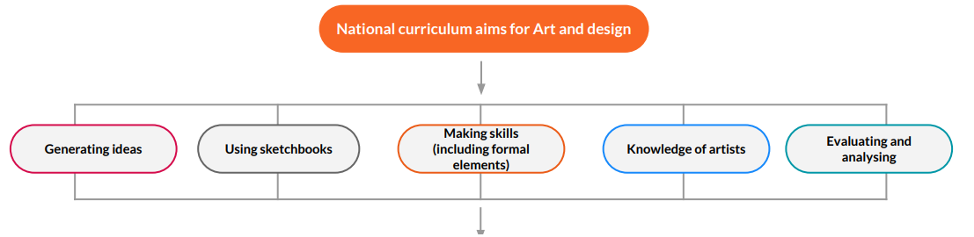

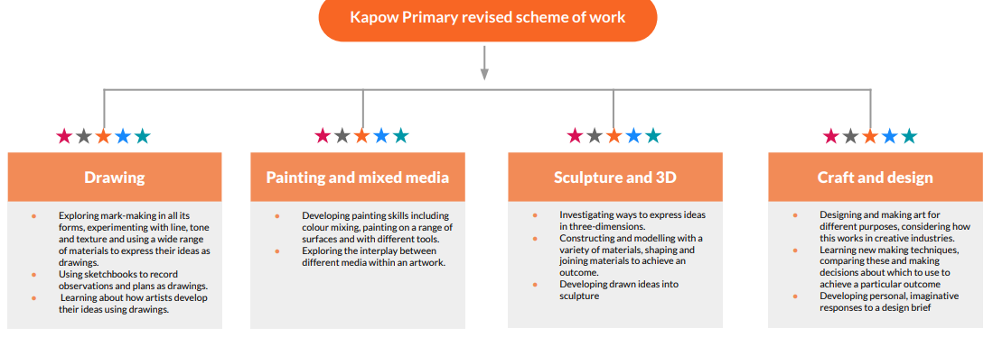

The Art and Design curriculum is based on the following knowledge and skills:

* Generating ideas and using sketchbooks, taking inspiration from a range of artists.
* Making skills: drawing, painting, printmaking, photography, mixed media, craft techniques and sculpture.
* Formal elements: colour, form, line, pattern, shape, texture and tone.
* Knowledge of artists’ work and techniques.
* Evaluating: critiquing their own work and that of others.

Breadth of study

Aims:

The national curriculum for art and design aims to ensure that all pupils:

* Produce creative work, exploring their ideas and recording their experiences.
* Become proficient in drawing, painting, sculpture and other art, craft and design techniques.
* Evaluate and analyse creative works using the language of art, craft and design.
* Know about great artists, craft makers and designers, and understand the historical and cultural development of their art forms.

**EYFS**

Art is delivered to our EYFS pupils within the ‘Expressive Arts and Design’ area of learning and through a cross curricular topic based approach at various points throughout the academic year to fit within their core text.

Pupils are given the opportunities to:

* Explore what happens when they mix colours.
* Experiments to create different textures.
* Understands that different media can be combined to create new effects.
* Manipulates materials to achieve a planned effect.
* Constructs with a purpose in mind, using a variety of resources.
* Uses simple tools and techniques competently and appropriately.
* Selects appropriate resources and adapts work where necessary.
* Selects tools and techniques needed to shape, assemble and join materials they are using.

By the end of the Reception year, most children will be aiming to achieve the Early Learning Goal; they safely use and explore a variety of materials, tools and techniques, experimenting with colour, design, texture, form and function.

**KS1**

**Pupils are taught**:

* To use a range of materials creatively to design and make products.
* To use drawing, painting and sculpture to develop and share their ideas, experiences and imagination.
* To develop a wide range of art and design techniques in using colour, pattern, texture, line, shape, form and space.
* About the work of a range of artists, craft makers and designers, describing the differences and similarities between different practices and disciplines, and making links to their own work.

**KS2**

Pupils are taught Pupils should be taught to develop their techniques, including their control and their use of materials, with creativity, experimentation and an increasing awareness of different kinds of art, craft and design.

**Pupils are taught**:

* To create sketch books to record their observations and use them to review and revisit ideas.
* To improve their mastery of art and design techniques, including drawing, painting and sculpture with a range of materials [for example, pencil, charcoal, paint, clay].
* About great artists, architects and designers in history.

**Assessment, recording and reporting**

Assessment is used to inform future planning and to provide information about individuals throughout their time in this school. Our methods of assessment include: -

* Teacher observations of pupils.
* Teacher/pupil discussions.
* Teacher questioning.
* Self-evaluation.
* Sketch books.
* Use of ICT.
* Termly assessment against key objectives for a unit of work.

At the end of Key Stage 2 it is expected that most of the children will achieve the expected standard, if not above this. However, all children will be encouraged to fulfil their whole potential in Art and do this to the best of their ability.

**Equal Opportunities**

At St John’s, we are committed to providing a teaching environment which ensures all children are provided with the same learning opportunities regardless of social class, gender, culture, race, special educational need or disability. Support for specific individuals is well considered and planned for, with consideration given to how deeper learning and further challenge can be provided for and demonstrated by children who require further challenge.

**Time Allocation**

Art is threaded through our curriculum. Children are regularly exposed to Art and have many opportunities to develop their artistic talents. Art and Design lessons are allocated to a minimum of 3 half terms.

An extra-curricular art club is offered to children in KS1 during the Autumn and Spring term.

**Online safety**

At St. John’s we understand online safety is paramount in an ever-changing world. We continue to ensure all children are safe in education and, following closely the Online Safety Policy. This is also in accordance with our Safeguarding Policy and in line with the Keeping Children Safe in Educations Act.

### Resources

Each teacher is able to access the Kapow scheme where planning and resources are provided. There are a range of resources to supplement Kapow in each classroom and in the Curriculum Den.

**INSET/training provision**

INSET is made available according to the needs identified in the School Improvement Plan, Teaching and non-teaching staff are encouraged to request any training they feel is appropriate to their needs and it is provided if possible. Information and ideas from courses, that staff have attended, are passed on and discussed at Curriculum Development Meetings. A local artist, frequently comes into school to deliver lessons across the key stages and training to staff.