 | 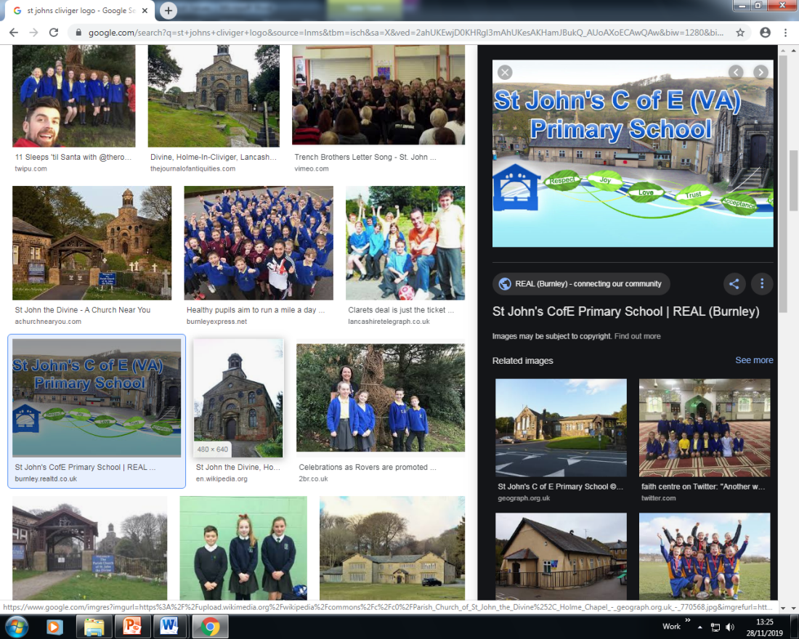 | ECM Education- Spiritual, Moral, Social & Cultural Audit Tool (SMSC)  SPIRITUAL DEVELOPMENT: Art and Design
The SPIRITUAL development of pupils is shown by their: |  |  | Curriculum Provision | Evidence of Impact on Pupils’ SPIRITUAL  Development
■ ability to be reflective about their own beliefs, religious or otherwise, that inform their perspective on life and their interest in and respect for different people’s faiths, feelings and values |  |  | - Pupils are encouraged to explore personal beliefs, emotions, and the world around them through creativity. | - Children’s work and ideas are celebrated through school displays show casing art skills and Christian values.  - Children have a sense of pride and achievement through the learning environment.
■ sense of enjoyment and fascination in learning about themselves, others and the world around them |  |  | - By combining spirituality with the art curriculum, children can gain a deeper sense of connection with themselves, each other and nature.  - Evaluating existing artists and their own work.  - Creating outcomes individually and as a group e.g. outdoor murals and display of work.  - Burnley Pride of Place Project. | - Children are able to gain an understanding of empathy, mindfulness and self-awareness.  - Children have a sense of pride and ownership of the murals around school that reflect Burnley and Christian values.  - Local artist, Lela Harris has been into every class to work alongside pupils to allow the children to become fascinated by their learning. Children can talk about artists they have studied or worked with.  - Burnley Youth Theatre come into school yearly and work alongside the children to produce a piece of art or drama. These are then showcased to the parents and displayed in school.  - Burnley, Pride of Place project- All children were involved in a project displayed in Burnley town centre to highlight their own culture, personalities and what they enjoy about living in Burnley. Their work was displayed for a month for the community of Burnley and surrounding areas to see and enjoy.
■ use of imagination and creativity in their learning |  |  | - Enterprise, children create/designs products to sell at fairs.  - Topics/projects are used effectively to engage the children’s imagination and creativity. | - Children across the school enjoyed designing and making Christmas cards for a local government competition.  - The staff plan exciting and interesting ways to teach art skills through the Kapow curriculum. They are able to express their emotions through various art forms, such as drawing, painting and sculpture.  - Art club runs for 2 terms each year and allows the Year 2 children to explore a range of skills and feelings the children encounter during artistic exploration. The children occasionally complete mindfulness activities before the sessions.
willingness to reflect on their experiences. |  |  | - Children evaluate own work as well as artist studies. | - Children learn about and discuss artists and the art they produce. These artists are carefully planned into the curriculum giving the children a wide and diverse range. They are able to elaborate on what the work means to them and give opinions.

ECM Education- Spiritual, Moral, Social & Cultural Audit Tool (SMSC)

MORAL DEVELOPMENT: Curriculum Subject Art and Design
The MORAL development of pupils is shown by their: |  |  | Curriculum Provision | Evidence of Impact on Pupils’ MORAL  Development
■ ability to recognise the difference between right and wrong, readily apply this understanding in their own lives and, in so doing, respect the civil and criminal law of England |  |  | - Art can help the children explore moral questions, express their beliefs and reflect on the impact of their actions on others and the environment. | - Children are able to work together and get along. Our collaborative projects promote teamwork and cooperation.  - A mutual respect for each others views and opinions.  - Create displays that reflect Burnley and the Christian Values.  - The children understand that there is no wrong in art and that other people’s art may be different and that is ok.
■ understanding of the consequences of their behaviour and actions |  |  | - Through cross curricular activities, art is used to explore moral concepts such as fairness, kindness, justice, respect and honesty. | - These are explored in RE and often art is used as a way of showing the children’s understanding.  - Storytelling is shown through art in EYFS and KS1 to show the difference between right and wrong in stories, traditional tales and nursery rhymes.  - In PSHE, art is used to show kindness, understanding, or the importance of helping others in need.
interest in investigating and offering reasoned views about moral and ethical issues, and being able to understand and appreciate the viewpoints of others on these issues. |  |  | - Respecting each other’s views on artists, working together to evaluate and respecting other people’s outcomes. | - Children are confident to contribute to discussions and debates about a variety of artwork from a variety of artist and cultures.  - Children understand and appreciate the views of others and value different views from their own.  - The children understand that there is no wrong in art and that other people’s art may be different and that is ok.

ECM Education- Spiritual, Moral, Social & Cultural Audit Tool (SMSC)

SOCIAL DEVELOPMENT: Curriculum Subject Art and Design
The SOCIAL development of pupils is shown by their: |  |  |  |  | Curriculum Provision | Evidence of Impact on Pupils’ SOCIAL  Development
■ use of a range of social skills in different contexts, including working and socialising with pupils from different religious, ethnic and socio-economic backgrounds |  |  |  |  | - Family Fun Fridays linked to art and design.  - Burnley Youth Theatre projects throughout the school.  - Paired or group projects.  - Learning about a variety of artists from different backgrounds and cultures. | - Children take part in group activities with their families, demonstrating art skills and using them across the curriculum.  - Burnley Youth Theatre come into school yearly and work alongside the children to produce a piece of art or drama. These are then showcased to the parents and displayed in school.  - Kapow encourages collaborative work where the children have to design and work together.  - Local artist, Lela Harris has been into every class to work alongside pupils to allow the children to become fascinated by their learning. Children can talk about artists they have studied or worked with.  - Collaborative art work can lead to disagreements and challenges through differing ideas. Therefore the children have to practice problem solving.
■ willingness to participate in a variety of communities and social settings, including by volunteering, cooperating well with others and being able to resolve conflicts effectively |  |  |  |  | - Remembrance Day art work for our D-day celebrations. | - Each year group were given an art activity to complete for our D- Day celebrations. These were displayed for the community to see in Church House, at our Cenotaph and leading up to the church.  - Children have ownership over the learning environment and show a sense of pride to the displays created together.  - Children’s ability to build relationships and contribute to their community was enhanced.
acceptance and engagement with the fundamental British values of democracy, the rule of law, individual liberty and mutual respect and tolerance of those with different faiths |  |  |  |  | - Voting on themes for art projects. | - Through cross curricular links with RE, Worship Club set a challenge to produce a design for our Prayer Bench. The whole school were able to enter the competition and Worship club held a vote to identify a winner. The bench was then completed.
 | and beliefs; the pupils develop and demonstrate skills and attitudes that will allow them to participate fully in and contribute positively to life in modern Britain.

ECM Education- Spiritual, Moral, Social & Cultural Audit Tool (SMSC)

CULTURAL DEVELOPMENT: Curriculum Subject Art and Design
The CULTURAL development of pupils is shown by their: |  |  | Curriculum Provision | Evidence of Impact on Pupils’ CULTURAL  Development
■ understanding and appreciation of the wide range of cultural influences that have shaped their own heritage and that of others |  |  | - A wide range of genres and artists from a variety of backgrounds and cultures are selected for each year group to study.  - Burnley Pride of Place project. | - The children are introduced to a wide range of cultures through art and cross curricular links.  - Local artist, Lela Harris has been into every class to work alongside pupils to allow the children to become fascinated by their learning. Children can talk about artists they have studied or worked with.  - Burnley, Pride of Place project- All children were involved in a project displayed in Burnley town centre to highlight their own culture, personalities and what they enjoy about living in Burnley. Their work was displayed for a month for the community of Burnley and surrounding areas to see and enjoy.  - Displays that reflect Burnley and the Christian Values.  - A mutual respect for each other’s views and opinions.
■ understanding and appreciation of the range of different cultures within school and further afield as an essential element of their preparation for life in modern Britain |  |  | - Displays.  - Burnley Pride of Place project. | - Displays/mural that reflect Burnley and the Christian Values.  - Children were encouraged to visit their work on display in Burnley Town Centre. Here some children were able to look at a range of art work from different cultures that live within Burnley.  - In discussion children show mutual respect for each others views and opinions.
■ knowledge of Britain's democratic parliamentary system and its central role in shaping our history and values, and in continuing to develop Britain
■ willingness to participate in and respond positively to artistic, sporting and cultural opportunities |  |  | - Respecting each other’s views on artists, working together to evaluate and respecting other people’s outcomes. | - Children are confident to contribute to discussions and debates about a variety of artwork from a variety of artist and cultures.
■ interest in exploring, improving understanding of and showing respect for different faiths and cultural diversity, and the extent to which they understand, accept, respect and celebrate diversity, as shown by their tolerance and attitudes towards different religious, ethnic and socio- economic groups in the local, national and global communities |  |  | - Students are encouraged to express their own identities and explore various cultures within their art lessons. | - Children learn about celebrations in different religions. They produce art in relation to this, such as rangoli patterns for the Hindu festival of Diwali.

 |  |  | British Values: Curriculum Subject Art and Design
 | Understanding and knowledge expected of pupils as a result of schools promoting fundamental British values. |  |  |  | Curriculum Provision | Evidence of Impact on Pupils’ Understanding of  BRITISH VALUES
• an understanding of how citizens can influence decision-making through the democratic process; |  |  |  | - Group discussions during the teaching of art.  - Promotion of speaking and listening skills during our art lessons. |  | - Children are able to take part in discussions and debates during lessons.
• an appreciation that living under the rule of law protects individual citizens and is essential for their wellbeing and safety; |  |  |  | - Health and Safety- Using and handling equipment safely. |  | - Children can confidently and safely handle the equipment used to develop skills.
 | • an understanding that there is a separation of power between the executive and the judiciary, and that while some public bodies such as the police and the army can be held to account through Parliament, others such as the courts maintain independence;

• | an understanding that the freedom to choose and hold other faiths and beliefs is protected in law; | - Different Faiths through art  - Picture news. | - Children study a variety of Artists and cultures through Art lessons and cross curricular links such as RE.
• | an acceptance that other people having  different faiths or beliefs to oneself (or having none) should be accepted and tolerated, and should not be the cause of prejudicial or discriminatory behaviour; | - Different Faiths through art.  - Picture news. | - Children study a variety of Artists and cultures through Art lessons and cross curricular links such as RE.
• | an understanding of the importance of identifying and combatting discrimination. | • Different Faiths through art | - Children study a variety of Artists and cultures through Art lessons and cross curricular links such as RE.
NB: It is not necessary for schools or individuals to ‘promote’ teachings, beliefs or opinions that conflict with their own, but nor is it acceptable for schools to promote discrimination against people or groups on the basis of their belief, opinion or background.

In addition, the ‘Promoting Fundamental British Values as Part of SMSC’ advice for schools suggests:

Through their provision of SMSC, schools should:
- enable students to develop their self-knowledge, self-esteem and self-confidence;

- enable students to distinguish right from wrong and to respect the civil and criminal law of England;

- encourage students to accept responsibility for their behaviour, show initiative, and to understand how they can contribute positively to the lives of those living and working in the locality of the school and to society more widely;

- enable students to acquire a broad general knowledge of and respect for public institutions and services in England;

- further tolerance and harmony between different cultural traditions by enabling students to acquire an appreciation of and respect for their own and other cultures;

- encourage respect for other people; and

- encourage respect for democracy and support for participation in the democratic processes, including respect for the basis on which the law is made and applied in England.

