‘Love one another as Jesus loved us’ John 13 v 34-35

St. John's C.E. (VA) School Cliviger

‘Learn, Pray, Care & Play’

Our church school through its Christian values and caring community seeks to inspire each individual to achieve and grow.

Assessment Policy

Introduction
Assessment is central to good teaching practice. It should be used to set targets and inform planning to ensure that all children achieve a standard of work, which reflects their individual ability.

This policy document reflects the aims and philosophy of the school. The policy sets out the framework within which the whole staff operates and provides information on the strategies for the assessment of pupils’ work, the ways in which records are kept and the ways in which reports on pupils’ performance are made. This policy should be read in conjunction with all other policy documents and schemes of work.

Assessment Methods

Assessment is undertaken for different functions:
Formative – showing what pupils know, understand and can do. This informs subsequent teaching/steps and is used to help teachers with their planning and to help pupils work towards learning targets.
Diagnostic – identifying particular strengths and weaknesses. This is used primarily for individual pupils and enables the teacher to support learning by changing support and resources.
Summative – used at the end of a key stage, units of work and termly. This fulfils a summarising function, summing up attainment at a particular time.

Formative Assessment strategies
Effective assessment arises from the setting of clear intended learning outcomes at the planning stage and clear exposition of learning objectives through the use of a learning objective. This is implemented through formative classroom strategies, which include:
- Formal and informal observations
- Asking questions
- Talking with, and listening to pupils
- Giving pupils feedback about what they need to do next
- Marking work using the objective led marking frame (see marking policy)
- Informal tests
- Levelled writing takes place at least every two weeks and at least twice a half term as extended writing across the curriculum.

Teacher Assessment
- Lancashire Tracker will be used to track teacher assessment for Reading, Writing and Mathematics.

- Data collected from Lancashire Tracker will be used to inform the Self Evaluation Form and School Improvement Plan. Teachers will undertake regular moderation meetings within schools and in external clusters, to ensure that Teacher Assessments using Lancashire Tracker are accurate. The subject leaders for literacy and mathematics moderate standards each half term.

Pupil Progress records will happen termly; this will lead to the organisation of appropriate intervention programs, directed Teaching Assistant time and additional teacher support to form our Provision Map.

Teacher Assessment | How this relates to End Of Key Stage targets
1 | WORKING TOWARDS THE EXPECTED STANDARD  SOME EVIDENCE BUT NOT SECURE
2 | WORKING AT THE EXPECTED STANDARD  MOSTLY SECURE
3 | WORKING AT GREATER DEPTH WITHIN THE EXPECTED STANDARD  SECURE AND APPLIES IN OTHER CONTEXTS, NO REMINDERS NEEDED

Statutory Assessment

The Foundation Stage
A Baseline is carried out on entry to Reception and again at the end of the year using ‘Development Matters’ to create individual documents.
Each child has a personal profile, which is completed over six terms and highlights achievement.
Evidence is collected through observation and discussion and recorded in a variety of books (Writing, Mathematics, Learning Journals) and 2Simple software is used to collate evidence from observations in all areas of learning.
Each ELG is split into smaller, more achievable targets.
The profiles reflect their achievements within the Early Learning Goals and are used to inform the end of year reports to parents.

Key Stage 1
Phonics screening is administered in June in Y1 and to the Y2 children who did not achieve the pass mark in Y1. Phonic assessments take place every half term in both EYFS and KS1. The Year 2 teacher also records end of Year 2 test/task results onto the Key Stage 2 transfer sheet as the children move into Year 3.
NFER assessments are also completed termly to assess the children against age-related standardised scores.

Key Stage 2
The end of Key Stage SATs is administered by the class teacher.
NFER assessments are completed termly in Years 3, 4, 5 and 6 termly to assess the children against age-related standardised scores.
The SLT and staff have implemented AFL (assessment for learning) throughout the school. This enables all staff to assess learning as it takes place and if necessary, adjust lessons, teacher input or level of challenge to better facilitate learning.

Formal Assessments and Testing in Key Stage 1 and 2
Teacher assessments:
In year 2 and 6 pupils will be assessed against the interim teacher assessment framework for reading, writing and mathematics and judged whether they are working;
- • towards the national standard;
- • at the national standard or;
- • at greater depth than the national standard.

They will also be assessed against the interim teacher assessment framework for science and judged whether they are working at the national standard or not.

Formal Tests (SATs):
Pupils in year 2 and 6 will take national tests in reading, mathematics and spelling, punctuation and grammar (SPAG). These tests will be externally marked for year 6 and internally marked for year 2. The children will be given a standardised score which will be shared with parents.

Record Keeping

Throughout the school, records are on the computer system for ease of transfer from year to year.
Subject Leaders have access to a representative selection of evidence from all year groups.
The school also keeps formal curricular records for individual pupils as required by the Education (school records) Regulations.

Reporting
Assessment data is shared verbally with parents during our twice-yearly Parents’ Evening meetings.
Targets are set each September and parents are kept informed about their child’s progress through the ‘Pupil Conferences’. An end of term summary on a child’s progress is sent in December and March.

Formal reports to parents are produced in the Summer Term. These reports provide: -
- Comments on National curriculum subjects
- Comments on general progress
- Attendance and punctuality
- End of Key Stage levels (tasks and/or tests)
- Targets set in discussion with the pupil
- Headteacher’s comments
- Child’s comments on achievements and areas for improvement
EYFS, Phonics Screening, KS1 and KS2 standardised scores will be shared with parents via a report at the end of the year.

When pupils move from one class to another; relevant information and records are transferred to inform any subsequent teachers.

Children New to School
During the first two weeks of a child starting school, a baseline assessment will be carried out and a Steps judgement made on Target Tracker.
The school meets the requirements to provide reports for pupils on transfer to another school or transition to High School. The DfES transfer forms will be used in conjunction with other material.

Reports are made to the Governing Body in the context of the Curriculum and SEC Committees and relevant information passed to the whole Governing Body via the Minutes. The same information will be available through the SIP (School Improvement Plan)

Special Educational Needs
Pupils identified on the SEN register are assessed using Lancashire Tracker, using the expectations from prior year groups. If required, children may be assessed against PIVATs to measure small steps in attainment.

Resources

Assessment material will be purchased via the school budget – part of which is always allocated for this purpose.

Professional Development

In line with the job description the subject leader will:
- keep abreast of developments in assessment by attending courses, being aware of resources available and disseminating relevant information to staff.
- will keep the Head Teacher informed of the outcomes of assessment and together they will report these to the Governing Body and identify areas for further development.
- organise meeting with staff to evaluate assessments and use the outcomes to inform future planning.
- offer guidance and support to staff in relation to the assessment of pupils.
- prepare summaries and reports on assessment for governors and for publications eg. School Prospectus.
- staff training for assessment procedures and monitoring/moderation will be available through the Staff INSET programme.

Monitoring and Evaluation
The monitoring and evaluation cycle will be updated termly.
Roles and Responsibilities:
- Assessment Leader: Mrs Healey
- Target Tracker Leader: Mr Klee
- Teaching and Learning Leader: Miss Moran
- Curriculum Leader: Mrs Johnston
- Head Teacher: to have the overall responsibility for evaluating how effective the teaching of different elements of the curriculum has been and identify any necessary modifications - to relate this information to the Governing Body.
- SENDCO: Mrs Pickup, to record and evaluate progress made in relation to SEN pupils (including POPs (Pupils Overview of Provision)), Pupil premium, LAC (Looked after Children) and also AT (able and talented) pupils and in discussion with staff and parents to outline procedures necessary for further development.
- Subject Leaders: to monitor the assessment of their subject as outlined in the policy, to evaluate the information and to provide a report for the basis of discussion with the Head Teacher and Assessment Co-ordinator.
- Class Teacher; to be responsible for assessing the achievements of pupils in all areas of the curriculum and conveying individual information to parents through discussion and annual reports and to convey the general outcomes of assessment to the Assessment Co-ordinator. Also to be responsible for organising and directing Classroom Assistants and Support Assistants in observing and recording ongoing assessments and liaising with support teachers as outlined below. To regularly review and update IPPs. Pupil progress meetings with the SENDCo, DHT and HT every term and Pupil Conferences meetings with the children every term.
- SEN teacher (Mrs Pickup) To liaise with teachers regarding the needs of individuals.
- Classroom Assistants and Support Assistants: for assisting in the assessment of pupil progress in relation to the children they are working with and to observe and record as directed by the class teacher.
- Governing Body: with the Head Teacher to evaluate the outcomes of assessment and targets for action and improvement. To set the targets for the percentage of pupils in year 6 to achieve year group expectations.

Evaluation and Review
It is the responsibility of all the staff and Governors to monitor their adherence to this policy. The policy is reviewed bi-annually by all concerned. The Headteacher and the Governing Body evaluate the outcomes and targets for action and improvement are included within the School Development Plan.

Success Indicators

- Are staff and Governors fulfilling their roles in relation to the Assessment policy?
- Is assessment reflecting comprehensively the achievements of pupils?
- Does the assessment inform future planning in highlighting general areas for particular development and individual pupil’s needs?
- Are parents informed of their children’s assessment and are they involved in subsequent support for their child’s development?
- Is assessment and target setting improving the raising standards in the school and enabling each child to make acceptable progress?

Effective Feedback for All
Do all children receive the same type of feedback?
Teachers need to be able to use different feedback strategies to respond to the different needs of their children.
We considered how passive some written feedback is making children.
Couldn’t they and shouldn’t they make more progress when having to think more and make some independent choices?
If some children can work independently after teacher input why are we making them passively read a comment and respond?
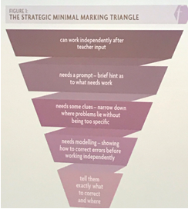

Image from @ClareSealy’s blog (credit to @kwest91)

This table shows how feedback can be easily differentiated to meet the

needs of the different pupils.

Child’s responsiveness to feedback | Methods of feedback
Can work independently after teacher input | - Whole class verbal feedback using whole class feedback formats, either on the board or teacher notes after English/ Maths lesson  - Self-assessment after teacher input  - Use the success criteria to self-assess after teacher input  - Teacher stops mid-lesson to give verbal feedback
Needs a prompt – briefing hint what needs work | - Dots in the margin  - Work with partner to support them/ have conversations about improvements  - Teacher stops mid-lesson to put examples on the board using visualiser/ ipad  - Verbal feedback within the lesson in a group
Needs some clues- narrow down where problems lie without being too specific | - Use symbols to direct them to particular aspects of whole class feedback on board  - Using written marking code to be more specific about the error  - Using board challenges to give examples of improvements and child chooses from these examples  - Cooperatively improved with some teacher input
Needs modelling- showing how to correct errors before working independently | - Teacher models improvements to a group of children with similar errors, then children work independently
Tell them exactly what to correct and where | - Teacher includes written comment telling them what to improve  - Teacher working with individuals to support them to make improvements  - Pink highlighter on the work exactly where the improvements need to be made
Children must always make improvements (in response to verbal or written feedback) in purple pen

Appendix 1: Whole Class Feedback Expectations
Our principles for Whole Class Feedback
- Feedback must be linked to lesson learning objectives and help children to improve their understanding.
- Feedback given to children can take the form of spoken, written, peer or self-assessment. Children use this feedback to make improvements in their work in a purple pen.
- Feedback must be meaningful: it varies by age group and subject.
- Feedback must be manageable: whole class feedback is used for most children; this feedback is matched to the needs of the children.
- Feedback must be motivating: it should help children to make progress. It is important to value a child’s efforts and achievement and celebrate success.
- Teachers must not accept work that children have not checked sufficiently and then provide extensive feedback. Children should be taught and encouraged to check their own work in an age appropriate way, so that they complete work to the highest standard.
Immediate feedback in lessons includes:
- Discussion of success criteria/ exemplification of learning objectives (used at teacher discretion to support the children).
- Mini- plenaries where the teacher responds to the needs of the class at any point in the lesson, sometimes redirecting, offering additional challenge or modelling.
- Questions and answers offer opportunities to adapt teaching to the needs of the class throughout the lessons
- Children should mark their own work in maths (as often as possible) and be encouraged to self/ peer assess in the lesson. Children are not allowed to write in another child’s book, but post-its should be used.
After children have worked in English/maths/Wider curriculum books (as per expectations below):
- Teacher completes ‘whole class feedback sheet’ to review English/ maths/Wider curriculum books. Teacher identifies which pupils need more support in the next lesson or more challenge and records this on the grid. Any notes are for the teachers own reflection/ planning. These will be also used to help inform book scrutinies.
- When completing a whole class feedback power point, this replaces the feedback sheet and should be put in the marking file.
At the beginning of the next lesson:
- The teacher can share their feedback with the class, explaining/ re-teaching aspects of the previous lesson, focusing on key children’s misconceptions.
Any feedback actions completed by children are completed in a purple pen. Children should be able to talk about how they have improved their work in response to feedback. Whole class feedback sheets are stuck into children’s books.
All pieces of work will have been reviewed by the teacher and will still have some form of teacher marking, e.g. dots, marking symbols, highlighting and/or ticks.
There should be clear evidence of challenge in all books, e.g. extension tasks, further challenge or extension questions. High expectations are evident for presentation of work in books.
Expectations for re-drafting will lead to improvements in writing so a lesson/ significant amount of time in a lesson should be devoted to this and included in the expected pieces.
Work in wider curriculum should be reviewed with children and verbal feedback given against the learning objective.
√√√ Three ticks are given for work that shows the learning objective has been achieved and is presented in a thoughtful way.
√√Two ticks are awarded for achieving the learning objective and good presentation.
√ One tick awarded reflects that more feedback/ guidance is needed so that the pupil can adapt/ improve their work and achieve a higher standard.

Appendix 2
Marking Code
EYFS and KS1 will introduce marking symbols progressively and model the symbols through
teaching. Sometimes single dots are used with verbal feedback to indicate improvements needed.
MARKING KEY
✓ | I like this – Great Words
CL | Capital Letter
^ | A missing word
// | A new paragraph needed
 | Spelling mistake
L.O. | Highlight the entire objective yellow if achieved
I | In the margin if the work is independently completed
GW | In the margin if it is a guided write
S | In the margin if the work has been supported
S – support given
G – guided group work
I – independent work

Anyone marking work other than the class teacher must initial the work they have marked.
Stamps, stickers and smiley faces to be used to encourage, acknowledge good work and learning objectives achieved

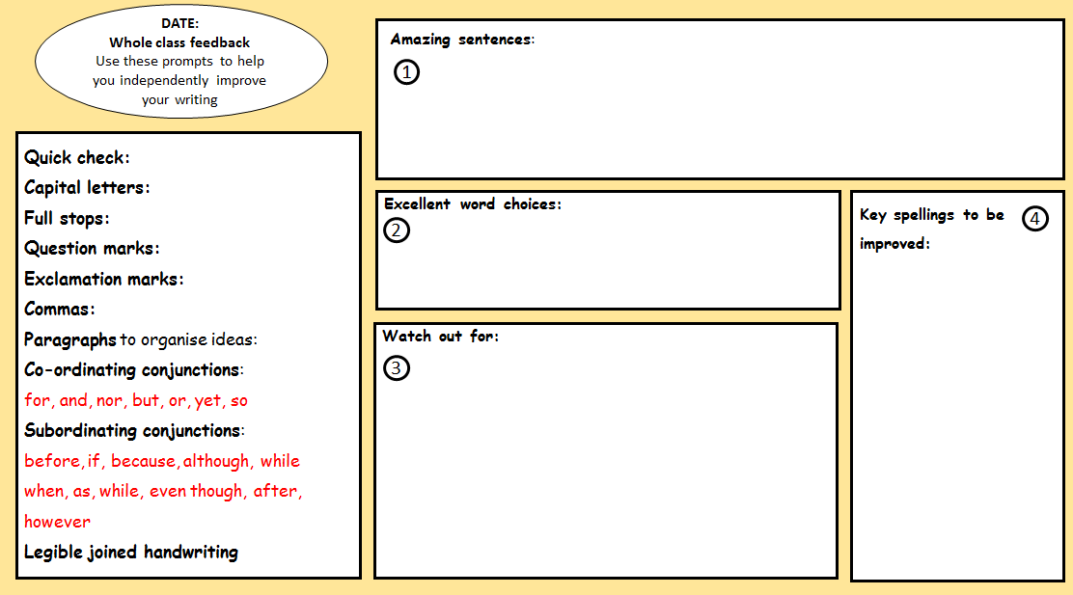
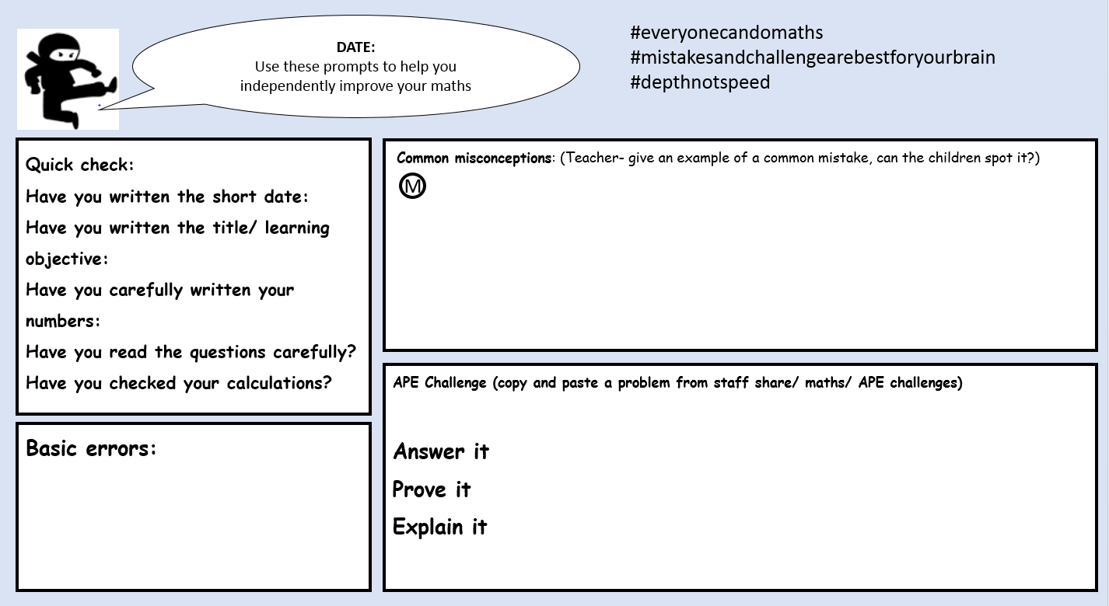
Appendix 3: Whole Class Feedback (English/Maths)

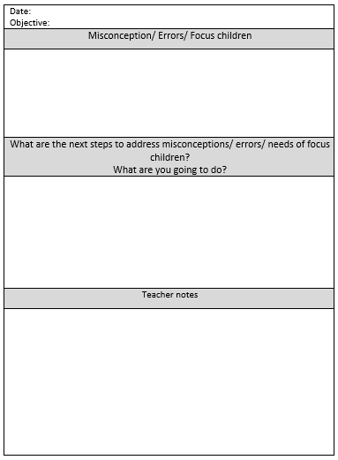
These are used as a presentation in class with the children.
These are used for teachers to fill in after English/ maths lessons to inform lesson planning/ adaptations.

Appendix 4
Termly Assessment Calendar
Term 1 | Term 2 | Term 3
EYFS Baseline  Literacy and Maths Baseline  End of Year Target Setting  Autumn Assessments  Data Input onto Target Tracker  Target setting Meetings  Termly reporting to parents  PSHE & Christian Value reports  Phonics tracking – each half term  Pupil progress meetings to set up Brain Buddies  Assessment coordinator meets with middle leaders & governors coordinators to share data trends (SEC) | Spring Assessments  Data Input onto Target Tracker  Termly reporting to parents  PSHE & Christian Value reports  Phonics tracking – each half term  Pupil progress meetings to set up Brain Buddies  Assessment coordinator meets with middle leaders & governors coordinators to share data trends (SEC) | EYFS Profile  KS1 SATs (May)  KS1 Phonics (June)  Y4 Times table testing  Y3,4 and 5 testing (May)  KS2 SATs (May)  Data Input onto Target Tracker  End of year reports  PSHE & Christian Value reports  Phonics tracking – each half term  End of year Pupil Progress to hand over assessments and set targets (HT, SENDCo, current and next teacher).  Assessment coordinator meets with middle leaders & governors coordinators to share data trends (SEC)

