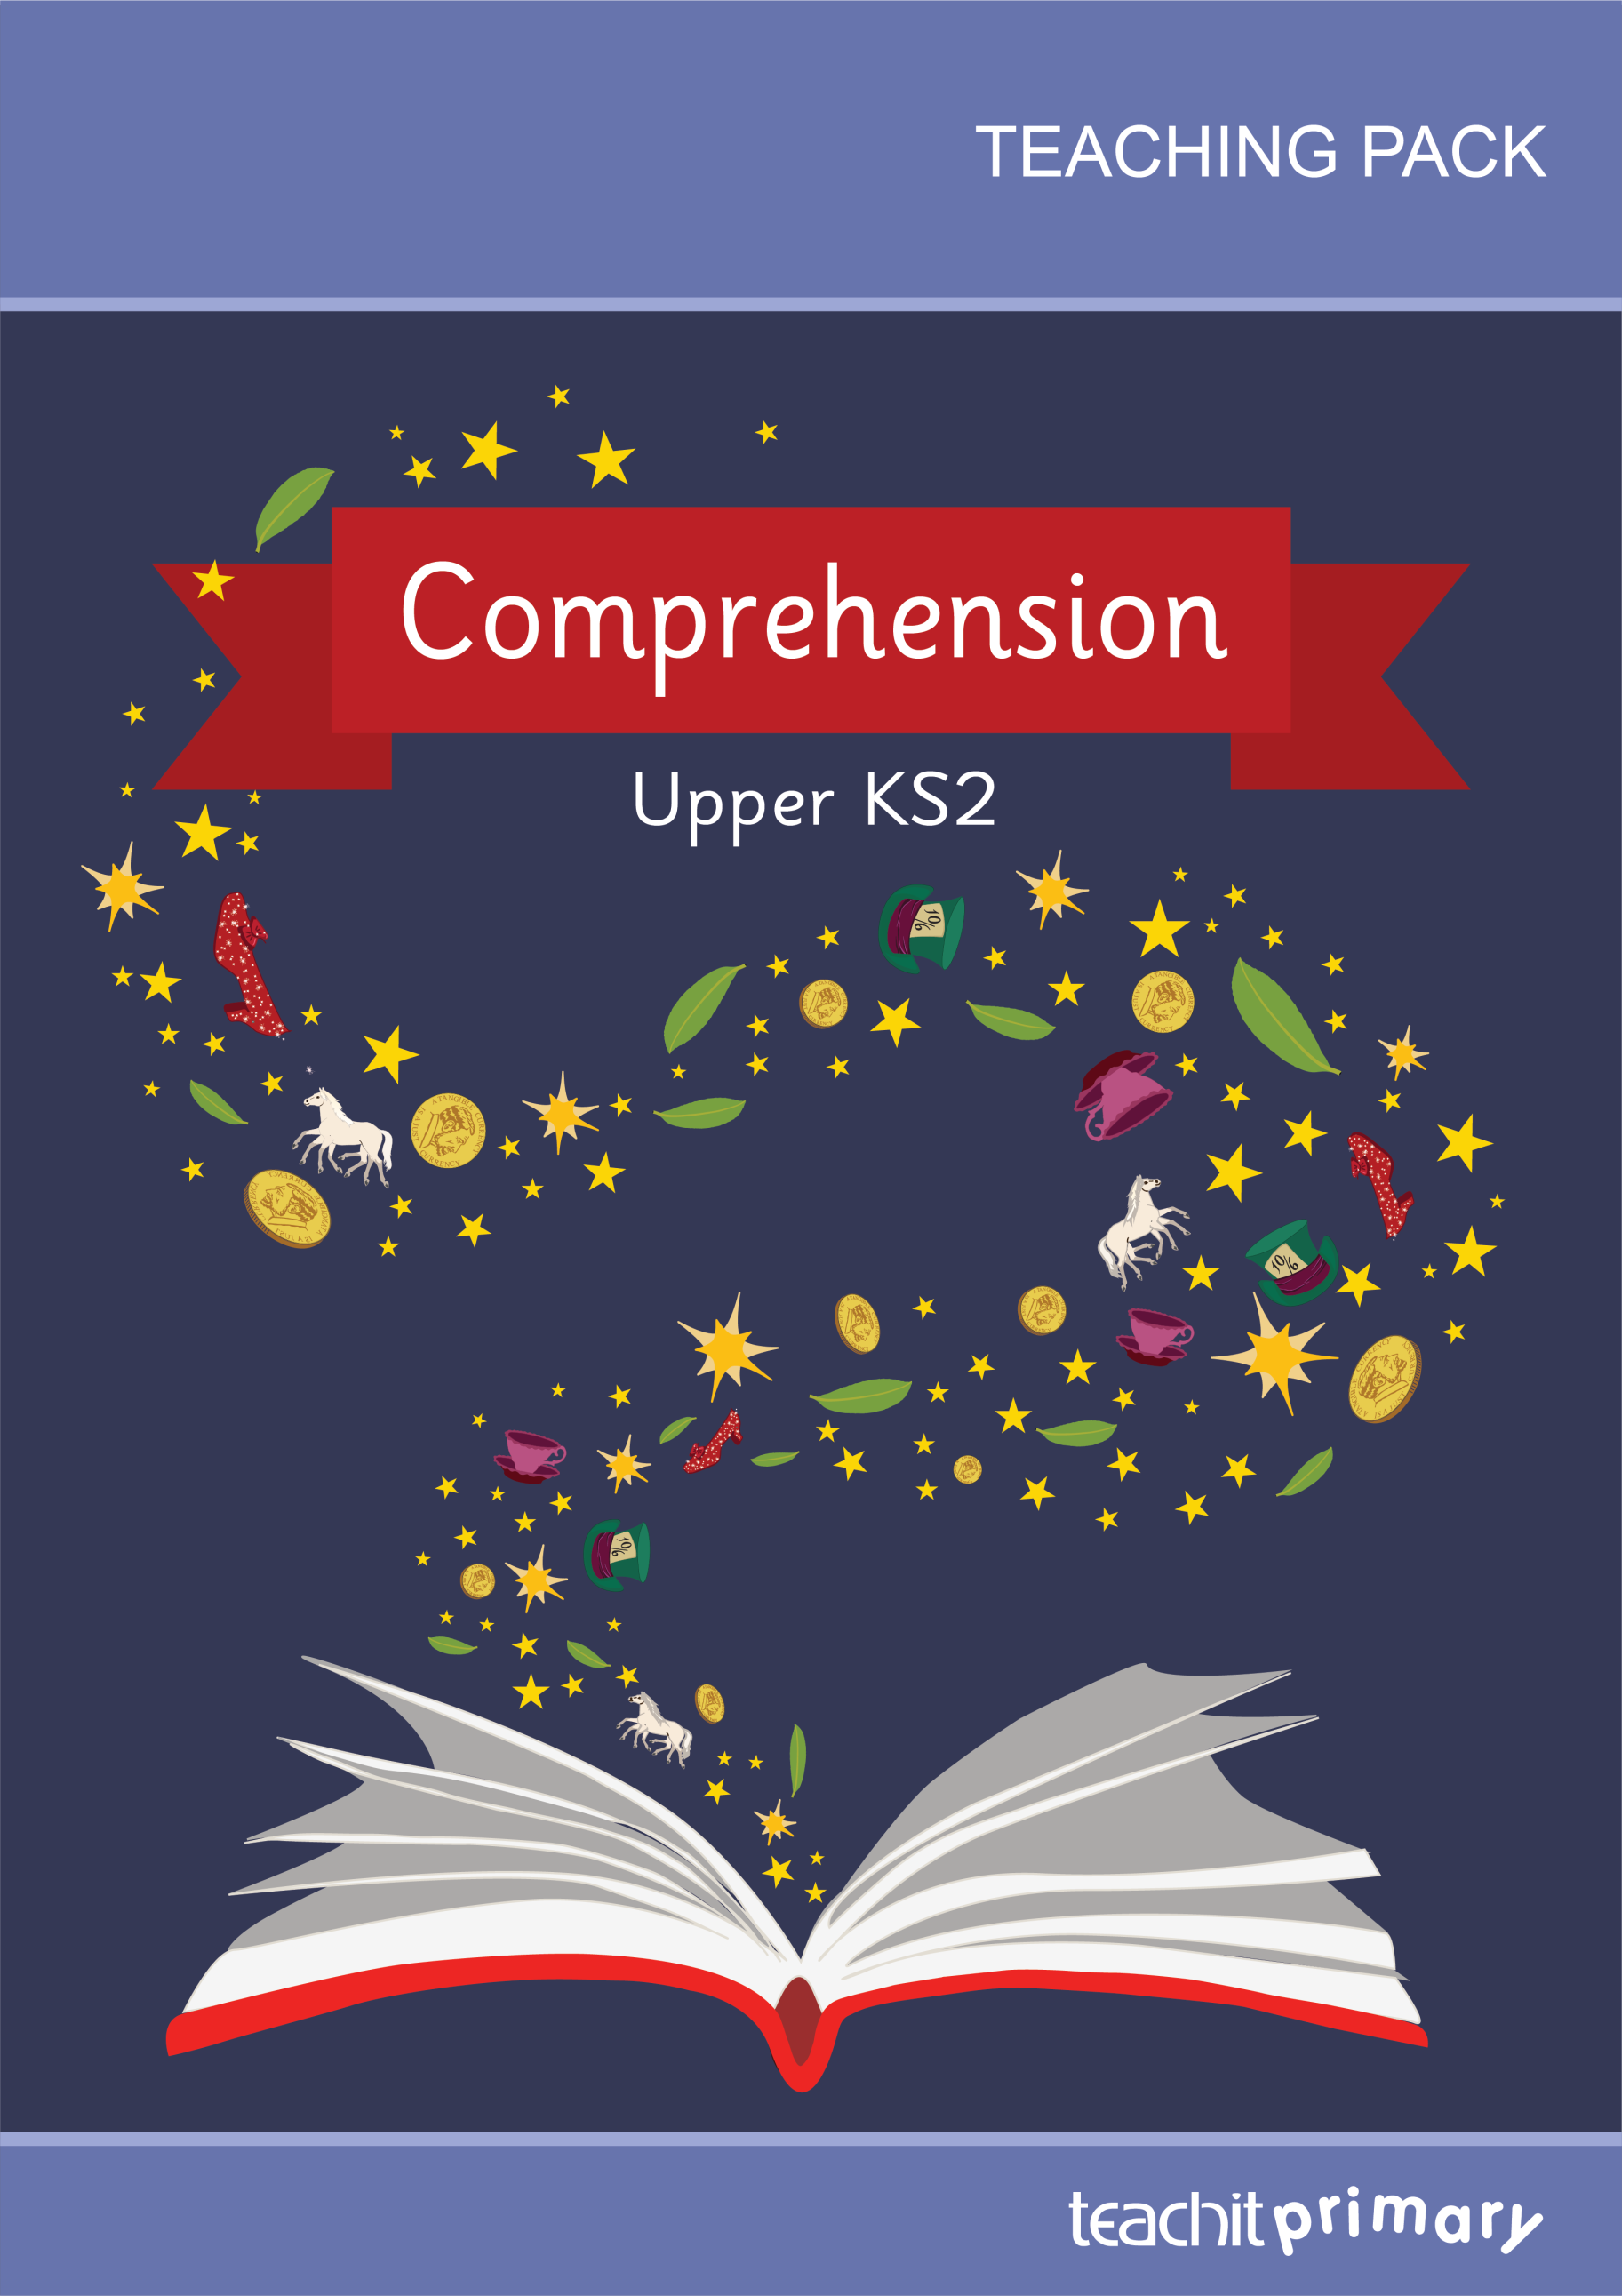
Front cover

Conten

Listening skills
Unit 1 – Five Children and It

Teaching notes

Starter:
- Fantasy fiction: Explain that the extract the children are going to read today comes from the fantasy genre. Ask the children: what is fantasy fiction? Establish that it is a type of story that could not happen in real life, often set in an alternative world to our own and involving magic or magical creatures. Divide the children into table teams and challenge them to come up with as many examples of fantasy fiction as they can in two minutes. Take feedback. Which team thought of the most books? How many different fantasy books did the class manage to think of altogether?

Main activities:
- Main teaching activity: Choose children to take turns in reading the extract aloud, while the rest of the class follows along on their copy. Now put the children into groups of two or three and provide them with a copy of the comprehension questions. Explain that they are going to work together to come up with the answers to the questions. Ask: what strategies could they use to help them find the answers? (Children may suggest: underlining key words and phrases; using a dictionary to check the meaning of tricky vocabulary; scanning the text for key words from the question to find the relevant passage; visualising what is going on in the story; asking one another to explain parts of the story they don’t understand.) Write the suggested strategies on the interactive whiteboard for all the groups to refer to.

When the children have answered as many questions as they can, bring the class back together and discuss the answers. Ask: which strategies were the most helpful? Could you add any more strategies to our list?

- Pupil activity one: Provide each child with a copy of Resource 1 – Picturing the Psammead. Explain that they will use the extract to find out what the Psammead looks like, and then draw a picture of him. First, they need to read through the extract, underlining all the words and phrases which describe the Psammead’s appearance. They should then copy the relevant descriptions into the first column on Resource 1 – Picturing the Psammead, and use the second column to sketch the body part described. You may wish to allow children access to the internet or to a range of non-fiction books about animals to help them make these sketches. Finally, in the right-hand box, the children should put all the body parts together to create a full picture of their Psammead!
Once all the children have finished, invite them to tour the classroom to look at one another’s work. Ask: how similar are their finished pictures of the Psammead?; Do the children think that the author has done a good job of describing what the Psammead looks like? Why / why not?
- Pupil activity two: In which time period do the children think that Five Children and It is set? Ask them to decide in groups, looking for clues in the text to justify their choice. Take feedback from the class. Explain that Five Children and It was first published over a hundred years ago, in 1902 – the year after Queen Victoria died. The clues we have for when this extract is set is the language the children use, but elsewhere in the book they talk about having servants and wearing petticoats!
Provide each pair of children with a copy of Resource 2 – That’s Greek to me! (a) Ask them to look at the old-fashioned phrases in the first column. What do the children think the phrases mean? Encourage them to look at the phrases within the context of the extract to help them work out the meanings. They should then write their definitions down in the corresponding boxes. (A differentiated version of this activity is provided in Resource 3 – That’s Greek to me! (b) – children can work in pairs or groups to match the phrases with the given meanings.)

Plenary:
- Newsflash!: Challenge the children to summarise the events of the story extract in a news headline of no more than ten words. For example: CHILDREN MAKE SHOCK DISCOVERY OF MAGICAL CREATURE! Invite children to stand up and announce their newsflash to the rest of the class.

Taking it further:
- Time-travelling story: Explain that the famous children’s author Jacqueline Wilson has written her own version of this book, called Four Children and It. She set her book in the present day, and the children in her book were a family of step- and half-siblings. Challenge the children to write their own version of the extract where the Psammead is discovered for the first time – but in a different time period. They could choose to set their story during World War Two, or the Elizabethan era – or even the Iron Age! The children must ensure that they put clues into their story to indicate the time period it is set in – this might be the characters’ clothes, or the vocabulary they use, or the things the characters talk about. When the children have finished writing their stories, ask them to swap stories with a partner. Can they find the clues in their partner’s story to work out when it is set?
- Home learning activity: The Psammead, or sand-fairy, is an example of a fantasy creature. Ask the children to find another example of a fantasy creature in a book at home or from the library. Challenge them to create a fact-file about the creature, including its appearance, habits, diet, and powers or skills. Make an interactive display of the creature fact-files in the classrooms, with flaps to lift for the other children to discover which book the creature comes from. If possible, provide a selection of these books for the children to borrow and read for themselves.

Five Children and It – extract
The children have been playing in an old gravel-pit, trying to dig a hole to Australia. Some of the children have grown bored and have drifted off to explore an old cave instead, but Anthea has remained behind, digging the hole.  Anthea suddenly screamed:  “Cyril! Come here! Oh, come quick—It’s alive! It’ll get away! Quick!”  They all hurried back.  “It’s a rat, I shouldn’t wonder,” said Robert. “Father says they infest old places—and this must be pretty old if the sea was here thousands of years ago”—  “Perhaps it is a snake,” said Jane, shuddering.  “Let’s look,” said Cyril, jumping into the hole. “I’m not afraid of snakes. I like them. If it is a snake I’ll tame it, and it will follow me everywhere, and I’ll let it sleep round my neck at night.”  “No, you won’t,” said Robert firmly. He shared Cyril’s bedroom. “But you may if it’s a rat.”  “Oh, don’t be silly!” said Anthea; “it’s not a rat, it’s much bigger. And it’s not a snake. It’s got feet; I saw them; and fur! No—not the spade. You’ll hurt it! Dig with your hands.”  “And let it hurt me instead! That’s so likely, isn’t it?” said Cyril, seizing a spade.  “Oh, don’t!” said Anthea. “Squirrel, don’t. I—it sounds silly, but it said something. It really and truly did”— | “What?”  “It said, ‘You let me alone.’”  But Cyril merely observed that his sister must have gone off her head, and he and Robert dug with spades while Anthea sat on the edge of the hole, jumping up and down with hotness and anxiety. They dug carefully, and presently everyone could see that there really was something moving in the bottom of the Australian hole.  Then Anthea cried out, “I’m not afraid. Let me dig,” and fell on her knees and began to scratch like a dog does when he has suddenly remembered where it was that he buried his bone.  “Oh, I felt fur,” she cried, half laughing and half crying. “I did indeed! I did!” when suddenly a dry husky voice in the sand made them all jump back, and their hearts jumped nearly as fast as they did.  “Let me alone,” it said. And now everyone heard the voice and looked at the others to see if they had heard it too.  “But we want to see you,” said Robert bravely.  “I wish you’d come out,” said Anthea, also taking courage.  “Oh, well—if that’s your wish,” the voice said, and the sand stirred and spun and scattered, and something brown and furry and fat came rolling out into the hole, and the sand fell off it, and it sat there yawning and rubbing the ends of its eyes with its hands.

“I believe I must have dropped asleep,” it said, stretching itself.  The children stood round the hole in a ring, looking at the creature they had found. It was worth looking at. Its eyes were on long horns like a snail’s eyes, and it could move them in and out like telescopes; it had ears like a bat’s ears, and its tubby body was shaped like a spider’s and covered with thick soft fur; its legs and arms were furry too, and it had hands and feet like a monkey’s.  “What on earth is it?” Jane said. “Shall we take it home?”  The thing turned its long eyes to look at her, and said—  “Does she always talk nonsense, or is it only the rubbish on her head that makes her silly?” It looked scornfully at Jane’s hat as it spoke.  “She doesn’t mean to be silly,” Anthea said gently; “we none of us do, whatever you may think! Don’t be frightened; we don’t want to hurt you, you know.”  “Hurt me!” it said. “Me frightened? Upon my word! Why, you talk as if I were nobody in particular.” All its fur stood out like a cat’s when it is going to fight.  “Well,” said Anthea, still kindly, “perhaps if we knew who you are in particular we could think of something to say that wouldn’t make you angry. Everything we’ve said so far seems to have done so. Who are you? And don’t get angry! Because really we don’t know.” | “You don’t know?” it said. “Well, I knew the world had changed—but—well, really—Do you mean to tell me seriously you don’t know a Psammead when you see one?”  “A Sammyadd? That’s Greek to me.”  “So it is to everyone,” said the creature sharply. “Well, in plain English, then, a Sand-fairy. Don’t you know a Sand-fairy when you see one?”  It looked so grieved and hurt that Jane hastened to say, “Of course I see you are, now. It’s quite plain now one comes to look at you.”  “You came to look at me, several sentences ago,” it said crossly, beginning to curl up again in the sand.  “Oh—don’t go away again! Do talk some more,” Robert cried. “I didn’t know you were a Sand-fairy, but I knew directly I saw you that you were much the wonderfullest thing I’d ever seen.”  The Sand-fairy seemed a shade less disagreeable after this.  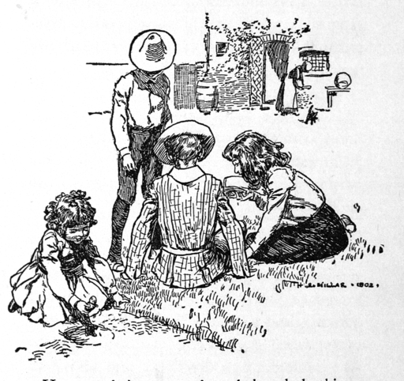

Comprehension questions
Name: Date:

- Which of the children discovers the creature first?

- What reasons does Anthea give that the creature cannot be a snake?

- Why does Robert not want Cyril to sleep with a snake around his neck?

- Why does Anthea try to stop the other children from using the spade to dig?

- Anthea ‘began to scratch like a dog does when he has suddenly remembered where it was that he buried his bone.’

What do you think the author is trying to show with this simile?

- Read the following line from the extract:

‘… suddenly a dry husky voice in the sand made them all jump back, and their hearts jumped nearly as fast as they did.’

What do the words ‘their hearts jumped’ tell you about how the children were feeling?

- The creature says it is called a ‘Sand-fairy’ in English. What is its other name?

- The Sand-fairy says to the children:

“Why, you talk as if I were nobody in particular.”

What do you think it means by this?

- What made the Sand-fairy seem ‘a shade less disagreeable’?

- Find and copy two words in the sentence below that show that the Sand-fairy is upset:

‘It looked so grieved and hurt that Jane hastened to say, “Of course I see you are, now. It’s quite
plain now one comes to look at you.”’

Comprehension answers
- Which of the children discovers the creature first?

Anthea

- What reasons does Anthea give that the creature cannot be a snake?

She says that it cannot be a snake because it has feet and fur.

- Why does Robert not want Cyril to sleep with a snake around his neck?

Because the two boys share a bedroom, and Robert seems to be afraid of snakes.

- Why does Anthea try to stop the other children from using the spade to dig?

Anthea is worried that the spade might hurt the creature.

- Anthea ‘began to scratch like a dog does when he has suddenly remembered where it was that he buried his bone.’ What do you think the author is trying to show with this simile?

Answers should acknowledge that a dog trying to get to its bone would be digging frantically/excitedly. The author is trying to show how excited/focused Anthea is about digging out the creature.

- What do the words ‘their hearts jumped’ tell you about how the children were feeling?

Answers should acknowledge that ‘their hearts jumped’ shows that the children’s hearts were beating faster or skipping a beat, suggesting that the children felt shocked/frightened/excited.

- The Sand-fairy says to the children:

“Why, you talk as if I were nobody in particular.”

What do you think it means by this?

Answers may include one or more of the following: that the creature is somebody important; the creature is shocked that the children don’t know who it is; the creature is offended that the children think it might be frightened.

- The creature says it is called a ‘Sand-fairy’ in plain English. What is its other name?

Psammead.

- What made the Sand-fairy seem ‘a shade less disagreeable’?

Robert calling the Sand-fairy the ‘wonderfullest’ creature he’d ever seen.

- Find and copy two words in the sentence below that show that the Sand-fairy is upset:

‘It looked so grieved and hurt that Jane hastened to say, “Of course I see you are, now. It’s quite plain now one comes to look at you.”’

Grieved and hurt.

Resource 1 – Picturing the Psammead
- Read through the extract, underlining all the words and phrases that describe the Psammead’s appearance.

- Copy the words and phrases you have found about each of the Psammead’s body parts into the table below. For example, put all of the words and phrases describing the Psammead’s eyes into one box.

- Use the descriptions you have found to help you make sketches of the Psammead’s body parts.

- Put the sketches together to create your own full portrait of the Psammead!

Name: Date:

Description of the Psammead’s body part | Sketch of the Psammead’s body part | My portrait of the Psammead

Resource 2 – That’s Greek to me! (a)
Name: Date:

Can you work out what these old-fashioned phrases mean?

Top tip: Find the phrase in the extract and read around it to help you work out the meaning!

Phrase | What I think it means

It’s a rat, I shouldn’t wonder.

…his sister must have gone off her head.

“Let me alone,” it said.

Me frightened? Upon my word!

A Sammyadd? That’s Greek to me.

It’s quite plain now one comes to look at you.

I knew directly I saw you that you were...

The Sand-fairy seemed a shade less disagreeable after this.

Resource 3 – That’s Greek to me! (b)

Can you match each phrase to its correct meaning?

Top tip: Find the phrase in the extract and read around it to help you work out the meaning!

Phrase | Meaning
I shouldn’t wonder. | A bit less unfriendly.
She’s gone off her head. | I knew the moment I saw you.
Let me alone. | It’s very clear.
Upon my word! | I don’t understand that.
That’s Greek to me. | She’s being crazy.
It’s quite plain. | Leave me alone.
I knew directly I saw you. | Oh my gosh!
A shade less disagreeable. | I wouldn’t be surprised.



That’s Greek to me! (b) – answers
Phrase | Meaning
I shouldn’t wonder. | I wouldn’t be surprised.
She’s gone off her head. | She’s being crazy.
Let me alone. | Leave me alone.
Upon my word! | Oh my gosh!
That’s Greek to me. | I don’t understand that.
It’s quite plain. | It’s very clear.
I knew directly I saw you. | I knew the moment I saw you.
A shade less disagreeable. | A bit less unfriendly.

Listening skills
Unit 2 – The Wonderful Wizard of Oz

Teaching notes

Starter:
- Clue in a box: Prepare a cardboard box filled with the words printed and cut up from Resource 1 – Pass the parcel words: slippers, scarecrow, kansas, road, Toto, lion, yellow, tin, brick, munchkins, emerald, witch. Tell the class that inside the box, there are clues as to which book they will be reading an extract from today. When they think they know what the book is, they may raise their hand and take a guess. Pass the box around the class while music plays. When the music stops, the child who has the box must remove one of the slips of paper and read it aloud to the class. Continue until a child guesses correctly The Wonderful Wizard of Oz. How many clue words did it take? Isn’t it amazing that the children need so few of a writer’s words to be able to guess the book they’ve been taken from? Words can be very powerful!
Once the children have guessed correctly, ask them to suggest other words that could be in the box. Compile a list and reveal the remaining words from the box to see if any match those on the list.

Main activities:
- Main teaching activity: Provide each pair of children with a copy of the extract and ask them to read through it, raising their hand when they find an example of a reporting clause. Ask them to share the clauses with the class.
Ask: what is a reporting clause? What is its function in writing? Establish that it is a type of subordinate clause that indicates who has spoken (e.g. ‘the girl’ or ‘the Lion’) – and sometimes how they have spoken (e.g. ‘anxiously’ or ‘thoughtfully’). Split the children into two groups. Hand out copies of Resource 2 – He said, she said. The first group will look through the extract and highlight as many different reporting verbs as they can (e.g. ‘added’, ‘cried’) and record them on the sheet. The second group will highlight all the adverbs or adverbial phrases within the reporting clauses and record them on their sheet. Take feedback and write the children’s findings up on the class whiteboard, in two columns Reporting verbs and Adverbs / adverbial phrases. Check understanding of trickier vocabulary, then ask: why does the author use such a variety of reporting clauses? Elicit that it is a good way of giving the reader extra information about what the character thinks and feels.
Now give the class two minutes to add to the groups of words on the whole class lists with as many of their own ideas as possible. You should finish with a substantial class word bank. Ask the children to look at the dialogue at the bottom of Resource 2 – He said, she said . Ask: which characters do you think are speaking? Ask pairs of children to use the word bank to come up with their own reporting clauses for the given dialogue. Each pair must then share their best reporting clause with the class. Can the class identify what extra information it gives to the reader?
- Pupil activity one: Provide each child with a copy of the comprehension questions. Which reading strategies did they find most useful during the comprehension task in Unit1: Five Children and It? Take suggestions and write on the interactive whiteboard for the children to refer to as they work independently to answer the questions. You may prefer children to work in pairs or give adult support to lower ability children for this task.
- Pupil activity two: Frank L. Baum’s book The Wonderful Wizard of Oz was turned into a famous film starring Judy Garland in 1939, called The Wizard of Oz. How many of the children have seen the film version of the story? Did they know (before this lesson) that it was a book first? Have the children read any other books that have been turned into films? (Examples include: Charlie and the Chocolate Factory, How to Train Your Dragon, Alice in Wonderland, the Harry Potter series.) Explain to the children that they are going to write a book recommendation poster for a book that they have read that is also a film. Give each child a copy, ideally printed on A3 paper, of Resource 3 – Seen the movie? Now read the book! Challenge them to fill in the relevant sections with exciting detail: remember, they are trying to persuade someone else in their class to read the book!
Display the finished book recommendations somewhere prominent in the classroom – ideally with a selection of the recommended books also on display, for the children to borrow and read.

Plenary:
- What could happen next?: Stand the children in a circle and ask them to imagine that Dorothy and her friends meet a new character on the yellow brick road. Who would that character be, and what would they want from the Great Oz? Ask the children to throw a soft ball or bean bag to each other across the circle. When they catch the ball, they must introduce their new character and say why they are travelling to the Great Oz. Once a child has introduced their character they may sit down. Continue until all the children have introduced their new character.

Taking it further:
- Making a movie: Divide children into groups to make their own movie of the scene from the extract. Provide them with video equipment, e.g. digital cameras or iPads, for recording their movies. Challenge them to use just one prop/costume item per character – they must decide what will be most helpful for the audience to recognise the character. They do not need to use the exact dialogue from the extract – they could adapt it, just like real film directors do. What sound effects will they need? Will the sound effects be produced during filming, or edited in afterwards? The children could then show their finished movies to other classes in the school for constructive feedback.
- Home learning activity: Ask children to prepare their own ‘Clue in a box’ activity (see starter) for a favourite book. They should choose at least fifteen key words to put into their box. They could also decorate their box in keeping with the book as an extra clue, if they like, ensuring their design doesn’t give away the title. Challenge the children to ask their family and friends at home to pull clues from the box and guess which book they come from. Who in their family can guess the book with the fewest clues? The children could also bring their boxes in to school and challenge their peers or children from other classes to guess their favourite book. Once the book has been guessed, can the child explain why it is their favourite book?

The Wonderful Wizard of Oz – extract
All this time Dorothy and her companions had been walking through the thick woods. The road was still paved with yellow brick, but these were much covered by dried branches and dead leaves from the trees, and the walking was not at all good.  There were few birds in this part of the forest, for birds love the open country where there is plenty of sunshine. But now and then there came a deep growl from some wild animal hidden among the trees. These sounds made the little girl’s heart beat fast, for she did not know what made them; but Toto knew, and he walked close to Dorothy’s side, and did not even bark in return.  “How long will it be,” the child asked of the Tin Woodman, “before we are out of the forest?”  “I cannot tell,” was the answer, “for I have never been to the Emerald City. But my father went there once, when I was a boy, and he said it was a long journey through a dangerous country, although nearer to the city where Oz dwells the country is beautiful. But I am not afraid so long as I have my oil-can, and nothing can hurt the Scarecrow, while you bear upon your forehead the mark of the Good Witch's kiss, and that will protect you from harm.”  “But Toto!” said the girl anxiously. “What will protect him?”  “We must protect him ourselves if he is in danger,” replied the Tin Woodman.  Just as he spoke there came from the forest a terrible roar, and the next moment a great | Lion bounded into the road. With one blow  of his paw he sent the Scarecrow spinning over and over to the edge of the road, and then he struck at the Tin Woodman with his sharp claws. But, to the Lion’s surprise, he could make no impression on the tin, although the Woodman fell over in the road and lay still.  Little Toto, now that he had an enemy to face, ran barking toward the Lion, and the great beast had opened his mouth to bite the dog, when Dorothy, fearing Toto would be killed, and heedless of danger, rushed forward and slapped the Lion upon his nose as hard as she could, while she cried out:  “Don’t you dare to bite Toto! You ought to be ashamed of yourself, a big beast like you, to bite a poor little dog!”  “I didn’t bite him,” said the Lion, as he rubbed his nose with his paw where Dorothy had hit it.  “No, but you tried to,” she retorted. “You are nothing but a big coward.”  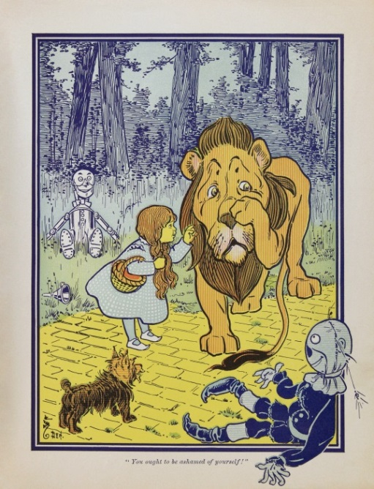

“I know it,” said the Lion, hanging his head in shame. “I’ve always known it. But how can I help it?”  “I don’t know, I’m sure. To think of your striking a stuffed man, like the poor Scarecrow!”  “Is he stuffed?” asked the Lion in surprise, as he watched her pick up the Scarecrow and set him upon his feet, while she patted him into shape again.  “Of course he’s stuffed,” replied Dorothy, who was still angry.  “That’s why he went over so easily,” remarked the Lion. “It astonished me to see him whirl around so. Is the other one stuffed also?”  “No,” said Dorothy, “he’s made of tin.” And she helped the Woodman up again.  “That’s why he nearly blunted my claws,” said the Lion. “When they scratched against the tin it made a cold shiver run down my back. What is that little animal you are so tender of?”  “He is my dog, Toto,” answered Dorothy.  “Is he made of tin, or stuffed?” asked the Lion.  “Neither. He’s a – a – a meat dog,” said the girl.  “Oh! He’s a curious animal and seems remarkably small, now that I look at him. No one would think of biting such a little  thing, except a coward like me,” continued the Lion sadly. | “What makes you a coward?” asked Dorothy, looking at the great beast in wonder, for he was as big as a small horse.  “It’s a mystery,” replied the Lion. “I suppose I was born that way. All the other animals in the forest naturally expect me to be brave, for the Lion is everywhere thought to be the King of Beasts. I learned that if I roared very loudly every living thing was frightened and got out of my way. Whenever I’ve met a man I’ve been awfully scared; but I just roared at him, and he has always run away as fast as he could go. If the elephants and the tigers and the bears had ever tried to fight me, I should have run myself – I’m such a coward; but just as soon as they hear me roar they all try to get away from me, and of course I let them go.”  “But that isn’t right. The King of Beasts shouldn’t be a coward,” said the Scarecrow.  “I know it,” returned the Lion, wiping a tear from his eye with the tip of his tail. “It is my great sorrow, and makes my life very unhappy. But whenever there is danger, my heart begins to beat fast.”  “Perhaps you have heart disease,” said the Tin Woodman.  “It may be,” said the Lion.  “If you have,” continued the Tin Woodman, “you ought to be glad, for it proves you have a heart. For my part, I have no heart; so I cannot have heart disease.”  “Perhaps,” said the Lion thoughtfully, “if I had no heart I should not be a coward.”

“Have you brains?” asked the Scarecrow.  “I suppose so. I’ve never looked to see,” replied the Lion.  “I am going to the Great Oz to ask him to give me some,” remarked the Scarecrow, “for my head is stuffed with straw.”  “And I am going to ask him to give me a heart,” said the Woodman.  “And I am going to ask him to send Toto and me back to Kansas,” added Dorothy.  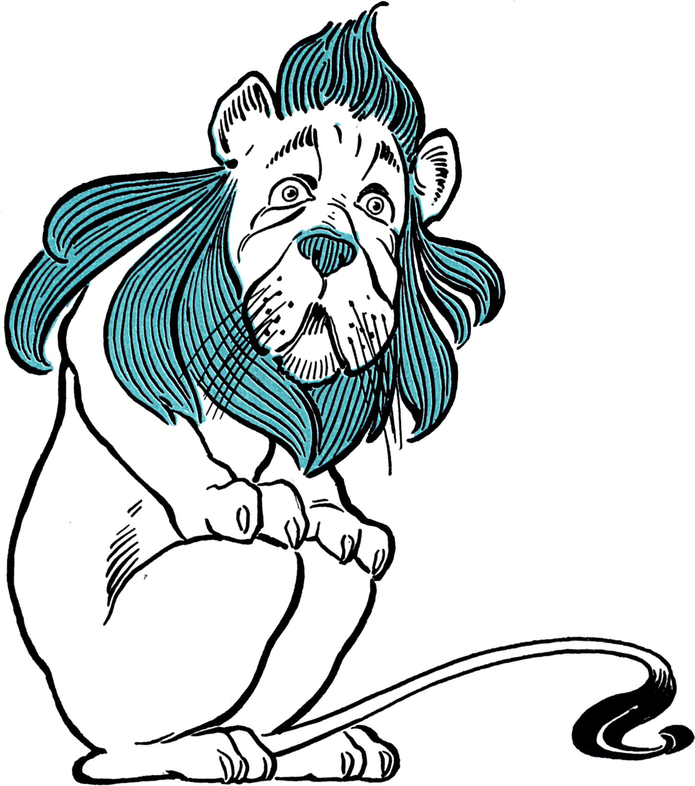 | “Do you think Oz could give me courage?” asked the Cowardly Lion.  “Just as easily as he could give me brains,” said the Scarecrow.  “Or give me a heart,” said the Tin Woodman.  “Or send me back to Kansas,” said Dorothy.  “Then, if you don’t mind, I’ll go with you,” said the Lion, “for my life is simply unbearable without a bit of courage.”

Comprehension questions
Name: Date:

- Which character has a father who once went to the Emerald City?

- ‘There were few birds in this part of the forest …’

What was the reason for this?

- Look at the paragraph which begins: ‘There were few birds …’ How can you tell that Toto is scared? Give two reasons.

- ‘A great lion bounded into the road …’

What does the word bounded tell you?

- What evidence is there that Dorothy is a brave person?

- Look at the paragraph which begins: “That’s why he went over…”

Find and copy one word which means ‘surprised’.

- The Lion asks Dorothy: “What is that little animal you are so tender of?”

What do you think it means to be tender of something?

- Look at the following line from the extract:

‘“What makes you a coward?” asked Dorothy, looking at the great beast in wonder, for he was as big as a small horse.’

Why is Dorothy surprised that the Lion is a coward?

- What three things are the Tin Woodman, the Scarecrow and Dorothy planning to ask the Great Oz for?

- Do you think that the others will let the Lion come with them to the Great Oz? Why / why not? Refer to the text in your answer.

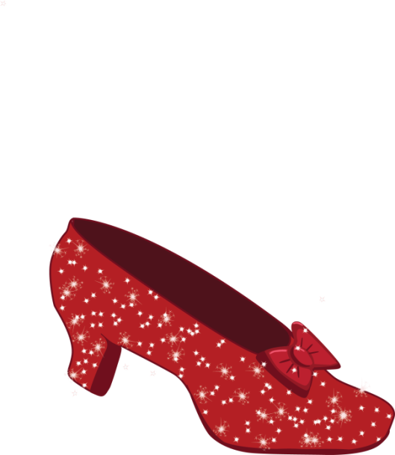

Comprehension answers
- Which character has a father who once went to the Emerald City?

The Tin Woodman

‘There were few birds in this part of the forest …’

What was the reason for this?

Birds love the ‘open country where there is plenty of sunshine’, but Dorothy and her friends are in ‘thick woods’ so it must be dark and gloomy.

- Look at the paragraph which begins: ‘There were few birds …’ How can you tell that Toto is scared? Give two reasons.

He walks ‘close to Dorothy’s side’ and he does not ‘bark in return’.

‘A great lion bounded into the road …’

What does the word bounded tell you?

That the Lion was jumping/leaping quickly.

- What evidence is there that Dorothy is a brave person?

She slaps the Lion on the nose to protect Toto, even though this might put herself in danger.

- Look at the paragraph which begins: “That’s why he went over …”

Find and copy one word which means ‘surprised’.

Astonished.

- The Lion asks Dorothy: “What is that little animal you are so tender of?”

What do you think it means to be tender of something?

To be fond of it / to love it.

- Look at the following line from the extract:

‘“What makes you a coward?” asked Dorothy, looking at the great beast in wonder, for he was as big as a small horse.’

Why is Dorothy surprised that the Lion is a coward?

Because he is such a large animal – ‘as big as a small horse’.

- What three things are the Tin Woodman, the Scarecrow and Dorothy planning to ask the Great Oz for?

A heart, a brain, and for Dorothy and Toto to be sent back to Kansas.

- Do you think that the others will let the Lion come with them to the Great Oz? Why / why not? Refer to the text in your answer.

Children should give a clear reason for their view.

Resource 1 – Pass the parcel words

Print and cut out the following words and place into a box. Play ‘pass the parcel’ and when the music stops, pull out a word and see if you can guess the book.

slippers | scarecrow | Kansas
road | Toto | lion
yellow | tin | brick
munchkins | emerald | witch



Resource 2 – He said, she said
Name: Date:

- Look through the extract and find as many different reporting verbs and adverbs / adverbial phrases as possible. Can you think of any more to add?

Reporting verbs | Adverbs / adverbial phrases
- Which characters from The Wonderful Wizard of Oz do you think say the dialogue below? Can you use your word bank to add some reporting clauses?
“How do you feel?”
“I’m supposed to be a Great Wizard,”
“We wish to go to the Emerald City,”
“You are a wicked creature!”
“Be careful!”
“I’m very sorry, indeed,”
“We must try to find him,”

Resource 3 – Seen the movie? Now read the book!
Name: Date:
Title of book here!
Author's name here!
You will like this book if…
Portrait of your favourite character
Name of character
Describe the book in 3 words:
An exciting moment in the book when…
I would rate this book
out of ten!
Easy
Trickier
Super-tough
Unit 3 – Alice’s Adventures in Wonderland

Teaching notes

Starter:
- Developing deduction: Display Resource 1 – Illustration by Sir John Tenniel. Do any of the children recognise the girl in the picture? Even if the children have not seen the illustration before, they may pick up on similarities in the Tenniel drawing to the Walt Disney version of Alice. Explain that this is an illustration drawn by Sir John Tenniel, the original illustrator for Lewis Carroll’s Alice’s Adventures in Wonderland. Ask the children to work in talking partners to look for evidence in the illustration as to when the story was written. Take feedback (children may mention the style of Alice’s shoes, her dress and apron, and the style of the illustration itself, which is a woodblock engraving). Reveal that the illustrations were completed in 1864, during the reign of Queen Victoria.
Now ask them how they think Alice is feeling in the picture, and why they think she feels this way. They may suggest ‘scared’ or ‘angry’, depending on how they interpret the expression on Alice’s face and the way she is holding her body. Explain that, just as we have looked for evidence in this picture, we can also look for evidence in a text to find out more about a character. This is what the children will be doing next when they answer the comprehension questions about Alice’s Adventures in Wonderland.

Main activities:
- Main teaching activity: Provide each child with a copy of the extract and a highlighter. Ask them to read through the extract, highlighting any information that they think might be important. Then provide them with a copy of the comprehension questions to answer. If they like, they can use the highlighter again to help them select the relevant information from the text for each answer. Did they find it useful to highlight the extract before they’d seen the comprehension questions?
- Pupil activity one: Provide groups of three children with a key, a small bottle, and a digital camera or tablet/iPad for taking photographs. The children must use the props to take five photographs illustrating five key moments from the extract. They should then write a one-line caption on a strip of paper to go with each photograph. Finally, they swap photographs and captions with another group, who must sequence the photographs and match the captions to the photographs correctly. Did all the groups choose the same key moments? Which captions were the most effective at summarising the events of the story?
- Pupil activity two: Read Resource 2 – Alice grows with the children. Provide each child with a copy of Resource 3 – Comprehension chatterbox. Explain that they are going to make chatterboxes to ask one another questions about this new extract from the story. There are question words already printed on the chatterbox template to prompt them to write in their own questions. They could also refer back to the comprehension questions from the main teaching activity for ideas of the kind of questions to ask. Remind them that they need to write down the answers to the questions too, so that they know if their player gets it right!
Model writing a question, then demonstrate how to cut out and fold the chatterbox. Choose a volunteer to come up and show the other children how to play the game (instructions for making and playing the game are also printed on Resource 3 – Comprehension chatterbox).Lower attaining children may choose to work in pairs for support. When the children have finished their chatterboxes, they can partner up and take it in turns to play the game.
For an interactive display you could also print out a large copy of Resource 2 – Alice grows to display on the wall, with a box underneath to hold the finished chatterboxes. Children could then come up at any time and choose a chatterbox to challenge themselves with a comprehension question!

Plenary:
- I wonder … Children sit in a circle and take it in turns to say something about the session today, beginning with the words ‘I wonder …’ They might, for example, wonder what a certain word in the extract means (in which case they could look it up in a dictionary!). They might wonder whether Lewis Carroll wrote any other books. They might wonder what would have happened if Alice had remembered to get the key off the table before she shrank. If there is time, allow other children to respond to the wonderings, as this is likely to generate interesting discussion about the story.

Taking it further:
- Advert in Wonderland: Ask the children to imagine that the magical drink that makes Alice shrink is going to be sold as a product in a supermarket! The children must work in groups to write a script for a television advert for the drink. What adverts have they seen in real life that they could use as inspiration? Who is their target audience? What language techniques (e.g. imperative verbs, emotive language, rhetorical questions) will they use to persuade the audience to buy their product?
- Home learning activity: Lewis Carroll describes the contents of Alice’s ‘DRINK ME’ bottle as a ‘very nice’ drink with ‘a sort of mixed flavour of cherry-tart, custard, pineapple, roast turkey, toffee, and hot buttered toast.’ Challenge children to find descriptions of food and drink in other children’s fiction or poetry. Ask them to copy out two or three of their favourite descriptions and illustrate them. They could even try to recreate the recipes in real life (with adult supervision!) and bring the results in for the rest of the class to taste!

Alice’s Adventures in Wonderland – extract
After following a talking rabbit, Alice has tumbled down a hole into a strange underground world.  Alice was not a bit hurt, and she jumped up on to her feet in a moment: she looked up, but it was all dark overhead: before her was another long passage, and the White Rabbit was still in sight, hurrying down it. There was not a moment to be lost: away went Alice like the wind, and was just in time to hear it say, as it turned a corner, “Oh my ears and whiskers, how late it’s getting!” She was close behind it when she turned the corner, but the Rabbit was no longer to be seen: she found herself in a long, low hall, which was lit up by a row of lamps hanging from the roof.  There were doors all round the hall, but they were all locked; and when Alice had been all the way down one side and up the other, trying every door, she walked sadly down the middle, wondering how she was ever to get out again.  Suddenly she came upon a little three-legged table, all made of solid glass: there was nothing on it but a tiny golden key, and Alice’s first idea was that this might belong to one of the doors of the hall; but, alas! either the locks were too large, or the key was too small, but at any rate it would not open any of them. However, on the second time round, she came upon a low curtain she  had not noticed before, and behind it was a little door about fifteen inches high: she tried the little golden key in the lock, and to her great delight it fitted! | 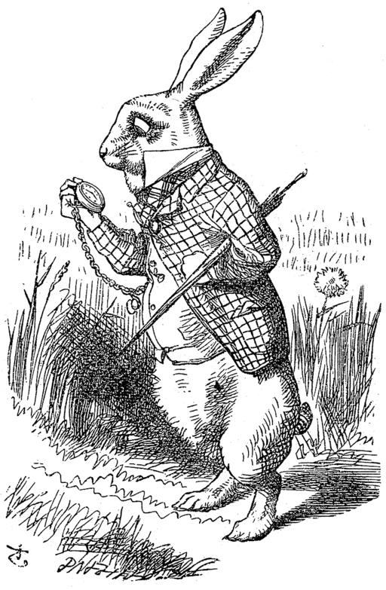
 | Alice opened the door and found that it led into a small passage, not much larger than a rat-hole: she knelt down and looked along the passage into the loveliest garden you ever saw. How she longed to get out of that dark hall, and wander about among those beds of bright flowers and those cool fountains, but she could not even get her head through the doorway; “and even if my head would go through,” thought poor Alice, “it would be of very little use without my shoulders. Oh, how I wish I could shut up like a telescope! I think I could, if I only knew how to begin.” For, you see, so many out-of-the-way things had happened lately, that Alice had begun to think that very few things indeed were really impossible.

There seemed to be no use in waiting by the little door, so she went back to the table, half hoping she might find another key on it, or at any rate a book of rules for shutting people up like telescopes: this time she found a little bottle on it (“which certainly was not here before,” said Alice), and tied round the neck of the bottle was a paper label, with the words “DRINK ME” beautifully printed on it in large letters.  It was all very well to say “Drink me,” but the wise little Alice was not going to do that in a hurry. “No, I’ll look first,” she said, “and see whether it’s marked ‘poison’ or not;” for she had read several nice little stories about children who had got burnt, and eaten up by wild beasts, and other unpleasant things, all because they would not remember the simple rules their friends had taught them: such as, that a red-hot poker will burn you if you hold it too long; and that, if you cut your finger very deeply with a knife, it usually bleeds; and she had never forgotten that, if you drink much from a bottle marked “poison,” it is almost certain to disagree with you, sooner or later.  However, this bottle was not marked “poison,” so Alice ventured to taste it, and finding it very nice (it had, in fact, a sort of mixed flavour of cherry-tart, custard, pineapple, roast turkey, toffee, and hot buttered toast), she very soon finished it off.  “What a curious feeling!” said Alice. “I must be shutting up like a telescope.”  And so it was indeed: she was now only ten inches high, and her face brightened up at the thought that she was now the right size for going through that little door into that | lovely garden. First, however, she waited for a few minutes to see if she was going to shrink any further: she felt a little nervous about this: “for it might end, you know,” said Alice to herself, “in my going out altogether, like a candle. I wonder what I should be like then?” And she tried to fancy what the flame of a candle looks like after the candle is blown out, for she could not remember ever having seen such a thing.  After a while, finding that nothing more happened, she decided on going into the garden at once; but, alas for poor Alice! when she got to the door, she found she had forgotten the little golden key, and when she went back to the table for it, she found she could not possibly reach it: she could see it quite plainly through the glass, and she tried her best to climb up one of the legs of the table, but it was too slippery; and when she had tired herself out with trying, the poor little thing sat down and cried.

Comprehension questions
Name: Date:

- ‘There was not a moment to be lost: away went Alice like the wind ...’

What does the simile like the wind tell you?

- Look at the paragraph which begins: ‘There were doors all round the hall …’

Why is Alice walking sadly in this paragraph?

- ‘... but, alas! either the locks were too large, or the key was too small’

Which of the following is closest in meaning to alas?

 | Interestingly! |  | Oh dear! |  | Amazing! |  | Surprise!

- Why can’t Alice go through the door into the garden at first?

- When Alice returns to the glass table, what is she hoping to find? Name one item.

- In the stories Alice had read, what unpleasant things had happened to children? Name two.

- Why does Alice decide that it is safe to drink from the bottle?

- ‘“What a curious feeling!” said Alice. “I must be shutting up like a telescope.”’

What do you think Alice means by ‘shutting up like a telescope’?

 | Becoming silent |  | Getting taller |  | Shrinking |  | Looking very far away

- Look at the paragraph that begins: ‘And so it was indeed …’

Find and copy the group of words that show that Alice is feeling happier.

- Look at the final paragraph. Why does Alice sit down and cry?



Comprehension answers
- ‘There was not a moment to be lost: away went Alice like the wind ...’

What does the simile like the wind tell you?

That she was running fast/swiftly.

- Look at the paragraph which begins: ‘There were doors all round the hall …’

Why is Alice walking sadly in this paragraph?

Because all the doors are locked and she cannot get out of the hall.

- ‘... but, alas! either the locks were too large, or the key was too small’

Which of the following is closest in meaning to alas?

 | Interestingly! | X | Oh dear! |  | Amazing! |  | Surprise!

- Why can’t Alice go through the door into the garden at first?

She is too big – not even her head will fit through.

- When Alice returns to the glass table, what is she hoping to find? Name one item.

Either “another key” or “a book of rules for shutting people up like telescopes”.

- In the stories Alice had read, what unpleasant things had happened to children? Name two.

Burnt; eaten up by wild beasts.

- Why does Alice decide that it is safe to drink from the bottle?

Because it is not marked ‘poison’.

- ‘“What a curious feeling!” said Alice. “I must be shutting up like a telescope.”’

What do you think Alice means by shutting up like a telescope?

 | Becoming silent |  | Getting taller | X | Shrinking |  | Looking very far away

- Look at the paragraph that begins: ‘And so it was indeed …’

Find and copy the group of words that show that Alice is feeling happier.

“her face brightened up.”

- Look at the final paragraph. Why does Alice sit down and cry?

Because she still can’t get through the locked door: she’s left the key on the table and now she’s too small to reach it.

Resource 1 – Illustration by Sir John Tenniel
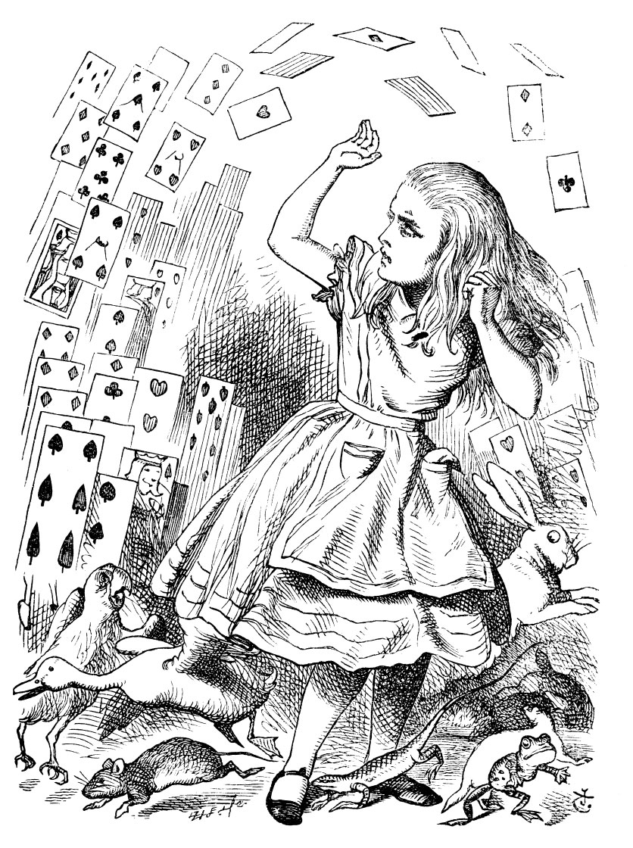

Resource 2 – Alice grows
By this time she had found her way into a tidy little room with a table in the window, and on it (as she had hoped) a fan and two or three pairs of tiny white kid gloves: she took up the fan and a pair of the gloves, and was just going to leave the room, when her eye fell upon a little bottle that stood near the looking-glass. There was no label this time with the words “DRINK ME,” but nevertheless she uncorked it and put it to her lips. “I know something interesting is sure to happen,” she said to herself, “whenever I eat or drink anything; so I’ll just see what this bottle does. I do hope it will make me grow large again, for really I’m quite tired of being such a tiny little thing!” | 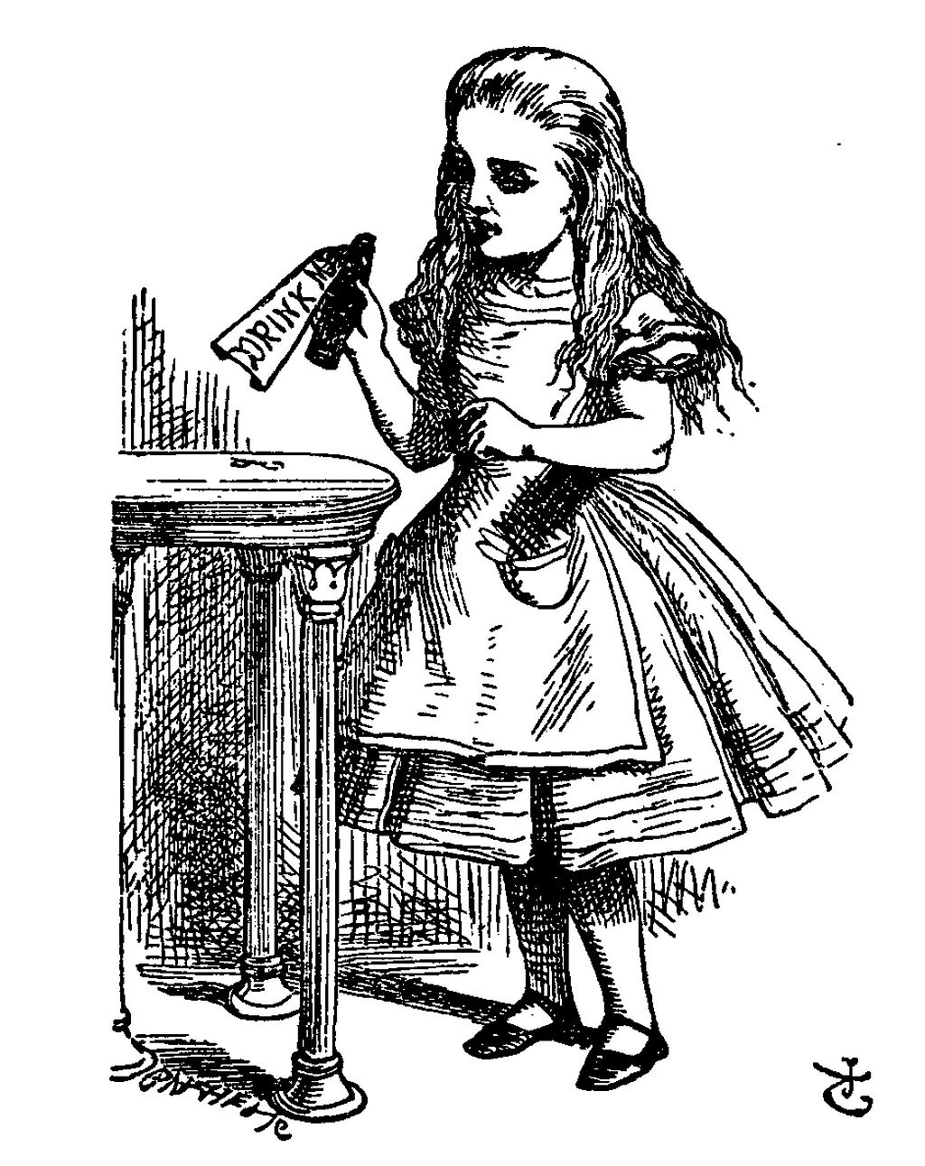
It did so indeed, and much sooner than she had expected: before she had drunk half the bottle, she found her head pressing against the ceiling, and had to stoop to save her neck from being broken. She hastily put down the bottle, saying to herself “That’s quite enough—I hope I sha’n’t grow any more—As it is, I can’t get out at the door—I do wish I hadn’t drunk quite so much!”

Alas! it was too late to wish that! She went on growing, and growing, and very soon had to kneel down on the floor: in another minute there was not even room for this, and she tried the effect of lying down with one elbow against the door, and the other arm curled round her head. Still she went on growing, and, as a last resource, she put one arm out of the window, and one foot up the chimney, and said to herself “Now I can do no more, whatever happens. What will become of me?”

Luckily for Alice, the little magic bottle had now had its full effect, and she grew no larger: still it was very uncomfortable, and, as there seemed to be no sort of chance of her ever getting out of the room again, no wonder she felt unhappy.

“It was much pleasanter at home,” thought poor Alice, “when one wasn’t always growing larger and smaller, and being ordered about by mice and rabbits. I almost wish I hadn’t gone down that rabbit-hole—and yet—and yet—it’s rather curious, you know, this sort of life! I do wonder what can have happened to me! When I used to read fairy-tales, I fancied that kind of thing never happened, and now here I am in the middle of one! There ought to be a book written about me, that there ought! And when I grow up, I’ll write one—but I’m grown up now,” she added in a sorrowful tone; “at least there’s no room to grow up any more here.”
“But then,” thought Alice, “shall I never get any older than I am now? That’ll be a comfort, one way—never to be an old woman—but then—always to have lessons to learn! Oh, I shouldn’t like that!”

“Oh, you foolish Alice!” she answered herself. “How can you learn lessons in here? Why, there’s hardly room for you, and no room at all for any lesson-books!”

And so she went on, taking first one side and then the other, and making quite a conversation of it altogether; but after a few minutes she heard a voice outside, and stopped to listen.

“Mary Ann! Mary Ann!” said the voice. ”Fetch me my gloves this moment!” Then came a little pattering of feet on the stairs. Alice knew it was the Rabbit coming to look for her, and she trembled till she shook the house, quite forgetting that she was now about a thousand times as large as the Rabbit, and had no reason to be afraid of it.

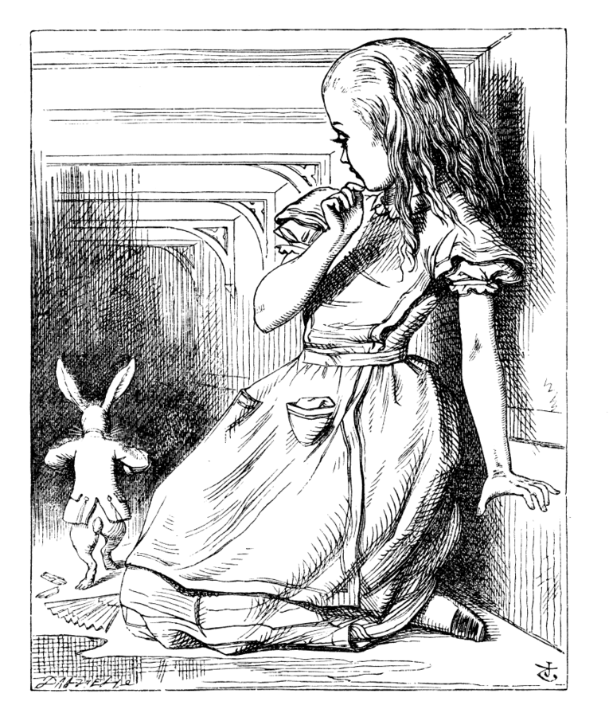

Resource 3 – Comprehension chatterbox

Red
2
1
5
6
4
3
7
8
Green
Blue
Orange
When …
Why …
What …
How …
Who …
Find …
Which …
Where …



How to make:

- Cut out the chatterbox square along the dotted lines of the outside edge.
- Fold it in half to make a triangle, and then in half again to make a smaller triangle.
- Open it back out into a flat square, with the blank side facing upwards. Take the corner of each square and fold it in so that the point touches the centre of the chatterbox. This will make a smaller square.

- Turn the smaller square over and repeat: fold each corner in so that the point touches the centre of the chatterbox. All the numbers should now be facing upwards, and the colours should be on the reverse of the square.
- Fold the chatterbox in half so that it makes a rectangle. Slide your finger and thumb under two adjoining colour flaps. Repeat with the other finger and thumb and the other two flaps. Your chatterbox is now ready to ‘chatter’!

How to play:

- The player chooses a colour. The holder opens and closes the chatterbox the same number of times as there are letters in the colour’s name. Four numbers will be revealed inside the chatterbox.
- Then the player picks a number from the four available. The holder opens and closes the chatterbox that number of times. Four more numbers will be revealed.
- The volunteer picks a second number, and the holder lifts the flap to reveal the question!

Unit 4 – Odin’s Reward

Teaching notes:

Starter:
- Word explosion: Tell the children that the story we are going to be working on today comes from Norse mythology – tales of the Viking gods. Before we begin, we are going to create a class ‘word explosion’ based on word associations. Write the words ‘myth’, ‘Viking’ and ‘gods’ in the middle of a flipchart or whiteboard, and repeat for a second flipchart or whiteboard. Ask the class to stand in two lines – one for each board or flipchart. The child at the front of each line takes a pen and writes a word on the board that they associate with the ‘starter’ words. They must do this as quickly as possible, before passing the pen to the next child in line, who writes the next word. If they have another idea for a word, they must rejoin the back of the line. Continue until the children have run out of ideas, until the board is full or after a given time limit. Which team came up with the most word associations? How many of the words were the same for each team?

Main activities:
- Main teaching activity: Ask the children: what is a proper noun? Take examples. Establish that a proper noun is a name used for an individual person, place or organization, and it always begins with a capital letter – no matter where it comes in a sentence. Divide the children into groups of 2 – 4. Provide each group with a copy of the extract and a copy of Resource 1 – Pairs game. Explain that each card in the game contains either a proper noun taken from the story Odin’s Reward, or a definition of that noun. Their task is to play the game ‘Pairs’, matching each proper noun with its definition. They will need to read the extract all the way through before they can start the game, but also encourage them to refer to the extract throughout the game – this will allow them to practice scanning a text for specific information.
- Main teaching activity: Provide each child with a copy of the extract, and ask them to work in pairs to read it aloud to one another, taking turns to read alternate paragraphs. Remind them that they may choose to use a highlighter or a pencil to pick out key information from the extract. Now provide each child with a copy of the comprehension questions and ask them to work through the questions individually (you may wish to pair lower attaining children together, or provide them with an adult support).
- Pupil activity two: Challenge the children to rewrite the story as a comic strip for a younger child, using Resource 2 – Comic strip format. What are the key scenes they will need to include in their comic? How will they alter the language of the characters’ dialogue to make it suitable for a younger child to understand? Encourage them to use a thesaurus to help them find simpler synonyms for the vocabulary used in the extract.

Plenary:
- Recipe for a myth: Remind the children that the story they have read today is from Norse mythology. Ask the children: can you think of any other examples of myths? Take feedback: children might suggest stories such as Theseus and the Minotaur, or the Loch Ness monster. Based on the story they have read today, and their previous knowledge of myths, what key ingredients do the children think a myth requires (e.g. gods/goddesses, magical creatures, sacrifices, explanations of the world)? Ask them to work in groups to come up with a ‘recipe for a myth’!

Taking it further:
- Radio play: Tell the children that their task is to now adapt the story into a play suitable for radio. How will they let the audience know what is happening in the parts of the story where there is no dialogue? Encourage them to see that they could write their own dialogue, e.g. by having Odin talking to his pet wolves about his worries, or to his horse about his journey over the bridge. How will they make the play exciting for the audience to listen to? What sound effects could they include? Could they select (or compose!) music to help convey the emotion of the characters to the audience? Allow the children plenty of time to plan and practise their plays, before recording them to then play to the rest of the class.
- Home learning activity: Challenge the children to research information about another Norse god or goddess. They must then make a model of their god or goddess to bring in and present to the class, explaining what they have found out. Encourage them to be as creative as possible with their models. They could make them out of recycled materials, for example, or they could adapt a toy they already have at home by making them a costume and props. They could even make an entirely edible model!

Odin’s Reward - extract
This is a story from Norse mythology about Odin, the chief of the Aesir (the gods of Asgard).  One night when all was quiet in Asgard and the Aesir had gone to rest, Odin, the Allfather, sat awake on his high throne, troubled with many thoughts. At his feet crouched his two faithful wolves, and upon his shoulders perched the two ravens of thought and memory, who flew far abroad every day, through the nine worlds, as Odin’s messengers.  The Allfather had need of great wisdom in ruling the worlds; after thinking a long time on the matters which needed his care, he suddenly started up, and went forth with long strides from his palace of Gladsheim into the night. He soon returned, leading his beautiful, eight-footed steed, Sleipnir, and it was plain that Odin was going on a journey. He quickly mounted Sleipnir, and rode swiftly away toward Bifröst, the rainbow bridge, which reached from Asgard, the city of the gods, down through the air to the lower worlds.  When Sleipnir stepped upon the bridge it trembled, and seemed hardly strong enough to bear the horse and his rider; but they had no fear of its giving way, and Sleipnir galloped swiftly onward.  Soon Odin saw Heimdall, the watchman of the bridge, riding toward him on a fine horse, with a golden mane that reflected light upon the noble face of his rider. | 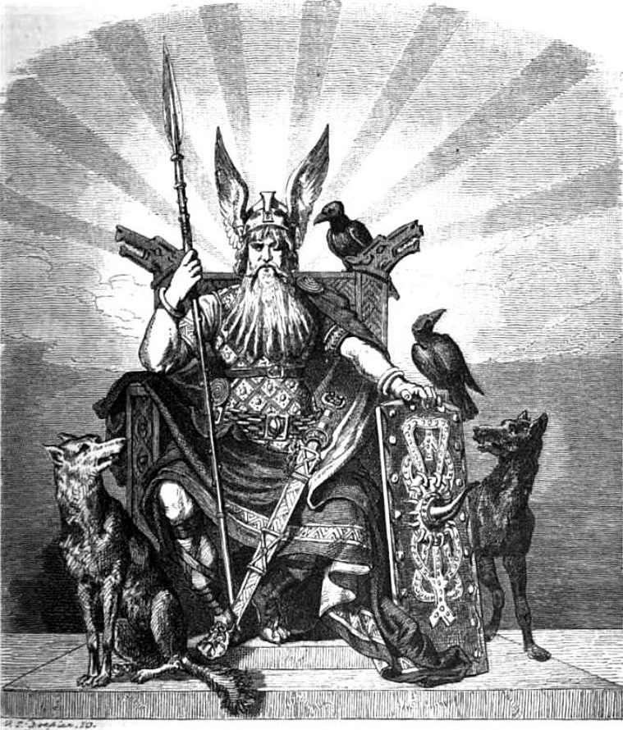
“You must be bound on some important errand, Father Odin, to be riding forth from Asgard so late at night,” said Heimdall.
“It is indeed a most important errand, and I must hasten on,” replied Odin. “It is well for us that we have such a faithful guardian of the ‘trembling bridge’; if it were not for you, Heimdall, our enemies might long ago have taken Asgard by storm. You are so watchful, you can hear the grass grow in the fields, and the wool gather on the backs of the sheep, and you need less sleep than a bird. I myself stand in great need of wisdom, in order to take care of such faithful servants, and to drive back such wicked enemies!”

They hurried over the bridge until they came to Heimdall’s far-shining castle, at the farther end of it. This was a lofty tower which was placed so as to guard the bridge, and it sent forth into the land of the giant enemies such a wonderful, clear light, that Heimdall could see, even in the darkest night, any one who came toward the bridge. Here Odin stopped a few moments to drink the mead which the good Heimdall offered him.  Then said Odin, “As I am journeying into the land of our enemies, I shall leave my good horse with you; there are not many with whom I would trust him, but I know that you, my faithful Heimdall, will take good care of him. I can best hide myself from the giants by going on as a wanderer.”  With these words the Allfather quitted Heimdall’s castle, and started off toward the north, through the land of the fierce giants.  During all the first day there was nothing to be seen but ice and snow; several times Odin was nearly crushed as the frost giants hurled huge blocks of ice after him.  The second day he came to mountains and broad rivers. Often when he had just crossed over a stream, the mountain giants would come after him to the other bank, and when they found that Odin had escaped them, they would send forth such a fierce yell, that the echoes sounded from hill to hill. | 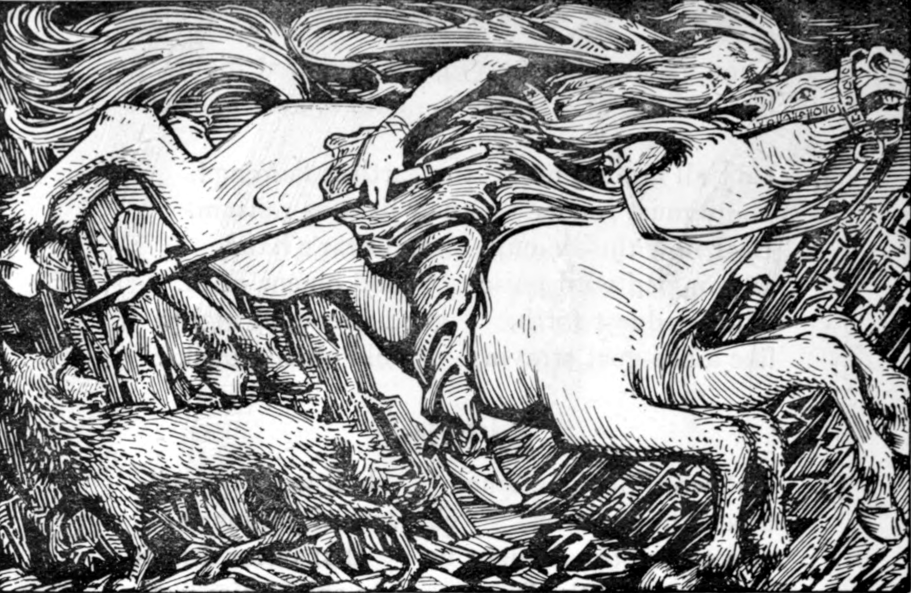
At the end of the third day, Odin came to a land where trees were green and flowers blooming. Here was one of the three fountains which watered the world tree, Yggdrasil, and near by sat the wise giant, Mimir, guarding the waters of this wonderful fountain, for whoever drank of it would have the gift of great wisdom.

Mimir was a giant in size, but he was not one of the fierce giant enemies of the gods, for he was kind, and wiser than the wisest.

Mimir’s well of wisdom was in the midst of a wonderful valley, filled with rare plants and bright flowers, and among the groves of beautiful trees were strange creatures, sleeping dragons, harmless serpents, and lizards, while birds with gay plumage flew and sang among the branches. Over all this quiet valley shone a lovely soft light, different from sunlight, and in the centre grew one of the roots of the great world tree. Here the wise giant Mimir sat gazing down into his well.

Odin greeted the kind old giant, and said, “Oh, Mimir, I have come from far-away Asgard to ask a great boon!”

“Gladly will I help you if it is in my power,” said Mimir.

“You know,” replied Odin, “that as father of gods and men I need great wisdom, and I have come to beg for one drink of your precious water of knowledge. Trouble threatens us, even from one of the Æsir, for Loki, the fire-god, has lately been visiting the giants, and I fear he has been learning evil ways from them. The frost giants and the storm giants are always at work, trying to overthrow both gods and men; great is my need of wisdom, and even though no one ever before has dared ask so great a gift, I hope that since you know how deep is my trouble, you will grant my request.”

Mimir sat silently, thinking for several moments, and then said, “You ask a great thing, indeed, Father Odin; are you ready to pay the price which I must demand?”

“Yes,” said Odin, cheerfully, “I will give you all the gold and silver of Asgard, and all the jewelled shields and swords of the Æsir. More than all, I will give up my eight-footed horse Sleipnir, if that is needed to win the reward.”

“And do you suppose that these things will buy wisdom?” said Mimir. “That can be gained only by bearing bravely, and giving up to others. Are you willing to give me a part of yourself? Will you give up one of your own eyes?”

At this Odin looked very sad; but after a few moments of deep thought, he looked up with a bright smile, and answered, “Yes, I will even give you one of my eyes, and I will suffer whatever else is asked, in order to gain the wisdom that I need!”

We cannot know all that Odin bravely suffered in that strange, bright valley, before he was rewarded with a drink from that wonderful fountain; but we may be quite sure that never once was the good Allfather sorry for anything he had given up, or any suffering he had borne, for the sake of others.

Comprehension questions
Name: Date:

- Who are Odin’s messengers?

- ‘... he suddenly started up, and went forth with long strides from his palace of Gladsheim into the night.’

What does went forth mean?

- What was unusual about Odin’s horse, Sleipnir?

- Look at the paragraph which begins: “It is indeed a most important errand …”

Name one extraordinary thing that Heimdall can do.

- Look at the paragraph which begins: ‘They hurried over the bridge …’

Why was the clear light from the tower important?

- What weather does Odin encounter on the first day of his journey?

- Why was Mimir guarding the fountain?

- “Oh, Mimir, I have come from far-away Asgard to ask a great boon!”

Which word most closely matches the meaning of the word boon?

 | question |  | curse |  | delight |  | favour

- What treasures does Odin offer Mimir in exchange for wisdom? Name two.

- Number the following events 1–5 to show the order in which they happened. The first one has been done for you:

 | Frost giants throw blocks of ice at Odin.
1 | Odin sits on his throne at night, awake.
 | Mimir asks Odin for an eye in exchange for wisdom.
 | Heimdall meets Odin on the rainbow bridge.
 | Odin is chased by the mountain giants.

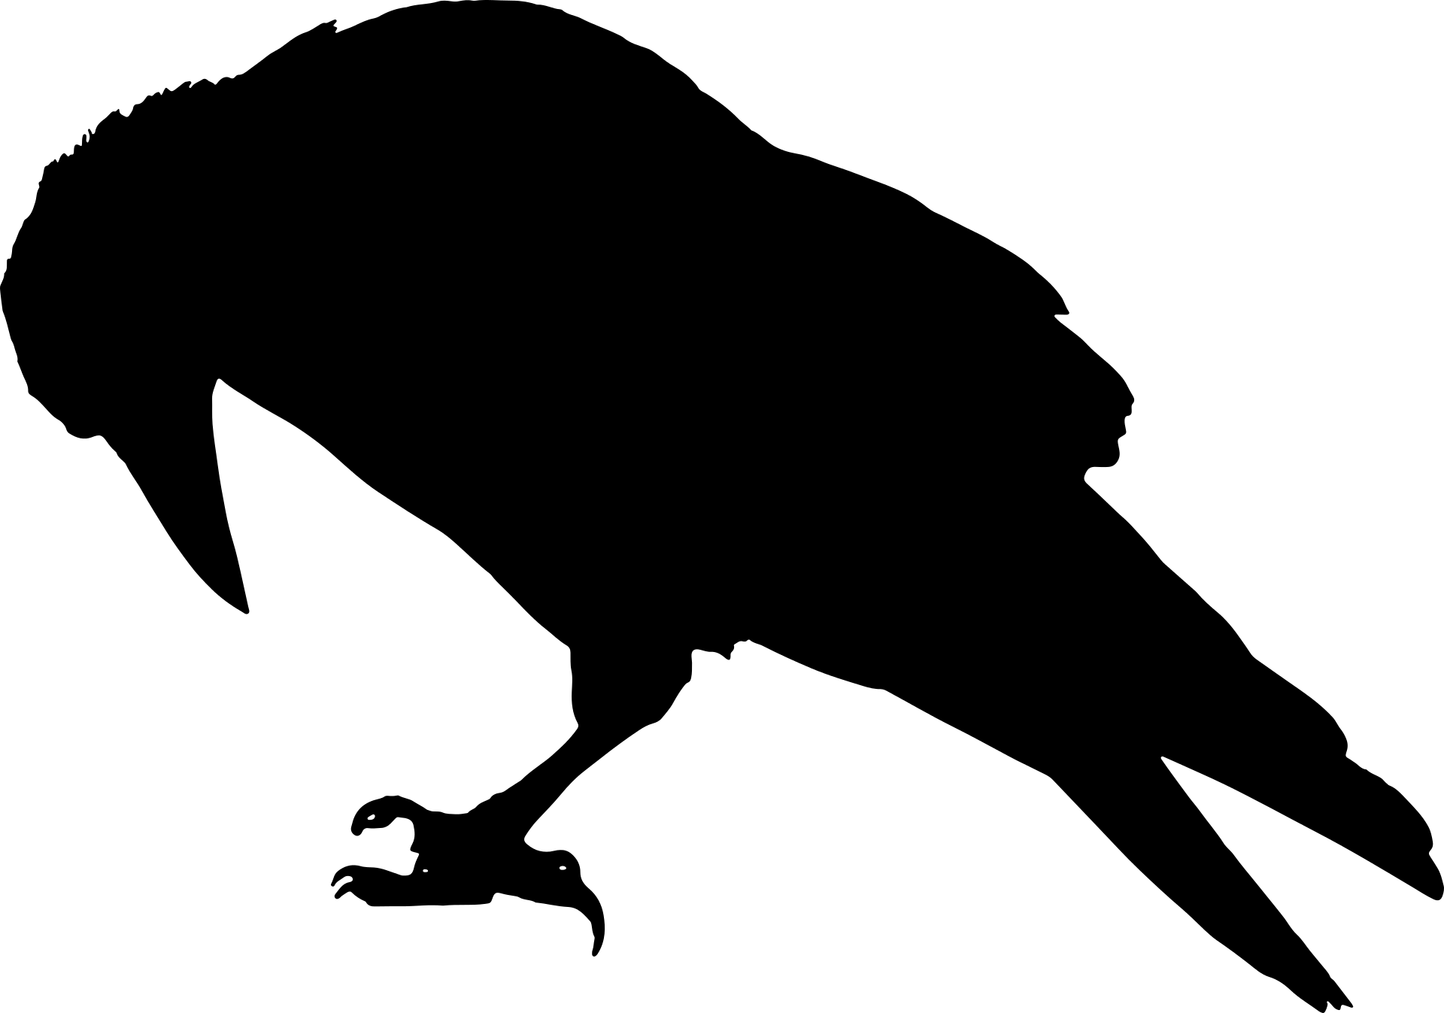

Comprehension answers
- Who are Odin’s messengers?

The two ravens.

- ‘... he suddenly started up, and went forth with long strides from his palace of Gladsheim into the night.’

What does went forth mean?

He ‘went onward’ or ‘went out’.

- What was unusual about Odin’s horse, Sleipnir?

He had eight feet.

- Look at the paragraph which begins: “It is indeed a most important errand …”

Name one extraordinary thing that Heimdall can do.

Either:
 | - he can hear the grass grow in the fields | - he needs less sleep than a bird.
 | - he can hear the wool gather on the backs of the sheep

- Look at the paragraph which begins: ‘They hurried over the bridge …’

Why was the clear light from the tower important?

So that Heimdall could see anyone coming towards the bridge.

- What weather does Odin encounter on the first day of his journey? Ice and snow.

- Why was Mimir guarding the fountain?

Because whoever drinks from the fountain will receive the gift of great wisdom.

- “Oh, Mimir, I have come from far-away Asgard to ask a great boon!”

Which word most closely matches the meaning of the word boon?

 | question |  | curse |  | delight | X | favour

- What treasures does Odin offer Mimir in exchange for wisdom? Name two. Any two of:

 | - all the gold and silver of Asgard; | - his eight-footed horse, Sleipnir.
 | - all the jewelled shields and swords of the Æsir

- Number the following events 1–5 to show the order in which they happened. The first one has been done for you:

3 | Frost giants throw blocks of ice at Odin.
1 | Odin sits on his throne at night, awake.
5 | Mimir asks Odin for an eye in exchange for wisdom.
2 | Heimdall meets Odin on the rainbow bridge.
4 | Odin is chased by the mountain giants.

Resource 1 – Pairs game
Players: 2–4
Instructions:
- Print this page onto card and cut out the cards below.
- Shuffle the cards and lay them face-down in a grid on the table.
- Each player takes it in turns to turn over two cards. If they turn over a matching proper noun and definition, they may keep the cards.
- Continue until all the cards have been matched.
- The player who finished the game with the most matching pairs is the winner.

Odin | Sleipnir | The city of the gods | The watchman of the bridge
The world tree | The rainbow bridge | Aesir | Gladsheim
The fire-god | Mimir | TheAllfather | Bifröst
Odin’s eight-footed horse | Asgard | Loki | Yggdrasil
The wise giant | Heimdall | Odin’s palace | The gods of Asgard

Resource 2 – Comic strip format
Name: Date:
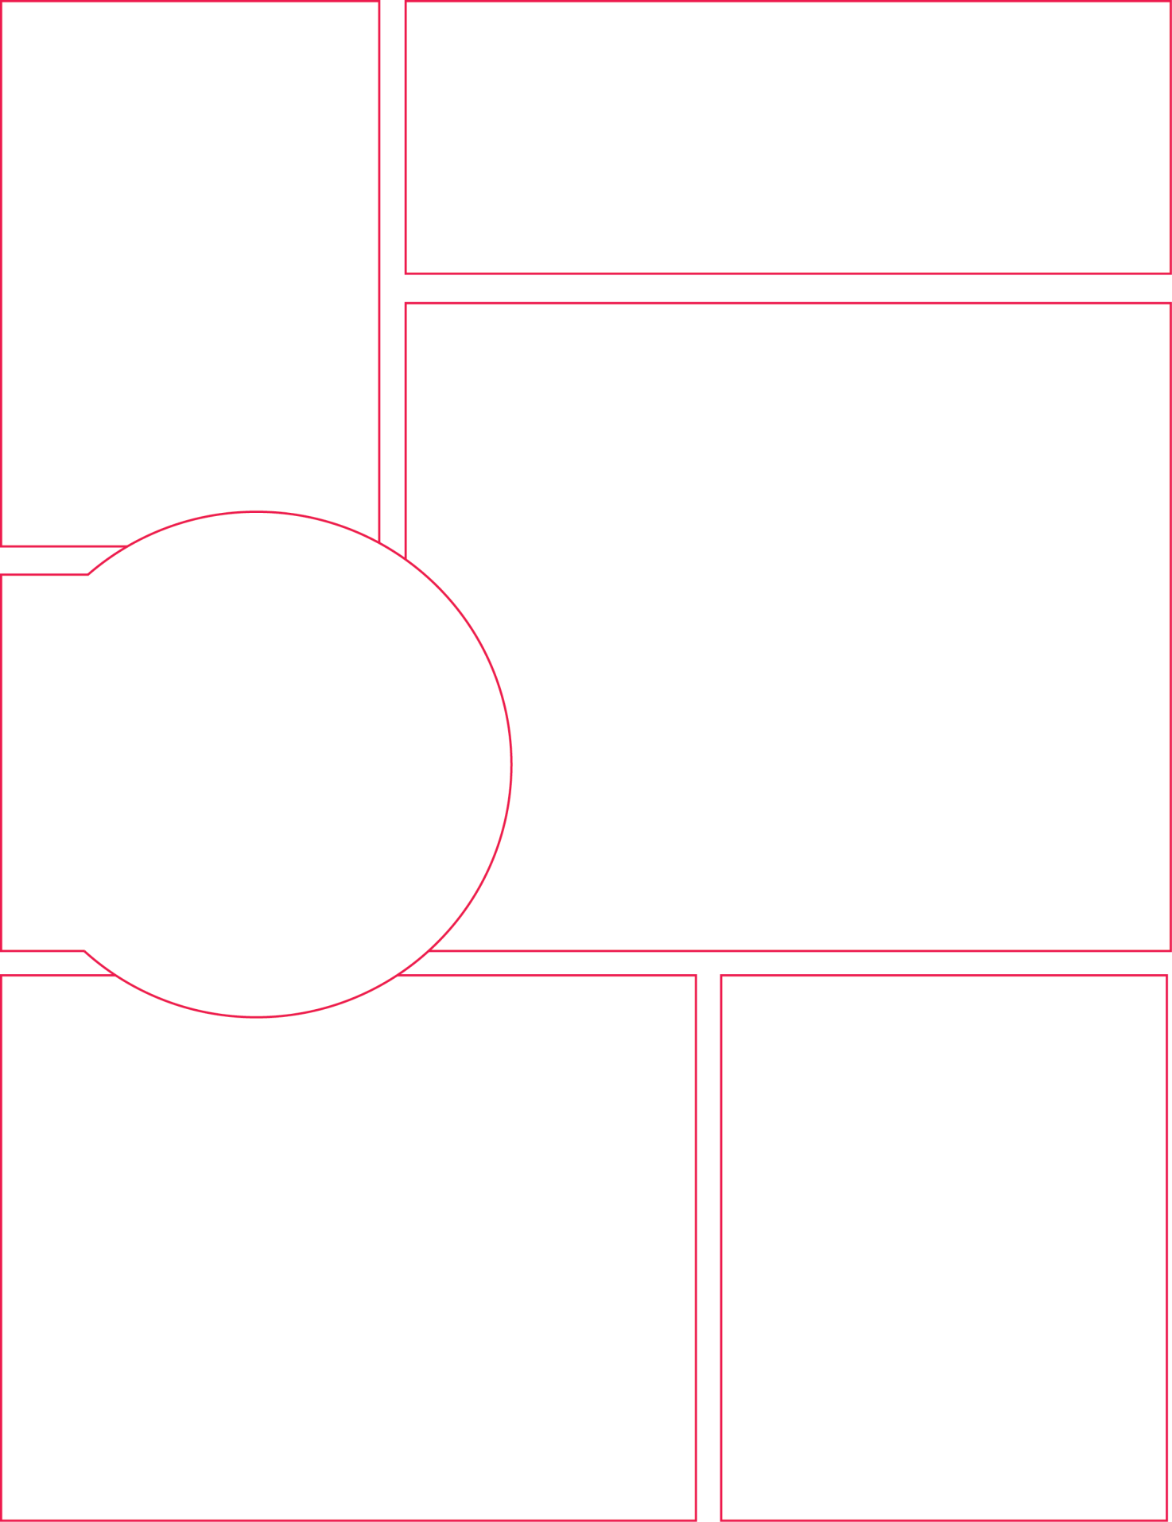



Unit 5 – A biography of Samuel Johnson

Teaching notes

Starter:
- What is a biography?: Ask the children in their table groups to come up with a definition of a biography. Take feedback. Establish that a biography is a piece of writing that gives an account of someone’s life. Ask: what sort of people might have biographies written about them? Why would someone want to read a biography? What is the difference between a biography and an autobiography? Explain that the first modern biography was a book written in 1791 by James Boswell, called The Life of Samuel Johnson, about a famous eighteenth-century English writer. The biography we will be looking at today is also about Samuel Johnson.

Main activities:
- Main teaching activity: Provide each child with a copy of the biography and a highlighter. Ask them to read through the extract, highlighting any information that they think might be important. Then provide them with a copy of the comprehension questions to answer. If they like, they can use the highlighter to help them select the relevant information from the text for each answer.

- Pupil activity one: Provide pairs of children with a copy of Resource 1 – Dr Johnson’s wonderful words. Explain that when Samuel Johnson’s Dictionary of the English Language was published in 1755, some of the words it contained were different to the ones that you and I use today! A lot of the words are now only used infrequently, or have fallen out of use. Can the children work out which definition belongs to which word? Answers can be found in Resource 2 – Answers for Resource 1 – Dr Johnson’s wonderful words. This resource also contains some prompts for further discussion.
- Pupil activity two: What elements are important to include in a biography? Ask the children to discuss this in talking partners, and take feedback. They may use the biography to help them come up with ideas. Record their suggestions on the interactive whiteboard for them to refer to later. They may offer suggestions such as: date and place of birth; childhood; education; achievements or what made the person significant; marriage; children; death. Explain to the children that they will be writing biographies of a significant person. You could limit their choice of biographical subject to their current topic (e.g. a king/queen), or you could give them free rein. Explain that whoever they choose, they must carry out research first by reading existing biographies of that person in non-fiction books or on the internet. They should record the facts and anecdotes they discover on Resource 3 – My biography notes. They should then use these notes to write a short, original biography of their chosen subject.

Plenary:
- Boiled-down biography: Challenge the children to work in pairs to write a ‘boiled-down biography’ of Dr Samuel Johnson. They should refer to the biography to ensure the details they include are accurate. You could provide pairs with different challenges: for example, can they write a biography of Dr Johnson in five sentences? How about three? Or one?! You could challenge more able children to write a one-sentence alliterative biography, or a two-line biography which rhymes. Pin the children’s boiled-down biographies around a large picture of Dr Johnson for an instant display.

Taking it further:
- DIY Dictionary: One of the problems Samuel Johnson noticed when he was writing the dictionary was that the English language is changing all the time – words fall in and out of fashion, and sometimes their meanings alter over time, too! The children will use lots of words today that Samuel Johnson wouldn’t have known, or wouldn’t have understood the modern meaning of. Can they think of any examples of such words? (They may offer suggestions such as ‘iPad’, ‘computer’, ‘epic’, or even ‘selfie’!) Can they think of some more of these words and write their own definitions for them? These could be compiled into a class ‘DIY dictionary’, to go in pride of place on the classroom bookshelf.

- Home learning activity: Samuel Johnson had an amazing memory, which came in handy when he was writing his famous dictionary! He learned many of the poems and passages he read by heart. As a small child, he astounded his mother when she asked him to learn a prayer and he managed to do so after only reading it twice! Challenge the children to find a poem that they like at home and spend time learning it by heart, ready to recite to the rest of the class.

A biography of Samuel Johnson
Samuel Johnson was born on 18th September 1709, in Lichfield, Staffordshire. As a baby, he contracted a serious disease called scrofula, which left him blind in one eye, deaf in one ear, and deeply scarred across his face and body. The sight in his other eye was also considerably weakened by the effects of the disease.  Because of Johnson’s poor sight, a nursemaid was sent every day to collect him from school. On one occasion, the nursemaid was late. Rather than ask for help, Johnson dropped to his hands and knees and began to crawl, following the line of the gutter to guide him home. When a teacher noticed what he was doing and hurried over to offer assistance, Johnson flew into a rage. He was an extremely proud and determined child, and did not want anyone’s pity.  As well as being proud, Johnson was also remarkably intelligent. His father happened to be a bookseller, which was a stroke of good fortune, as it gave the young Johnson access to a wealth of books and knowledge. He read hungrily, and his phenomenal memory meant that he learned many passages and poems by heart.  By the time he was 19, Johnson’s intelligence meant that he won a place at Pembroke College, Oxford. He studied there for a year, but he struggled to keep up with the university fees. On one occasion, a kindly fellow student noticed that Johnson’s shoes had worn out. Guessing that Johnson could not afford to replace them, the student left a pair of brand new shoes outside his door in the middle of the night. Far from  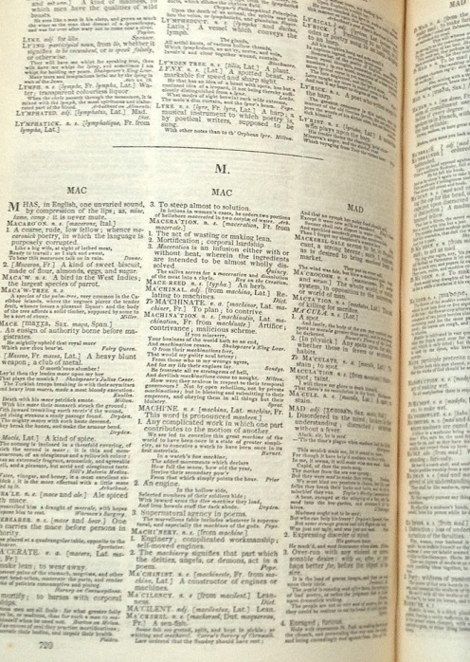 | 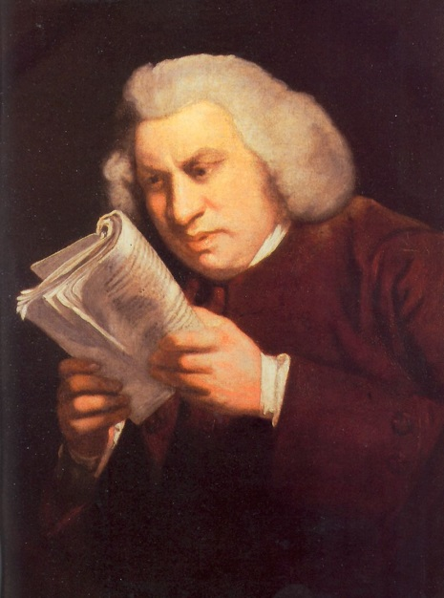
being pleased when he woke up and discovered the gift, Johnson was furious! He loathed the idea that someone had felt he needed their charity.

In the end, Johnson’s poverty forced him to leave Oxford without finishing his degree. In 1735, when he was 25 years old, he married a widow named Elizabeth Porter. Two years later, he travelled to London, where he began to work as a journalist.

Over the next several decades, Johnson would write many books, poems and essays. His most famous work, though, was undoubtedly his great Dictionary of the English Language, published in 1755. The dictionary was an immense labour, taking him eight years to complete – and no wonder, as it contained the definitions of 42,773 words! It was not the first

dictionary ever published, but it was the most popular dictionary of its time, and remained so for a staggering 150 years. It was an enormous book, too – nearly half a metre tall, and more than half a metre wide.

The publication of the Dictionary brought Johnson fame – and some fortune, too! King George III granted Johnson a pension of £300 a year, in recognition of his work on the Dictionary. Although he had never managed to go back to Oxford to finish his degree, in later life Johnson was awarded two honorary doctorates, and became known as Dr Samuel Johnson.

Dr Johnson died on December 13th, 1784, and was buried at Westminster Abbey.

© Jkarjalainen (Own work) [CC BY-SA 3.0 (creativecommons.org/licenses/by-sa/3.0)], via Wikimedia Commons, pl.wikipedia.org/wiki/A_Dictionary_of_the_English_Language

Comprehension questions
Name: Date:

- What were the consequences of the scrofula Johnson suffered from as a baby? Name two.

- Look at the paragraph which begins: ‘Because of Johnson’s poor sight …’

Why was Johnson angry when his teacher offered him assistance?

- What qualities did Johnson possess as a child? Name two.

- ‘He loathed the idea that someone had felt he needed their charity.’

Which of the following is closest in meaning to loathed?

 | Loved |  | Appreciated |  | Hated |  | Understood

- What was the name of the lady who became Johnson’s wife?

- What was the reason that Johnson became famous?

- Look at the paragraph beginning: ‘Over the next several years …’

Find and copy a word which means unquestionably.

- Why did the Dictionary take Johnson so long to complete?

- How old was Dr Johnson when he died? You will need to use the information given in the text to work this out.

- Number the following events 1–5 to show the order in which they happened. The first one has been done for you:

 | Awarded two honorary doctorates.
 | Forced to leave Oxford university due to poverty.
1 | Contracts scrofula.
 | Marries Elizabeth Porter.
 | Publishes his Dictionary of the English Language.

Comprehension answers
- What were the consequences of the scrofula Johnson suffered from as a baby? Name two.

Any two from:

 | blind in one eye | weak eyesight in his other eye
 | deaf in one ear | deeply scarred across his face and body

- Look at the paragraph which begins: ‘Because of Johnson’s poor sight …’

Why was Johnson angry when his teacher offered him assistance?

Because he did not want anyone’s pity.

- What qualities did Johnson possess as a child? Name two.

Any two of:

 | proud | intelligent
 | determined | phenomenal memory

- ‘He loathed the idea that someone had felt he needed their charity.’

Which of the following is closest in meaning to loathed?

 | Loved |  | Appreciated | X | Hated |  | Understood

- What was the name of the lady who became Johnson’s wife?

Elizabeth Porter

- What was the reason that Johnson became famous?

He wrote the Dictionary of the English Language.

- Look at the paragraph beginning: ‘Over the next several years …’

Find and copy a word which means unquestionably.

Undoubtedly.

- Why did the Dictionary take Johnson so long to complete?

It contained the definitions of 42,773 words.

- How old was Dr Johnson when he died? You will need to use the information given in the text to work this out.

75 years old.

- Number the following events 1 – 5 to show the order in which they happened. The first one has been done for you:

 | 5 | Awarded two honorary doctorates.
 | 2 | Forced to leave Oxford university due to poverty.
 | 1 | Contracts scrofula.
 | 3 | Marries Elizabeth Porter.
 | 4 | Publishes his Dictionary of the English Language.

Resource 1 – Dr Johnson’s wonderful words!
Cut out and match the words and definitions below. |  | 
awful | An inflammation in the throat, which sometimes produces suffocation.
bedpresser | Food made of milk.
chocolate-house | A mean fellow.
dirt-pie | Made of linen and wool mixed.
garlickeater | Forms moulded by children of clay, in imitation of pastry.
hurlyburly | A heavy lazy fellow.
linseywoolsey | Tooth-ache.
odontalgick | A house where company is entertained with chocolate.
quinsy | Commotion; bustle.
whitemeat | That which strikes with awe, or fills with reverence.



Resource 2 – Answers for Resource 1 – Dr Johnson’s wonderful words!
 | awful | That which strikes with awe, or fills with reverence. (This comes from the joining of two words – ‘awe’ and ‘full’, meaning ‘full of awe’. It is interesting to note that this is the opposite to the way in which we use the word today. In the past, ‘awful’ would have been used in a similar way to the word ‘awesome’.)
 | bedpresser | A heavy lazy fellow. (Can the children work out why this word has this definition?)
 | chocolate-house | A house where company is entertained with chocolate. (This was rather like a café, where customers were served a chocolate drink.)
 | dirt-pie | Forms moulded by children of clay, in imitation of pastry.
 | garlickeater | A mean fellow. (Why might this word have this definition?)
 | hurly-burly | Commotion; bustle.
 | linseywoolsey | Made of linen and wool mixed. (Can the children think of any modern fabric whose name is also a mixture of its two materials?)
 | odontalgick | Tooth-ache. (Can the children see any clues that the word is to do with teeth?)
 | quinsy | An inflammation in the throat, which sometimes produces suffocation.
 | whitemeat | Food made of milk.

Resource 3 – My biography notes
Name: Date:

Make notes about your chosen person here, and then use them to write your own short biography.

Full name:
Date and place of birth:
Names and occupations of parents:
Brothers or sisters:
Childhood:
Education:
Occupation:
Significant achievements:
Marriage:
Children:
Interesting quotes or stories:
Death:

Listening skills
Unit 6 – A newspaper report

Teaching notes

Starter:
- Headline hunters: Provide each table with an assortment of newspapers and magazines. (Check through the material first to ensure the content is appropriate.) Explain that they are going to become ‘headline hunters’ – their job is to hunt down the most exciting or intriguing headlines they can find, and cut them out to keep. Give the children a few minutes to look through the material and hunt for headlines in their pairs. Then bring the class back together. Which headlines did they think made the most impact, and why? Did they notice any common features the headlines had? Draw out examples of alliteration, word play, third person, powerful verbs, etc. What tense is usually used for headlines, and why? Elicit that present tense is used in order to create a sense of excitement and drama.

Main activities:
- Main teaching activity: Provide each child with a copy of the newspaper report and a highlighter. Ask them to read through the extract, highlighting any information that they think might be important. Then provide them with a copy of the comprehension questions to answer. If they like, they can use the highlighter to help them select the relevant information from the text for each answer.
- Pupil activity one: Ask the children: what are the 5Ws? Elicit that they are who, what, when, where, and why. Explain that the 5Ws are very important when writing newspaper reports – all of the five questions usually have to be answered for an article to be complete. Provide pairs of children with a clipping from a local or national newspaper and ask them to use highlighters to pick out the 5Ws in the story. Take feedback from the class. How many of the 5Ws appeared in their article’s first sentence? What about in the headline? Why do the children think this is?
- Pupil activity two: What is the difference between a fact and an opinion? Hold a whole-class discussion, eliciting that a fact is a statement that can be proven to be true, whereas an opinion is the way someone feels about something. Provide each child with a copy of Resource 1 – Fact or opinion? and a range of newspaper and magazine articles. (As before, check through the material first to ensure the content is appropriate). Ask them to find examples of facts and opinions in the articles and record them on their sheet. Then, for the second task, they should identify whether the sample statements are fact or opinion. Bring the class together to feed back. Did they notice a difference between the type of articles which tended to include mostly facts, and those which included mostly opinions?

Plenary:
- Complete the headline: Using Resource 2 – Complete the headline, asks pairs of children to fill in the gaps in the headlines with likely words/phrases. Challenge more able pupils to use alliteration or puns to make their headlines more attention-grabbing!

Taking it further:
- School newspaper: If you don’t already have one, this could be a great opportunity to start a termly school newspaper, written and compiled by the children themselves. Make sure all the children in the class have a role: you will need photographers, reporters, headline writers, caption writers, editors, proofreaders, cartoonists – and maybe even an advertising manager! Encourage them to come up with a list of events that should be covered (e.g. sports fixtures; fundraising events) and ensure that a reporter and photographer is assigned to each one. Give reluctant writers a subject to write about that they have an enthusiasm for – top tips for a favourite hobby, for example. This is also a good way of encouraging reluctant readers – they are more likely to read a newspaper to which they’ve contributed!
- Home learning activity: Ask the children to take the time to read a short article every day for a week. They could choose to read a sports report from their local newspaper, a film review on a news website, an opinion column from a national newspaper – anything, as long as they jot down a record of what they have read and what publication they found it in. You could also ask children to bring in articles they found particularly interesting to put in a classroom news box, so that other children can borrow them to read.

A newspaper report
The Humbleton Herald
Edition No. 72059 | “The voice of the community since 1878” |  |  |  | Thursday 12th October 2017
LOCAL PUPIL DISCOVERS BURIED TREASURE!
A pupil at Brownings Primary School has discovered a hoard of gold treasure hidden in the school field. Amelie Phipps, 10, was playing tag at lunchtime with her friends when she spotted something shining on the ground.  ‘It was sort of hidden under the leaves,’ she said. ‘I bent down to look closer, and there was a gold coin there. It was extremely dirty. I was really surprised.’  Amelie alerted the teacher on duty, Shahida Bansal, who realised at once that the pupil had found something rather special. ‘I put cones around the area and called the children off the field,’ Mrs Bansal said. ‘Then I rang the county archaeology team. They sent someone out immediately.’  By the afternoon, the school field had turned into an archaeological dig. Before long, more gold was unearthed. ‘It was a thrilling moment,’ Jack Walker, County Archaeologist, told us. ‘I knew straight away that we had something extraordinary on our hands.’  It transpired that the coin Amelie Phipps had found was part of a larger hoard. As well as the gold coins, a number of necklaces and brooches were also discovered. ‘It is at least 1300 years old – maybe more. It is  certainly of significant historic |  | 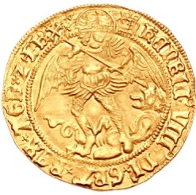  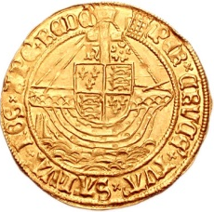 |  | 
 |  | interest,’ Mr Walker stated. ‘We are very excited to begin studying it.’  The archaeologist believes that a fox or a badger may have disturbed the hoard while digging, leading to Amelie spotting the coin on the ground. ‘Even so, if it hadn’t been for Amelie’s keen eyes, we might never have found this wonderful hoard,’ Mr Walker said. ‘Very soon, the falling leaves would have just buried it again.’  The school field will be out of bounds for the children for the next few weeks, while a team of archaeologists search the ground carefully for any further treasure. In the meantime, a neighbouring farmer has offered the school children the use of one of his fields for playtime. ‘I don’t mind the kids playing on it for a few weeks,’ Mr Andy Kew said. ‘It’s not fair for them to have to spend  playtimes in their classrooms. | I’m happy to help.’ The headteacher of Brownings Primary School, Mrs Karen Coleman, said the teachers and children were very grateful for the farmer’s kind offer.  The find will go out for valuation next month, but Mr Walker says it is likely to be worth, ‘In the tens of thousands of pounds.’ According to the Treasure Act 1996, any reward for finding the treasure should be shared equally between the finder and the owner of the land. In this case, the money will be split between Miss Amelie Phipps and her school.  I’m not sure what I will do with the money yet,’ Miss Phipps explained. ‘I will probably save a lot of it for when I’m older. But I’m definitely going to buy a metal detector straight away – so that I can go out and hunt for more treasure!’
©cea +, 2012, flic.kr/p/bSdxha

Comprehension questions
Name: Date:

- Look at the paragraph which begins: ‘By the afternoon, the school field …’

Find and copy a word which means discovered.

- Aside from the gold coins, what else was in the hoard? Name two different items.

- What season was it when Amelie found the first coin? Explain how you know.

- Jack Walker is an archaeologist. Tick the definition that you think best describes this word:

Someone who studies rocks and earth.
Someone who studies human history by examining ancient sites and objects.
Someone who works with schools to make sure they are safe for children.
Someone who shoots with a bow and arrow.

- ‘It transpired that the coin Amelie Phipps had found was part of a larger hoard.’

Which of the following is closest in meaning to transpired?

 | Told |  | Tricked |  | Transformed |  | Turned out

- How does Jack Walker think that the first gold coin got dug up?

- Why are the school children not allowed on the field for the next few weeks?

- Using information from the text, tick one box in each row to show whether each statement is true or false.

 | True | False
The hoard included coins and jewellery.
Mrs Bansal rang the police when she realised there was treasure on the school field.
Amelie will receive all the reward money for the treasure find.
The children will be able to play in the farmer’s field until the archaeologists have finished their work in the school field.

- Why will the reward money be split between Amelie and her school?

- What is Amelie going to do with her reward money? Name one thing.

Comprehension answers
- Look at the paragraph which begins: ‘By the afternoon, the school field …’

Find and copy a word which means discovered.

Unearthed.

- Aside from the gold coins, what else was in the hoard?

Name two different items.

Necklaces and brooches.

- What season was it when Amelie found the first coin? Explain how you know.

Autumn – the article was written in October, and the archaeologist said that the coin would very soon have been covered by fallen leaves.

- Jack Walker is an archaeologist. Tick the definition that you think best describes this word:

 | Someone who studies rocks and earth.
X | Someone who studies human history by examining ancient sites and objects.
 | Someone who works with schools to make sure they are safe for children.
 | Someone who shoots with a bow and arrow.

- ‘It transpired that the coin Amelie Phipps had found was part of a larger hoard.’

Which of the following is closest in meaning to transpired?

 | Told |  | Tricked |  | Transformed | X | Turned out

- How does Jack Walker think that the first gold coin got dug up?

By a fox or a badger.

- Why are the school children not allowed on the field for the next few weeks?

Because a team of archaeologists will be searching the ground for further treasure.

- Using information from the text, tick one box in each row to show whether each statement is true or false.

 | True | False
The hoard included coins and jewellery. | X
Mrs Bansal rang the police when she realised there was treasure on the school field. |  | X
Amelie will receive all the reward money for the treasure find. |  | X
The children will be able to play in the farmer’s field until the archaeologists have finished their work in the school field. | X

- Why will the reward money be split between Amelie and her school?

Because the Treasure Act 1996 states that the money should be split between the finder and the land owner.

- What is Amelie going to do with her reward money? Name one thing.

Either:
 | - buy a metal detector | - put it in savings.

Resource 1 – Fact or opinion?
Name: Date:
- Look through the articles you have been given to find examples of facts and opinions, and record them in the table below.
Fact | Opinion

- Read the statements below, and decide whether they are fact or opinion:

- Rabbits are herbivores, which means their diet is entirely plant-based.
- Football is the best sport to watch live.
- The capital city of Sweden is Stockholm.
- A kilogram is equal in weight to 1,000 grams.
- Teenagers should not be allowed to use social media.
- I think that Jurassic World was the worst film ever made.

Resource 2 – Complete the headline
Name: Date:

Can you think of likely words or phrases to complete the headlines below?

DEVASTATED AFTER

SCHOOLBOY LANDS STARRING ROLE IN
INJURED BY
SUPERMARKETS IN PRICE WAR OVER
SCIENTISTS DISCOVER INCREDIBLE NEW
HOW SAVED MY BASKETBALL CAREER.

SCIENTISTS DISCOVER INCREDIBLE NEW
PARENTS PROTEST OUTSIDE SCHOOL DUE TO
THE FUTURE IS HERE: SET TO HIT SHOP SHELVES IN TIME FOR CHRISTMAS
MIRACLE LEAVES FAMILY AMAZED.

