**Curriculum Pointers**

**INTENT**

We want our Adventurous Afternoons to empower and excite and fill our children with the knowledge, skills and values needed to access whatever their dreams are in the future. To help achieve this the curriculum has been designed to be at the heart of our education for the children and has been personalised to ensure needs of chn are being catered for e.g. building resilience, varying starting points individuals bring. Our Adventurous Afternoon has been designed to be a knowledge AND skills based curriculum to maximise the progress the children make. The two must work together and enhance each other. The knowledge we teach is the bedrock on which the skills can be built. When chn have developed their skills they have the ability to perform/completes tasks/solve problems but ONLY when they can draw on what they know. The long term plans are progressive and sequenced into relevant year groups, following the NC. Teachers and SL are aware of the end pointers for KS.

**IMPLEMENTATION**

* Our approach/delivery to teaching the new ‘Adventurous Afternoons’ curriculum is….

**The Learning Pit**

This is because of the needs of our children e.g. want to build resilience and experience/life skills to cope in situations, not just cry and wait for an adult to solve.

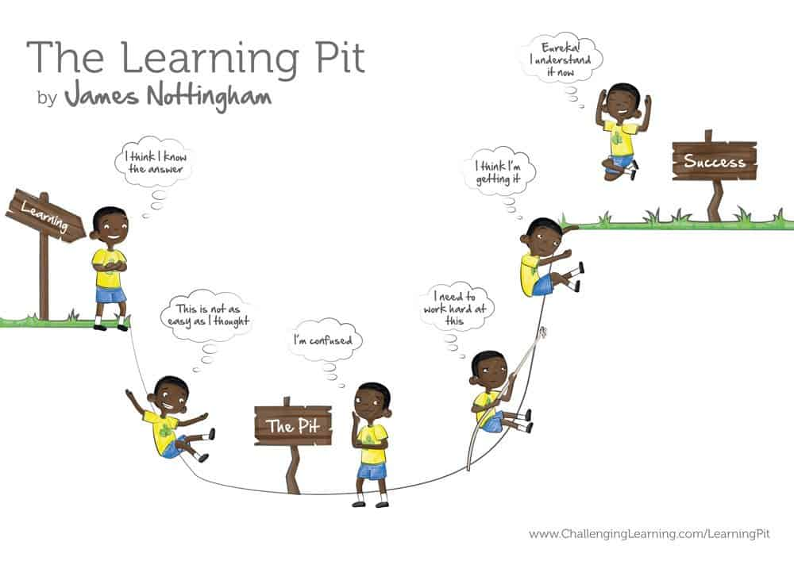

* Every lesson that you plan **MUST** use the sequence of this Learning Pit or elements of this sequence if you are planning it over a unit. Our ‘I wonder’ objectives help with the very start and there are lots of exciting, key questions that you can use in the Weaving Knowledge, understanding and skills’ document. Initial assessments **MUST** be used to help you decide where about your chn are starting in the pit! Your lessons after **MUST** allow the chn to experience learning opportunities and experiences that will allow them to feel confused, work on their challenge/activity and succeed. For the chn to feel the success you **MUST** include a reflection element within your lesson or unit. Please have high expectations, be child centered/involved/outdoor. Each lesson **MUST** build and make knowledge sticky.
* We are using the ‘Weaving Knowledge, understanding and skills’ document to ensure the NC is covered and all things progress. This document is on the OneDrive. KLIPS is not being used as coverage as it is too overwhelming but it can be still used as reference/your knowledge.
* We are having a thematic approach which is mapped out on the long term plans **BUT** science, PE and RE are still classed as discrete but cross curricular links can still be used. Therefore, we want geography and history to be the **main drivers** of the Adventurous Afternoons and art, DT, music, French, ICT and PSHE to be the **enhancers**. Making meaningful links will deepen the learning, make learning more memorable, help build use of vocab as the chn are being exposed to similar content in more transferable ways. Our Christian Values/British values should also be enhanced/used and linked.
* Science, PSHE and ICT are a little special as they are kind of both discrete and thematic – when it doesn’t fit in a cross curricular way then keep discrete e.g. Sex Ed, spreadsheets!!
* Assessments are now taking place each half term for the foundation subjects (inc science, RE, PSHE and PE) The findings/outcome of these assessments is being used to complete Foundation Assessment Grid Class. SL will monitor these, class teachers will see where gaps are for future planning. **Progress means knowing more and remembering more.**
* Initial and final assessments must be carried out to help teachers know where the gaps are and what is needed in their planning. **Prior knowledge** allows learning of new content. The more we link and build on prior knowledge the more it embeds in the chns long term memory.
* Knowledge organisers should still be being used – if you have changed year groups you might want to adapt. Remember nothing overwhelming, on an A4 piece of paper and **MUST** include key vocab and summary of sticky knowledge. Chn should be accessing these in each lesson.
* Weekly plans should be being used and put on the OneDrive so monitoring is productive for subject leaders. We don’t want to spend the time collecting things but rather analysing.
* Outdoor learning is another way our intent is translated into the learning process. It is another opportunity for chn to translate and adapt their long term memory with learning in different contexts and environments.

**IMPACT**

* Early days for us with the impact as we need to see what picture the assessments are showing us and what progress the chn are making – how ready are they for their next stage of education?
* SL monitoring will help us ascertain the impact, along with the use of the Foundation Assessment Grid SL sheets.