Have a go at chopping the following words, e.g. dog = d-o-g

[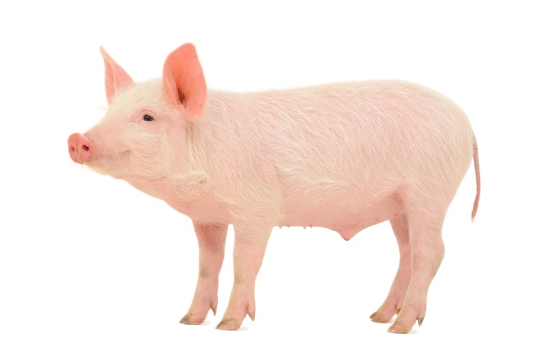](http://www.google.co.uk/url?sa=i&rct=j&q=&esrc=s&source=images&cd=&cad=rja&uact=8&ved=0CAcQjRxqFQoTCLmSttb89scCFYm6GgodQ_wDxA&url=http://www.marchwood-scientific.com/Food.html&bvm=bv.102537793,d.eXY&psig=AFQjCNGjeb95w0gPkHDKESAN-Vx7yiNf4g&ust=1442335523530113)[](http://www.google.co.uk/url?sa=i&rct=j&q=&esrc=s&source=images&cd=&cad=rja&uact=8&ved=0CAcQjRxqFQoTCOvj7cj89scCFUfaGgod5E8DTQ&url=http://www.vetprofessionals.com/catprofessional/&psig=AFQjCNHOuZu29k7pIncZXcXKbfTo8g6xCQ&ust=1442335494950003)

[](http://www.hpwarehouse.co.uk/edwardian-mono-basin-mixer-tap-and-waste.html)[](http://www.google.co.uk/url?sa=i&rct=j&q=&esrc=s&source=images&cd=&cad=rja&uact=8&ved=0CAcQjRxqFQoTCL7K9_n89scCFUnSGgod_h4GXg&url=http://www.slinkmagazine.com/2015/05/dressing-sensibly-but-fashionably-for-the-summer/&bvm=bv.102537793,d.eXY&psig=AFQjCNEpV8zcKJemKt_rBqkW5u_xw_nc0g&ust=1442335572258863)

[](http://www.google.co.uk/url?sa=i&rct=j&q=&esrc=s&source=images&cd=&cad=rja&uact=8&ved=0CAcQjRxqFQoTCMmt8Nv99scCFcFXGgod-ioOaw&url=http://www.telegraph.co.uk/news/worldnews/northamerica/usa/6506877/Hat-worn-by-Jack-Ruby-when-he-killed-Lee-Harvey-Oswald-to-be-sold.html&bvm=bv.102537793,d.eXY&psig=AFQjCNFoS4ouJBOG6_UD4z1cntTxwOTyMw&ust=1442335703222666)[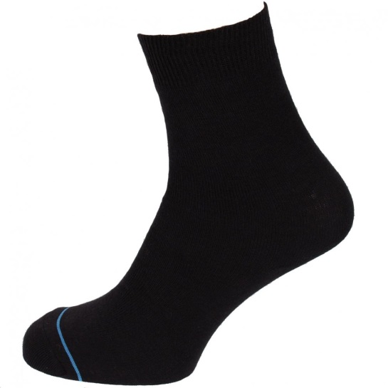](http://www.google.co.uk/url?sa=i&rct=j&q=&esrc=s&source=images&cd=&cad=rja&uact=8&ved=0CAcQjRxqFQoTCKKWxov-9scCFUtZGgod5CkIDw&url=http://www.tonyprycesports.co.uk/womens-c2/accessories-c19/socks-c66/1000-mile-ultimate-tactel-anklet-sock-white-p55960&psig=AFQjCNHmmRSOx0_N0ASMv8656fn_vZVobg&ust=1442335837329108)

You could play I-spy. I spy with my little eye a c-u-p. Can your child guess what you can see?