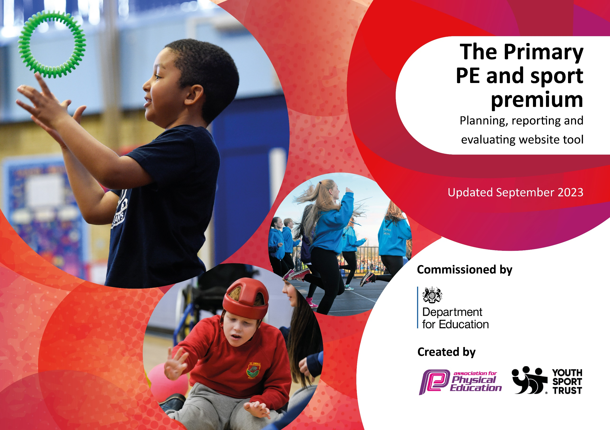

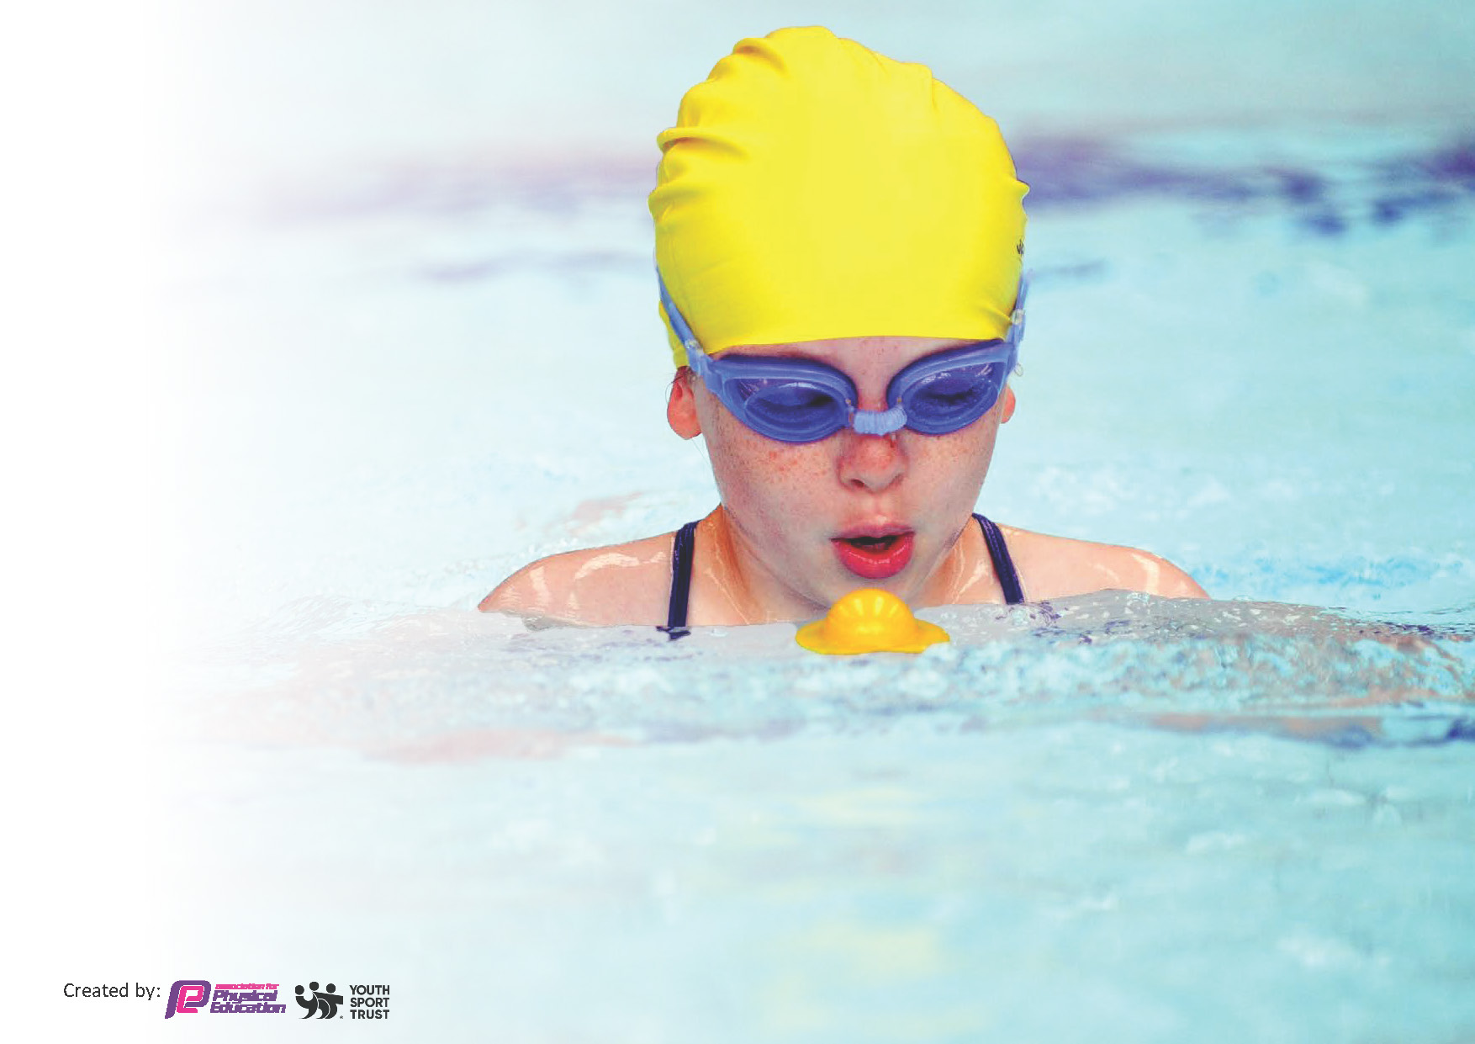
This template can be used for multiple purposes:
by:
- It enables schools to effectively plan their use of the Primary PE and sport premium
- It helps schools to meet the requirements (as set out in guidance) to publish information on their Primary PE and sport premium
- It will be an effective document to support Ofsted inspections enabling schools to evidence progress in Physical Education (PE) and evidence swimming attainment, which forms part of the PE National Curriculum. We would recommend schools consider
the Intent, Implementation and Impact of any spend, as examined within the Education Inspection Framework.

It is important that your grant is used effectively and based on school need.

Schools must use the funding to make additional and sustainable
improvements to the quality of the PE, School Sport and Physical Activity (PESSPA)
they offer. This means that you should use the Primary PE and sport premium to:

- Build capacity and capability within the school to ensure that improvements made now will benefit pupils joining the school in future years
- Develop or add to the PESSPA activities that your school already offers.

The Primary PE and sport premium should not be used to fund capital spend projects; the school’s core budget should fund these. Further detail on capital expenditure can be found in the updated Primary PE and sport premium guidance.

The Primary PE and sport premium guidance, outlines 5 key priorities that funding should be used towards. It is not

necessary that spending has to meet all the key priorities, you should select the priorities that you aim to use any funding towards.

Although completing this template is not a requirement for schools, schools are required to publish details of how they spend this funding. Schools must also outline what the impact this funding has had on pupils’ PE and sport participation and attainment and how any spending will be sustainable in the future. All funding must be spent by 31st July 2024.

The Department for Education has worked closely with the Association for Physical Education (afPE) and the Youth Sport Trust (YST) to develop this template and encourages schools to use it. This template is an effective way of meeting the reporting requirements of the Primary PE and sport premium.
Review of last year’s spend and key achievements (2022/2023)

We recommend you start by reflecting on the impact of current provision and reviewing your previous spend.

Activity/Action | Impact | Comments
- Sports Crew training with welfare staff.  - Change4life club to engage those children who are the least active.  - The whole school engages in active learning and, during the Adventurous Afternoons, to ensure that at least one lesson is outside each week and that the children are active for 30minutes a day in school.  - Baseline across the whole school for the FMS in September 2022. Long term lesson plans are then adapted to address the gaps and interventions in place for children in KS1 who are at risk of not achieving the FMS by the end of KS1.  - CPD delivery for teaching staff.  - Ensuring each class is assessed using the PE Passport APP. Gold, Silver and Bronze are tracked in every year group alongside attendance at clubs and external events.  - CPD for gifted and talented children and to develop young leaders.  - External agencies and venues to provide opportunities not available on our restricted site to ensure our children experience the full PE curriculum and are physically active.  - Top up swimming for children at risk of not achieving 25m by the end of Y6. | - The Sports Crew delivered activities every lunchtime throughout the academic year and were supported by the welfare staff.  - The children targeted attended and started to attend other clubs/events.  - Fitness levels are improving, and the least engaged learners do engage when outside learning. It has improved attention, progress and behaviour.  - The majority of children are leaving KS1 with the 10 FMS firmly embedded.  - CPD has been delivered and the SL can see the impact in the lessons. CPD has covered:- Deep dive in PE, Tennis, swimming, EYFS and Mental Health, OAA and gymnastics.  - Knowledge of the progress and standards in PE across the school. Ensuring every child has the opportunity to attend external events and attend the after-school clubs.  - The older children work as leaders in school and deliver lessons to the younger children.  - Swimming delivered and 25m achieved by 100% of Y6 cohort. The aim was also to ensure the children were confident and safe when accessing the water sports on the residential in Wales. | - Great engagement of the children in KS1 and promotion of being active. It helped underpin our ethos of nurturing and children developing as leaders.  - Monitor 23/24 if the children continue to engage in after school clubs and events when chosen.  - Continue to ensure that all teachers plan and deliver outdoor learning for all learners.  - Early assessment and planned intervention are key to ensuring all children achieve the 10FMS in KS1.  - Monitor the need for CPD and ask the staff for the areas where they are least confident in their delivery.  - Continue to track and monitor, ensure there is a wide range of after-school club provision on offer.  - Are these children going onto high school and continuing to be leaders?  - Continue to access external agencies and venues to ensure our PE coverage is deep, varied and accessible for all learners.  - Vital to ensure that Y6 are safe and confident in the water by June of each year which is when the residential takes place.

Key priorities and Planning
This planning template will allow schools to accurately plan their spending.

Action – what are you planning to do | Who does this action impact? | Key indicator to meet | Impacts and how sustainability will be achieved? | Cost linked to the action
Sports crew to be established and trained by SSP alongside welfare staff to improve engagement at lunchtimes.  Sports ambassadors with Y6 children (each term) to teach the key skills to identified children in KS1 (narrowing the gap).  Sports Crew to develop a ‘Challenge of the Week’ for the whole school based on one of the 10 FMS.  Run C4L club– targeting least active children and attend C4L festivals. | Welfare Staff  Y6 Sports Crew  KS1 children  Teachers  KS1 children  Y6 young leaders  Whole school being more active and achieving their 30mins a day.  Least active children in KS2. | Key indicator 2: The engagement of all pupils in regular physical activity – the Chief Medical Officer guidelines recommend that all children and young people aged 5 to 18 engage in at least 60 minutes of physical activity per day, of which 30 minutes should be in school. | More pupils meeting their daily physical activity goal, more pupils encouraged to take part in PE and Sport Activities.  Developing young sports leaders and ensuring they are confident as they move to high school. | £1000 costs for additional coaches and resources to support the Sports Crew and welfare delivering this.  £2000 costs to deliver C4L and ensure children are actively engaged.
The majority of children leave KS1 with the 10 fundamental movement skills.  All KS2 children are learning through a skill-based approach. A developmental approach to lessons should be in place. Learning through skills which can be applied to any sporting activity.  Awards in Golden Book (each half term) which celebrate the school sports values – passion, honesty, teamwork, self-belief, determination and respect.  Re-apply for Platinum School Games Award in 2024  Ensure each class has a ‘Welly Wednesday’ once per half term to increase outdoor learning and at least one curriculum lesson per week.  Ensure all children are engaged in sport and are physically active beyond the classroom. | EYFS and KS1 children  Teachers and support staff  Welfare staff  KS2 children  Teachers and support staff  Whole school – staff and children  PE subject leader  Whole school  PE subject leader to monitor the impact on children. | Key indicator 3: Raising the profile of PE and sport across the school, to support whole school improvement. | The gaps in PE will be identified in September 2023 and the long-term plan will be adjusted to ensure the children make progress and achieve.  Presenting and highlighting sporting values will ensure that children know PE and sport are not just about being competitive and we look for these values as we develop leaders of the future.  Children and staff are physically active and understand (and can see) the impact that this will have on their concentration, fitness levels and mental health.  All learners are engaged and making progress because lessons are adapted to meet the needs of every learner. | £4000 to deliver outdoor learning and ensure access for all learners.

Subject leader to model, monitor and evaluate curriculum lessons.  Subject leader to attend Y6/7 transition CPD and Subject Leader update training and PLT meetings.  Continue to invest in staff CPD and use coaches from BSSP during PE lessons so teachers become more confident to deliver HQ PE.  Ensure all staff are using the core skills to assess P.E CDP, within school, on using the PE Passport APP.  Headteacher and Subject Leader to continue to develop their role in sport within Burnley | PE subject leader  SSCo to support  PE Subject leader  Coaches  Teachers  SSCo  PE Subject leader  Teachers  Headteacher/subject leader | Key Indicator 1: Increased confidence, knowledge, and skills of all staff in teaching PE and sport. | Primary teachers are more confident to deliver effective PE supporting pupils to undertake extra activities inside and outside of school, including teaching water safety and swimming and as a result improved % of pupil’s attainment in PE.  PE Subject Leader is upto date with current developments in PE and has implemented, where applicable and necessary, these into the whole school PE curriculum. | £5000 for 5 teachers to undertake CPD.
Engage all children through a varied sport program.  Increase range of extracurricular activities delivered after-school.  Develop gifted and talented pupils and sports leaders.  Participation in Outdoor Adventurous Activities/Learning and Residential.  All KS2 children to have represented the school at sport by 2024 through: -  - Festival  - Developmental  - Pathway  To give opportunities to all our children to take part in intra and inter competition.  To raise aspirations  To promote the enjoyment of physical activity | Teachers  Specialist teachers and venues  Children  Teachers  Specialist teachers and venues  Children | Key indicator 4: Offer a broader and more equal experience of a range of sports and physical activities to all pupils.  Key indicator 5: Increased participation in competitive sport |  | £3000 to deliver the PE curriculum and after-school extracurricular opportunities.  £2000 to ensure children have the opportunity to access and take part in sport.

Key achievements 2023-2024
This template will be completed at the end of the academic year and will showcase the key achievements schools have made with their Primary PE and sport premium spending.

Activity/Action | Impact | Comments
Sports crew to be established and trained by SSP alongside welfare staff to improve engagement at lunchtimes.  Sports ambassadors with Y6 children (each term) to teach the key skills to identified children in KS1 (narrowing the gap).  Sports Crew to develop a ‘Challenge of the Week’ for the whole school based on one of the 10 FMS.  Run C4L club– targeting least active children and attend C4L festivals.  The majority of children leave KS1 with the 10 fundamental movement skills.  All KS2 children are learning through a skill-based approach. A developmental approach to lessons should be in place. Learning through skills which can be applied to any sporting activity.  Awards in Golden Book (each half term) which celebrate the school sports values – passion, honesty, teamwork, self-belief, determination and respect.  Re-apply for Platinum School Games Award in 2024  Ensure each class has a ‘Welly Wednesday’ once per half term to increase outdoor learning and at least one curriculum lesson per week.  Ensure all children are engaged in sport and are physically active beyond the classroom.  Subject leader to model, monitor and evaluate curriculum lessons.  Subject leader to attend Y6/7 transition CPD and Subject Leader update training and PLT meetings.  Continue to invest in staff CPD and use coaches from BSSP during PE lessons so teachers become more confident to deliver HQ PE.  Ensure all staff are using the core skills to assess P.E CDP, within school, on using the PE Passport APP.  Headteacher and Subject Leader to continue to develop their role in sport within Burnley.  Engage all children through a varied sport program.  Increase range of extracurricular activities delivered after-school.  Develop gifted and talented pupils and sports leaders.  Participation in Outdoor Adventurous Activities/Learning and Residential.  All KS2 children to have represented the school at sport by 2024 through: -  - Festival  - Developmental  - Pathway  To give opportunities to all our children to take part in intra and inter competition.  To raise aspirations  To promote the enjoyment of physical activity. | Sports Crew training took place in September 23 and they run lunchtime activities on a daily basis.  C4L club established in September 23 and targeted least active children.  Daily mile completed from EYFS to Y6. The stamina of the children has increased throughout the year.  Active Maths has been used and ensured that children are more active during the day whilst learning.  Y6 have been teaching EYFS for 1 lesson per term which has developed their leadership skills and EYFS’s 10 FMS.  Baselines were completed across the school in September 2023. The final assessments, in June 2024, showed an improvement in the FMS and application of skills in a game context in KS2. This final assessment will inform the long-term plans for PE for each class in the next academic year 24-25.  Sporting awards are presented on a half termly basis. They have concentrated on the sporting value awards and show the children what it means to be a good sports person.  The outdoor learning has run alongside our ‘Adventurous Afternoons’. It enhances our curriculum offer and ensures our children are active whilst learning.  Children are proud of representing the school and their success.  Children participate in a range of sporting competitions inside and outside of school.  School Games display board shows children representing the school in a variety of activities. The Games values are also displayed.  Platinum Award re-awarded for showing how we ensure children are active every day, in every class, for 60 minutes.  100% of the Y6 cohort attended Christian Mountain Residential.  100% attended the team building skills (2day) activities with a sleep over at school in autumn 2023.  The PE App allowed us to track the least active and target them for the BSSP events.  The whole school loved the glow dodgeball day and skipping day. Welfare staff and Sports Crew were also trained to deliver skipping effectively at lunchtimes.  YOGI sessions for EYFS were delivered in autumn 2023. This did improve their physical skills which includes their handwriting.  Y5 attended swimming the spring term – 28 children.  HAF programme has been accessed and promoted to our FSM children.  Bloggs are written by children who took part and included in the weekly newsletter.  C4L club children have attended inclusion events and SEND children attended festivals.  Year 3 and 4 and 5/6 have participated in a number of intra house competitions this year this has included hockey, athletics, netball, dodgeball, rounders, tag rugby and football.  School Games Day will take place in June 2024. | Running prior to the start of PE lessons has had a positive impact in upper KS2 on stamina.  For a small school there is a wide selection of lunchtime and after school clubs available throughout the year.  EYFS staff have been trained in delivering tots on tyres. This will ensure the delivery of this for the forthcoming years and means we can revisit this program if necessary, during a school year.  CPD has been tailored to the needs of the children in our school and school. This has included SEND training, all staff completed PE and autism with YST and dance CPD with the Primary Dance Package.  An ex-pupil has been on site once a week for her college course and has been delivering PE in upper KS2. This will extend to other classes from September 24.

Swimming Data
Meeting National Curriculum requirements for swimming and water safety.
Priority should always be given to ensuring that pupils can perform safe self-rescue even if they do not fully meet the first two requirements of the National Curriculum programme of study

Question | Stats: | Further context  Relative to local challenges
What percentage of your current Year 6 cohort can swim competently, confidently and proficiently over a distance of at least 25 metres? | 100%
What percentage of your current Year 6 cohort can use a range of strokes effectively [for example, front crawl, backstroke, and breaststroke]? | 100% | Children go swimming in the spring term of Y5. Once in Y6 we do check that they can swim competently and send them for extra lessons if necessary.

What percentage of your current Year 6 cohort are able to perform safe self-rescue in different water-based situations? | 100% | Use this text box to give further context behind the percentage.
If your schools swimming data is below national expectation, you can choose to use the Primary PE and sport premium to provide additional top-up sessions for those pupils that did not meet National Curriculum  requirements after the completion of core lessons. Have you done this? | No | Not this year as all could swim. We will use the data from Y5 in spring term to ensure all have 25m and are confident. If they are not, they will have additional lessons during 2024-2025.
Have you provided CPD to improve the knowledge and confidence of staff to be able to teach swimming and water safety? | Yes

Signed off by:

Head Teacher: | Naomi Healey
Subject Leader or the individual responsible for the Primary PE and sport premium: | Naomi Healey  Headteacher and PE Subject Leader
Governor: | John Sansom
Date: | 13th September 2023  3rd June 2024 – completed.

