‘Learn, Pray, Care & Play’

*”Love one another as Jesus loved us” (John 13 v 34-35)*

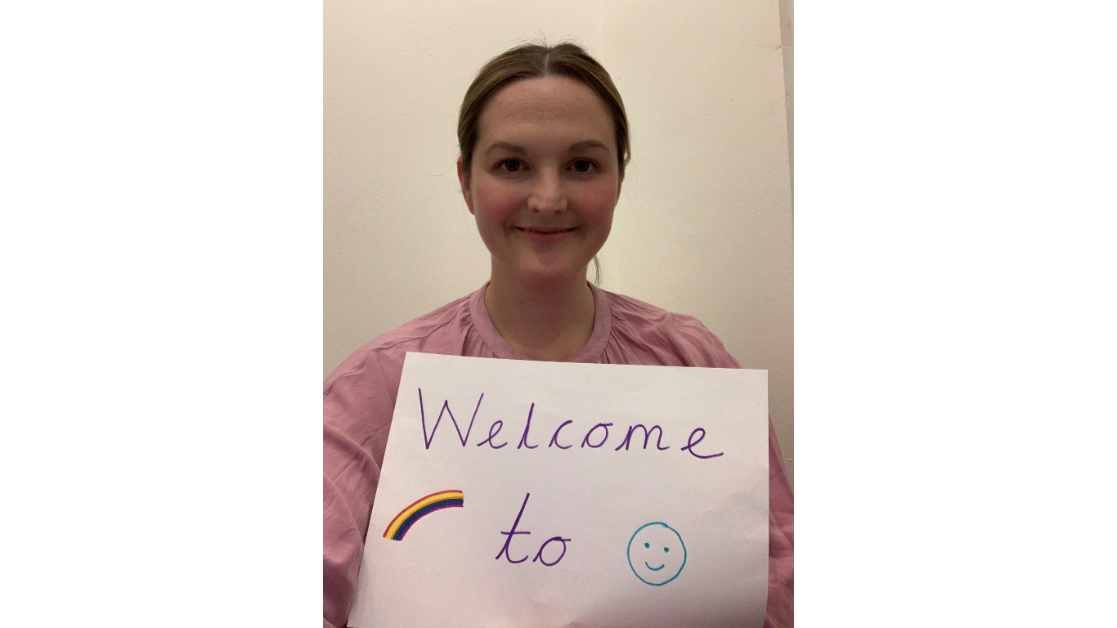**Hello children. We can’t wait to meet you all!**

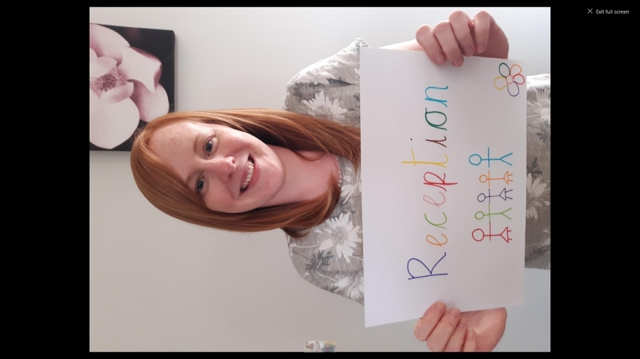

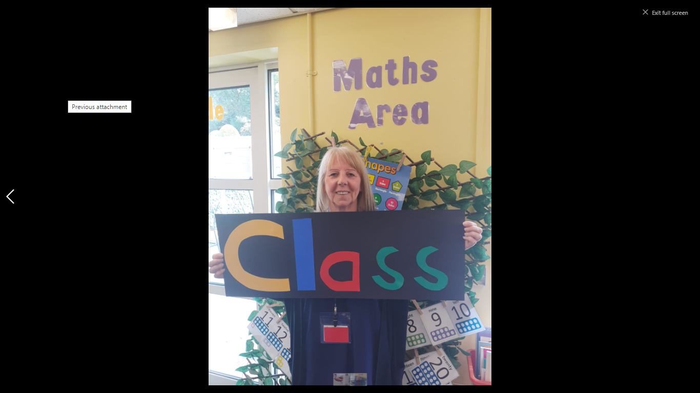**Mrs Kenny**

**Mrs Pickup**

**Mrs Green**