Key Vocabulary  Knowledge Organiser – Beegu  Year 1 | Definition
famous  significant  Emily Pankhurst  suffragette  Mary Prince  Mary Seacole  JK Rowling  Marcus Rashford | 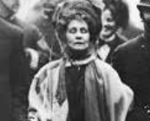  Known about by many people.  Someone or something that is important.  Born in 1858 she fought for women to have the right to vote.  This is the name of the movement that fought for equal rights for women.  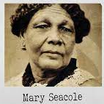  She fought for the abolition of slavery and was the first black woman to have an account of her life published in Britain.  Born in 1802, she also became famous for looking after injured soldiers.  A famous author who wrote, the Harry Potter series.    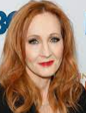  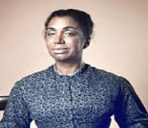  A footballer who plays for Manchester United and is campaigning to make sure all children have food each day.
Topic facts & figures
Windmills
A windmill is a building with sails or vanes that turn in the wind and generate power to grind corn into flour.

Science
Key vocabulary | Definition
absorbent  fabric  foil  elastic  floppy | ​Something that soaks up liquid, like water.  A soft material.    A shiny material which is bendy.    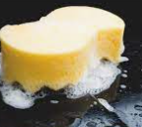  Stretchy and bendy.  Not strong.

