Key Vocab  Year 1 | 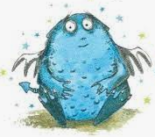  Definition  Knowledge Organiser – Bog Baby
bog  body  claw  features  fin  scales  hooves  senses  United Kingdom(UK)  Address  city | 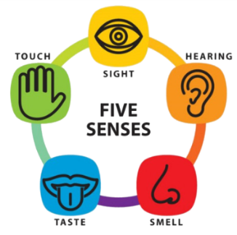  A wet, muddy area.  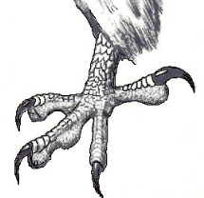  Where peoples insides are, like their heart.  What animals use to hunt and eat their food.  They are soft and protect animal’s bodies.  Some animals have these to help them swim.  They are waterproof and protect animal’s bodies.  Some animals have these instead of feet.  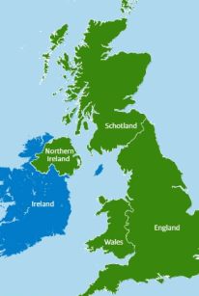  Five ways to understand what is around you. Sight, hearing, smell, taste and feel.  4 countries: England, Scotland, Wales and Northern Ireland.  Street number, name and postcode of where you live.  A large town.
Topic facts & figures
- There are a variety of common animals that are carnivores, herbivores and omnivores.

- People are mammals. So are dogs, cats, bats, hedgehogs, dolphins and whales. If an animal drinks milk
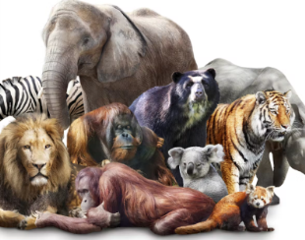
when it is a baby and has hair on its body, it belongs to the mammal family.

- Birds are animals that have feathers and that are born out of hard-shelled eggs.

- Fish are vertebrates that live in water and have gills, scales and fins on their body.

- Reptiles are a class of animal with scaly skin. They are cold blooded and are born on land. Snakes, lizards, crocodiles, alligators and turtles all belong to the reptile family.

- Amphibians are born in the water. When they are born, they breathe with gills like a fish. But when they grow up, they develop lungs and can live on land.

Harvest | Facts and figures
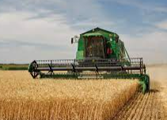  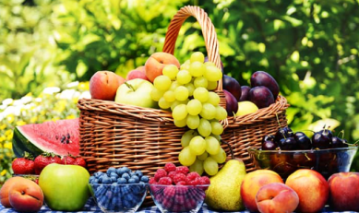  Harvest is the season of gathering crops. We thank God for the harvest during this festival. | A physical feature is something that is naturally created on Earth, including: a beach, cliff, coast, forest, hill, mountain, sea, ocean, river, soil, valley, season and weather.    A human feature is something made by man, including: a city, town, village, factory, house, office, port, harbour and shop. ​  

