Key Vocabulary  Knowledge Organiser – The Rabbit Problem  Year 1 | Definition
plant  tree  root  stem  leaf  flower  trunk  branches  blossom  berry  bark  bud  fruit  petal  seed  stalk | 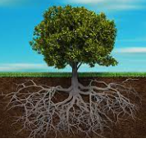  A living thing that grows and has a stem, leaves and roots.  A plant that grows year after year, with a trunk and branches with leaves.  The part of a plant that grows underground and takes water up to the rest of the plant.  A long thin part of a plant, that points up to the sky.  The flat green part of a plant that can change colour.  The colourful beautiful part of a flower.  The main thick stem of a tree.  The parts of a tree that grows out from the trunk.  The flower of a seed plant.  A usually edible part of a plant.  The outer layer of stems and roots of wood on a tree.  A small growth from a plant which will grow into a flower or blossom.  The usually edible part that grows from a plant.  Any of the usually brightly coloured parts that together form most of the flower.  The beginning of a plants growth.  The part which supports a plant.
Topic facts & figures
The Towneley Family
The Towneley family lived in the Hall for over 600 years. They were Catholics, Christians, who did not give up on their religion.
In 1903, the house was opened as an art gallery and museum.

Science
Key vocabulary | Definition
deciduous  evergreen  wild plants  garden plants  four seasons | 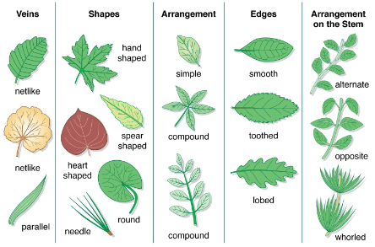  ​Trees that lose their leaves.  Plants that keep their leaves.  Plants that are not grown by people.  Plants that are grown by people.  Spring, Summer, Autumn and Winter.

