**St. John's C of E (VA) School Cliviger**

‘Learn, Pray, Care & Play’

Our church school through its Christian values and caring community seeks to inspire each individual to achieve and grow.

Key Stage 1

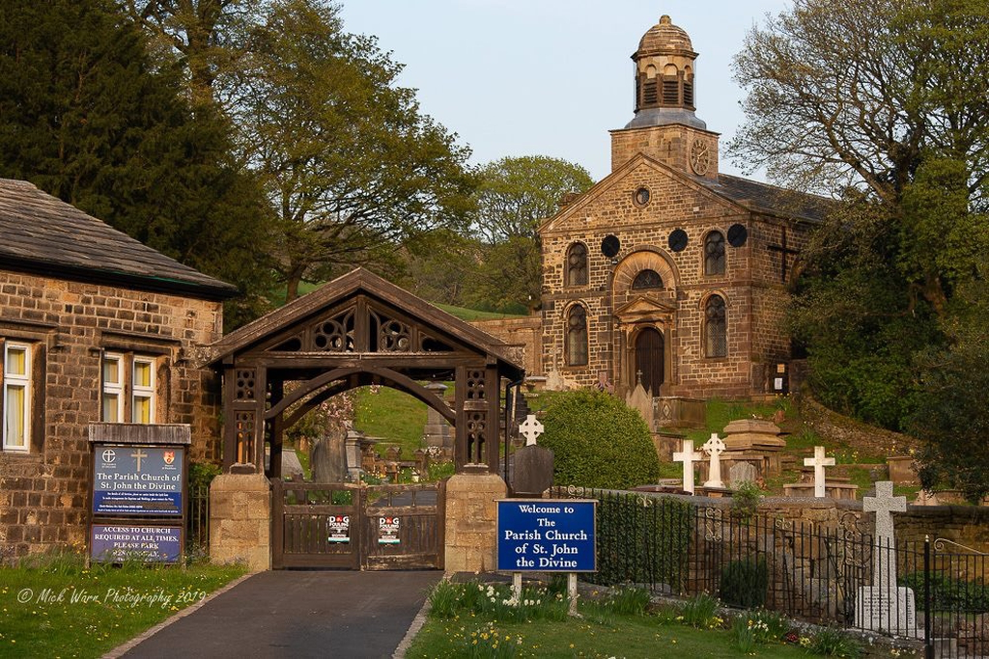Policy

**Introduction**

The overarching aim of the KS1 Policy at St John’s C of E, Cliviger is to promote the outcomes of ECM and the Statutory Requirements of the National Curriculum.

**Every Child Matters**

* Staying safe
* Being healthy
* Enjoying and achieving
* Making a positive contribution
* Achieving economic well-being

**Statutory Requirements of the National Curriculum**

The National Curriculum applies to pupils of compulsory school age in community and foundation schools, including community special schools and foundation special schools, and voluntary aided and voluntary controlled schools

Key Stage 1: Ages 5-7 (Years 1-2)

At key stages 1 and 2 the statutory subjects that all pupils must study are art and design, design and technology, English, geography, history, information and communication technology, mathematics, music, physical education and science. Religious Education must also be provided at Key Stages 1 and 2.

**Safeguarding**

There is a whole school policy related to Safeguarding and Child Protection and a risk assessment has been completed for the reception outdoor area. There are daily checks on the school and reception outdoor area to ensure all policies are being adhered to. There have also been overall risk assessments completed for relevant indoor learning environments e.g. PE in the school hall.

**KS1 Provision in this setting consists of:**

We aim to provide an inclusive, enabling and learning environment for the children in EYFS and KS1. The varying settings throughout EYFS and KS1 allow the children to become strong and independent learners. We feel it is important for the children to learn and develop their emotional resilience through social skills, awareness of others and emerging self awareness.

This policy reflects the main aims of the school which are:

‘Our church school, through its love of God and its Christian values, seeks to promote responsibility and respect for others, whilst encouraging the growth of each individual within the school community.’

**Key Stage 1 Provision at St Johns C of E, Cliviger**

**Staff in KS1 are:**

EYFS Class – Mrs C Kenny, Mrs Pickup and Mrs Stockburn

Year 1 Class - Mrs Grimshaw and Miss Saunders

Year 2 Class - Mrs Johnston, Mrs Hodson and Miss Woodrup

The SENDCo works within the EYFS and KS1 and provides support for the teachers and teaching assistants. Volunteer helpers also play an important role in the daily routines of EYFS and KS1.

**Organisation and management of provision:**

EYFS and KS1 provision at St John’s C of E, Cliviger is organised into 3 classes who all have access to shared areas, toilets and equipment facilities throughout the school e.g. Curriculum Den, hall, library, playground and green.

Please see timetables for Reception, Year1 and Year 2 daily routines.

**Organisation and management of the learning environment:**

We offer an environment which is carefully organised and planned to promote successful and effective teaching and learning. The environment supports opportunities for children to engage in whole class, small group adult led activities with opportunities for the children to engage in independent learning activities which enable the children to become independent learners whilst consolidation and extending their developing skills, knowledge and understanding within the context of the National Curriculum for KS1.

Within EYFS the teaching and learning is organised to take part within the classroom and in the outdoor area, which we consider to be an important part of the provision. Throughout the EYFS and KS1 activities are planned to incorporate adult directed activities (whole class and small groups) and opportunities for the children to engage in purposeful activities independently (individually or in groups).

Throughout each academic year staff within EYFS and KS1 organise a range of experiences and opportunities based on ‘real’ events and encounters linked to what is being taught at the time. For example, Year 2 children had a visit from ‘PendleSide Hospice’ fundraisers to help with their class charity and EYFS had a visit from a ‘Air Ambulance NW’ to link with their topic ‘People Who Help Us’.

The role of the adult plays a crucial part in the provision of the EYFS and KS1. Adults will work with children on directed/guided activities or support children who are working on independent tasks. The provision is flexible and adaptable to meet the needs of the individual children. This adaption and support is organised to promote the inclusion of children with SEND and the Able, Gifted and Talented children. We monitor the learning environment to change and develop it throughout the year to ensure the progression of learning and to create challenges for the children.

**KS1 Curriculum**

## The structure of the National Curriculum

For each subject and for each key stage, programmes of study set out what pupils should be taught, and attainment targets set out the expected standards of pupils' performance. It is for schools to choose how they organise their school curriculum to include the programmes of study.

### **Programmes of study**

The programmes of study (as defined by the Education Act 1996, section 353b) set out what pupils should be taught in each subject at each key stage and provide the basis for planning schemes of work. When planning, schools should also consider the four general teaching requirements ([use of language, use of ICT and health and safety](http://curriculum.qcda.gov.uk/key-stages-1-and-2/general-teaching-requirements/index.aspx) and inclusion) that apply across the programmes of study.

During the EYFS children will be working on goals from the Foundation Stage Curriculum and as they move into Year 1 and eventually Year 2 the children will begin to work on goals from the National Curriculum. Throughout the EYFS and KS1 children all have access to weekly RE lessons and collective acts of worship.

The wider curriculum for the EYFS and KS1 at St John’s Cliviger consists of educational visits, themed days and visitors e.g. school trips and visitors from the community. There are also sports clubs that take place after school for the children to take part in e.g. Multi Skills in Year 2 and Art Club. More details and photos of the wider curriculum for EYFS and KS1 can be found on our school website.

**KS1 Planning**

Teachers' planning follows the units and themes mapped out by the Curriculum Lead on their long-term plans. Teachers then use the medium-term plans, from the school’s scheme of work(s) to produce plans for the individuals and groups in their class. Kapow is used for DT and Art and the Learning Challenge Curriculum is used for history and geography. Initial assessments are carried out at the start of each unit/theme to ensure previous learning is taken into consideration and the children are taught the skills, knowledge and understanding they need to dive deeper within a subject.

At our school planning includes:

**Long Term Planning**: this informs and helps us focus on our medium-term planning

* We ensure coverage of all subject areas within the National Curriculum ensuring the curriculum meets the requirements of the programmes of study for FS and KS1 and whole school initiatives. We use different schemes to ensure progression and previous learning can be built on.
* We follow the requirements for the locally agreed syllabus for RE – Blackburn Diocese.
* We identify how we meet the requirements of the programmes of study for EYFS and KS1 in relation to the subject areas, which includes ongoing monitoring and evaluation.
* We evaluate our provision in relation to the National Curriculum requirements and as part of our KS1 action plan we review our provision in relation to our current targets.

**Medium Term Planning:** this informs and helps us focus on short term planning.

* We include a range of experiences and activities appropriate to our groups of children in line with the EYFS and KS1 programmes of study.
* Our daily routines which will include time for arrival, settling in and leaving, provision for outdoor activities as well as indoor, whole class and small group focused teacher led activities, independent activities (individual or small group) supported by adults.
* Main resources such as planning for provision within the classroom/ shared areas /outdoors as appropriate, planning for special events and celebrations, planning for identified themes for KS1.

**Short Term Planning:** this provides a weekly overview of teaching and learning activities covering elements of the programmes of study for KS1, daily literacy activities including phonics, and daily maths activities.

**Transition Procedures**

At St John’s Cliviger we are totally committed to the need of a smooth transition between different phases, in particular the EYFS to KS1. At the beginning of the year teaching practice may have to be adapted to support children settling in to KS1 in preparation for the future learning and development. The children and staff are actively involved in the process and there are clear targets for pupils with SEND at transition identified on POP’s. Throughout the year children within EYFS and KS1 often visit the other classrooms to familiarise themselves with the different adults, children and rooms. There are distinctive differences between EYFS and KS1, however, we still continue to promote children’s personal independence, independent learning and their decision-making skills which are reflected in the organisation of the KS1 teaching and learning.

**Transfer of Information**

Reception to Y1

* Approaches to teaching and learning are harmonised at the point of transition.
* Planning is based upon assessment information from previous class e.g. Floor books and any teacher assessments.
* Styles of teaching and learning meet the needs of the children and not preconceived notions of what is appropriate for the next phase/KS.
* Transition motivates and challenges the children.
* Specific meeting between EYFS and Y1 teachers to discuss information in summer term prior to transition
* The ‘Floor Books’ will continue to be used as an assessment tool in the autumn term in Year 1 for those children who are not yet ready for the National Curriculum levels.
* Continuous provision used in the Year 1 class for the first term.
* Yr 1 frequently use and change key areas for the children to use independently for the 4 specific areas of learning and development.
* Year 1 continue to use continuous provision for all children in the AUT1 term and AUT 2 and beyond for those who need it.

Y1 to Y2

* Approaches to teaching and learning are harmonised at the point of transition
* Planning is based upon assessment information from previous class e.g. teacher assessments and any other assessment documents.
* Styles of teaching and learning meet the needs of the children and not preconceived notions of what is appropriate for the next phase.
* Transition motivates and challenges the children.
* Specific meeting between Y1 and Y2 teachers to discuss information in summer term prior to transition
* The continuation of Lancashire Tracker will be used as an assessment tool in Year 2 building on from the data given by the Year 1 teacher.

Y2 to Y3

* Approaches to teaching and learning are harmonised at the point of transition
* Planning is based upon assessment information from previous class e.g. teacher assessments and any other assessment documents
* Styles of teaching and learning meet the needs of the children and not preconceived notions of what is appropriate for the next phase.
* Transition motivates and challenges the children.
* Specific meeting between Y2 and Y3 teachers to discuss information in summer term prior to transition
* The continuation of Lancashire Tracker will be used as an assessment tool in Year 3 building on from the data given by the Year 2 teacher.

Transition Expectations from EYFS – Yr2

|  |  |  |  |
| --- | --- | --- | --- |
|  | EYFS | Year 1 | Year 2 |
| Continuous Provision/ Planned Play | AUT – ongoing  SP – ongoing  SUM – ongoing with extra challenges in specific areas | AUT 1 – ongoing both morning and afternoon.  AUT 2 – continuous provision in the morning and planned play/skills development in the afternoon.  SP – continuous provision in the morning and planned play/skills development in the afternoon only for those children who have been identified to need it.  SUM - continuous provision in afternoon only for those children who have been identified to need it. | AUT – integrated into breaks and POP work.  SP - integrated into breaks and POP work.  SUM - integrated into breaks and POP work. |
| Date and learning objectives | SUM – just write the day in books and use a ruler independtly to underline it. Write the short date inn maths book and underline it. | AUT 1 – just write the day and underline it.  AUT 2 – write the full date/long date and underline it. | AUT – full date/long date and learning objective to be written by all children. Adaptions made for individuals. |
| Group work/table work to build independence | SUM – more focussed group work whilst sat at a table for longer periods. | SUM – all class structured working at their table for all independent parts of the lesson. All children using individual subject books. | AUT – all class structured working at their tables for independent parts of the lesson. All children using individual subject books. |

**Observation and Assessment**

### **Assessing attainment at the end of a key stage**

The statutory interim framework will be used to make a teacher assessment judgement at the end of the KS following completion of the KS1 curriculum. This is not used to track the assessments and progress of the children throughout the year. Teachers will use evidence from children’s books and test papers to demonstrate that children have met a certain standard.

**Formative Assessment**

Different forms of observation and assessment for learning are used in KS1. These are used by adults to develop knowledge of individual progress and group progress in order to inform future planning, e.g. talking to and listening to children, discussion with parents, participating in activities, etc.

Ongoing information is collected on a child’s progress and achievements throughout the year e.g. record of achievement, assessments tasks, test papers, books or learning journals that includes a range of annotated evidence, e.g. photographs, post it notes, observation sheets, discussion notes, samples of child’s work etc.

Scrapbooks are used to show initial assessments, progress and final assessments within a unit for music, DT and RE. Year 1 also have a science ‘Floor Book’.

This on-going information is recorded on Lancashire Tracker. Teachers can access this daily to monitor individuals and/or specific groups.

**Summative Assessment**

Statutory assessment for KS1

* End of reports to parents on the progress of their child in relation to the programmes of study for KS1
* Year 2 end of year assessments (English and Maths) which take place in the summer term and are reported to parents and the local authority at the end of the academic year.
* The ‘Floor Books’ started in the Foundation Stage will be passed onto Year 1 so progress can be maintained for those children still working on the Foundation Stage Curriculum.
* Year 1 Phonics Screening Check will also be reported to parents at the end of the year.

**Reporting to Parents**

Teachers are required to report annually to parents on pupils' progress.

In KS1 an annual report is sent to parents to inform them of their child’s progress in relation to the NC programmes of study for all subject areas within the national curriculum.

Parent evenings will be held twice a year to discuss achievements, progress, work and any other issues arising. Teachers also take part in Pupil Progress meetings, POP meetings with parents and Pupil Conferences throughout the year – all of which are reported to parents.

**Parental Engagement & Involvement**

Parents are always welcomed to become engaged with their child’s time at St John’s through weekly newsletters, termly class letters, home diaries, text services and the school website. These methods of communication highlight to the parents how they can support their child’s learning at home. Parents are also invited to attend an ‘EYFS Drop in Session’ to look at their child’s classroom and work and chat to the teacher. Parental involvement in school e.g. as parent helpers is very important at St John’s and parents can find information about this on the previous methods mentioned. Other parent/family support groups carried out at school include CHSA meetings, sports days, coffee afternoons, church services and Family Fun Fridays.

**Liaison with other agencies**

The school will often need support, advice or information from other agencies. This may be initiated by the class teacher, SENDCo or head teacher.

**Staff Development**

All staff working in KS1 are conversant with NC programmes of Study, Phonics, RE and the procedures for observation, assessment, record keeping and planning. KS1 staff frequently attend INSET meetings, courses and cluster meetings to develop their knowledge and understanding further or gain new qualifications.

The identification of training needs for teaching and non-teaching staff will take place through Performance Management and/or staff development interviews.

The KS1 Leader/ co-ordinator will ensure that:

* Appropriate dissemination of training/materials/good practice takes place regularly.
* A record of INSET activities is maintained.
* There is an assessment of the impact of INSET etc on the quality of teaching & learning.
* Monitoring and assessments are carried out appropriately for the age of children, are accurate and used purposefully.

**Resource Audit**

* Resources are reviewed annually and stored between the KS1 classrooms.
* Resources for the outdoors are stored in the Foundation Stage classroom or in the secure hut located to the side of the outdoor play area.
* KS1 staff take a shared responsibility for the upkeep of the resources.
* The development of provision is linked to the INSET/courses/clusters attended by the staff.
* The school SENCo has additional resources for KS1 staff to use for children with SEN or EAL.

**Reviewing the Key Stage 1 Policy.**

The head teacher, staff and governors will review this policy on a regular basis to ensure it is being implemented appropriately and to take account of changing circumstances.