 | 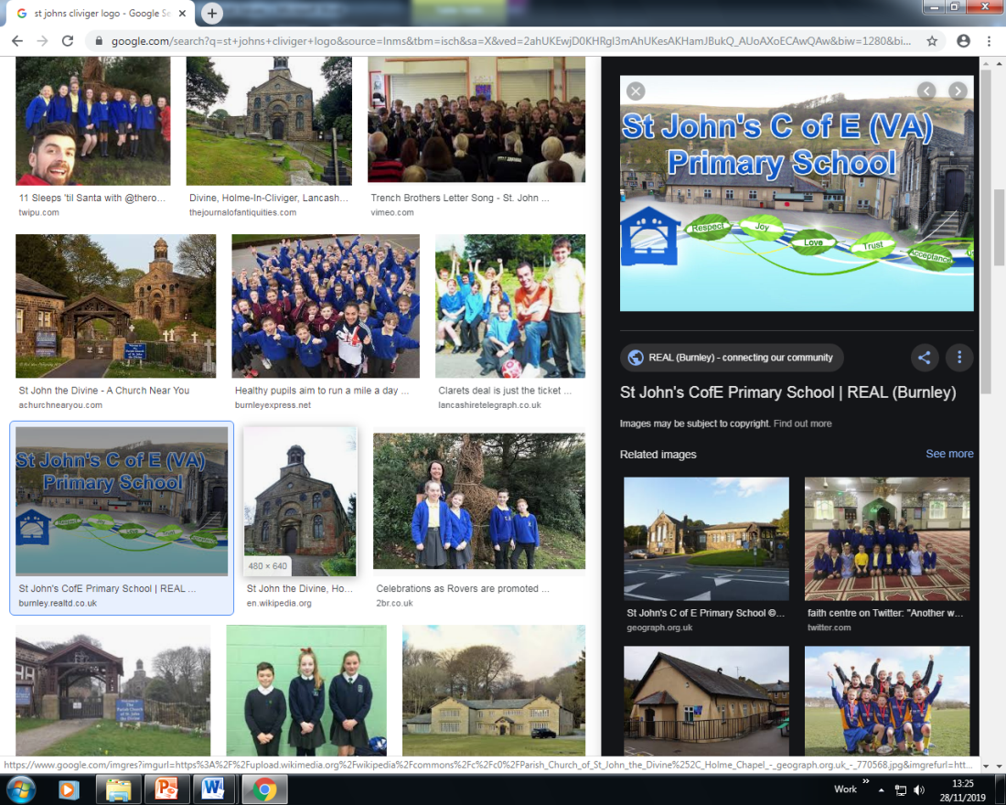 | Spiritual, Moral, Social & Cultural Audit Tool (SMSC)  SPIRITUAL DEVELOPMENT: Curriculum Subject: Maths_
The SPIRITUAL development of pupils is shown by their: |  |  | Curriculum Provision | Evidence of Impact on Pupils’ SPIRITUAL  Development
■ ability to be reflective about their own beliefs, religious or otherwise, that inform their perspective on life and their interest in and respect for different people’s faiths, feelings and values |  |  | Children learn about the world and different aspects of maths in the world. They relate mathematical concepts to their own lives, exploring subjects like money and time and how to gain a balance in their lives. Children think about moral dilemmas involving budgets and listen to people’s opinions on how to appraoch problems in different ways. | Pupil Voice  Lesson observations
■ sense of enjoyment and fascination in learning about themselves, others and the world around them |  |  | Children, from reception to year 6, play games involving maths helping them to learn. Technology is also used to strengthen enjoyment in maths. Children learn about numbers in different periods of history, such as Roman Numerals. Maths is also used within geography exploring climate, populations to name but a few.Concrete materials are used to allow children to explore maths in a range of ways. | Pupil Voice  Lesson observations
■ use of imagination and creativity in their learning |  |  | Much of the maths curriculum allows children to creatively problem solve. Pupils are asked to imagine word problems and draw pictures to show what is happening. A range of materials are available to be creative in the way they solve problems. | Resources available in class  Children’s feelings towards maths proble solving  Confidence in maths
willingness to reflect on their experiences. |  |  | Where mistakes are made in lessons, pupils are given opportunities to review their work and identify where they can correct their work, giving them greater independence as learners.  In EYFS, children learn through role play and making mistakes. | Books showing development  Pupil’s attitudes to mistakes and learning in maths

Spiritual, Moral, Social & Cultural Audit Tool (SMSC)

MORAL DEVELOPMENT: Curriculum Subject Maths
The MORAL development of pupils is shown by their: |  |  | Curriculum Provision | Evidence of Impact on Pupils’ MORAL  Development
■ ability to recognise the difference between right and wrong, readily apply this understanding in their own lives and, in so doing, respect the civil and criminal law of England |  |  | Discussions around fairness are had in maths lessons, for example sharing of items in division and equal parts in fractions. | - Lesson observations
■ understanding of the consequences of their behaviour and actions |  |  | The nature of mathematics lends itself very well to this looking at things like input and output machines and how the four operations cause a number to change. | - Pupil voice
interest in investigating and offering reasoned views about moral and ethical issues, and being able to understand and appreciate the viewpoints of others on these issues. |  |  | Opportunities are given for children to budget, for example, in Lego days to buy particular items for a value.  Chilren are invited to talk about different ways that they solved a problem and exploring which is the most efficient. They are always expected to respect each other in these conversations and appreciate that pupils have different ways of doing things. | Flashback and mental maths discussions.  Fluency Bees.

Spiritual, Moral, Social & Cultural Audit Tool (SMSC)

                - SOCIAL DEVELOPMENT: Curriculum Subject Maths
The SOCIAL development of pupils is shown by their: |  |  |  | Curriculum Provision | Evidence of Impact on Pupils’ SOCIAL  Development
■ use of a range of social skills in different contexts, including working and socialising with pupils from different religious, ethnic and socio-economic backgrounds |  |  |  | Children go to maths challenge days with other schools in which they problem solve together. | Pupil Voice
■ willingness to participate in a variety of communities and social settings, including by volunteering, cooperating well with others and being able to resolve conflicts effectively |  |  |  | Through the curriculum, pupils explore how to resolve conflicts when proportions aren’t fair. They apply their maths knowledge to helping raise money for their class charities each year. | Class Charities  Interaction with peers
acceptance and engagement with the fundamental British values of democracy, the rule of law, individual liberty and mutual respect and tolerance of those with different faiths |  |  |  | Throughout their maths journey, children learn to have freedom and choice over decisions. They learn about economies and how they can contribute monetarily to modern Britain. Every year is a building block to help them live in Britain with Brisith Values. | Lesson observations
 | and beliefs; the pupils develop and demonstrate skills and attitudes that will allow them to participate fully in and contribute positively to life in modern Britain.

Spiritual, Moral, Social & Cultural Audit Tool (SMSC)

CULTURAL DEVELOPMENT: Curriculum Subject Maths
The CULTURAL development of pupils is shown by their: |  |  | Curriculum Provision | Evidence of Impact on Pupils’ CULTURAL  Development
■ understanding and appreciation of the wide range of cultural influences that have shaped their own heritage and that of others |  |  | White Rose uses a range of characters in its material from different cultures. | - Book looks  - Pupil Voice
■ understanding and appreciation of the range of different cultures within school and further afield as an essential element of their preparation for life in modern Britain |  |  | The materials used to teach maths show a range of cultures. | Pupil Voice about learning materials
■ knowledge of Britain's democratic parliamentary system and its central role in shaping our history and values, and in continuing to develop Britain |  |  | Children learn that democracy comes from counting of votes and explore ration and proportion of this in Year 6. | Pupil Voice – understanding of democracy.
■ willingness to participate in and respond positively to artistic, sporting and cultural opportunities |  |  | Pupils explore personal bests of times and through word problems, understand achievements of travelling certain distances. | Book looks
■ interest in exploring, improving understanding of and showing respect for different faiths and cultural diversity, and the extent to which they understand, accept, respect and celebrate diversity, as shown by their tolerance and attitudes towards different religious, ethnic and socio- economic groups in the local, national and global communities |  |  | Teaching materials have characters from a range of cultures and backgrounds. | Pupil voice  Lessons

British Values

British Values: Curriculum Subject Maths
 | Understanding and knowledge expected of pupils as a result of schools promoting fundamental British values. |  |  |  | Curriculum Provision | Evidence of Impact on Pupils’ Understanding of  BRITISH VALUES
• an understanding of how citizens can influence decision-making through the democratic process;
• an appreciation that living under the rule of law protects individual citizens and is essential for their wellbeing and safety;
 | • an understanding that there is a separation of power between the executive and the judiciary, and that while some public bodies such as the police and the army can be held to account through Parliament, others such as the courts maintain independence;

• | an understanding that the freedom to choose and hold other faiths and beliefs is protected in law;
• | an acceptance that other people having  different faiths or beliefs to oneself (or having none) should be accepted and tolerated, and should not be the cause of prejudicial or discriminatory behaviour;
• | an understanding of the importance of identifying and combatting discrimination.
NB: It is not necessary for schools or individuals to ‘promote’ teachings, beliefs or opinions that conflict with their own, but nor is it acceptable for schools to promote discrimination against people or groups on the basis of their belief, opinion or background.

