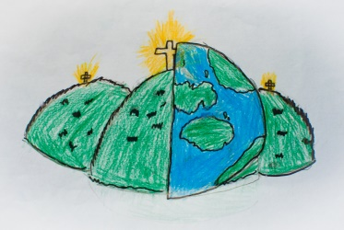

Hello, my name is Jane Blackston and I have been a member of staff at St John’s Cliviger since September 2016 and became a Governor in November 2020.

Prior to this, I ran my own Private Nursery, looking after children aged 0-5 for nine years. This was by far the most exhausting yet rewarding role I have ever undertaken. This followed a career in banking of 19 years that was both challenging and fun.

Being a mum of four and having worked in care and education for many years, I feel I have a wealth of experience to offer, supporting the school, children, my colleagues and families. I also love art, being creative and reading which is something I like to bring to the classroom and outdoors wherever possible.

I feel proud to be part of the Cliviger family who genuinely care for each and every individual. I am very privileged to work with many different year groups, supporting and encouraging the children to be the very best they can be.