 | 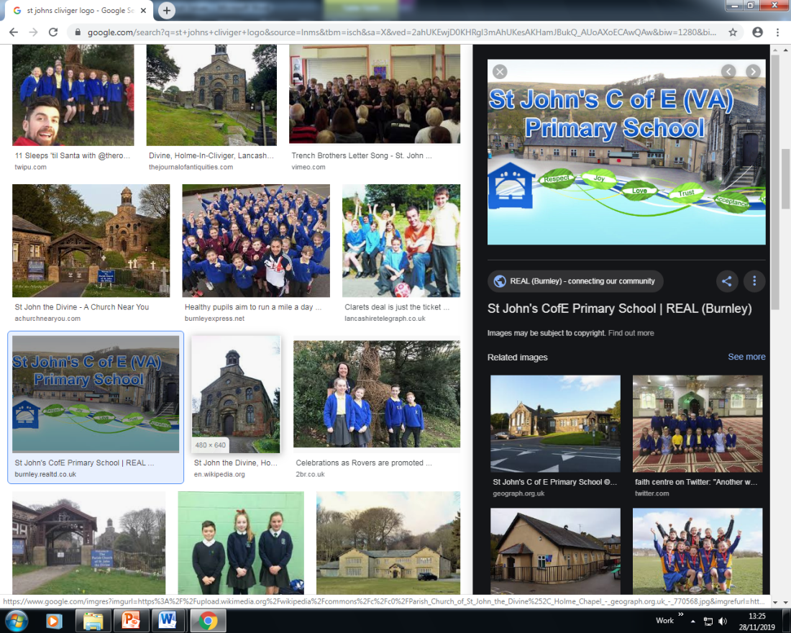 | Spiritual, Moral, Social & Cultural Audit Tool (SMSC)  SPIRITUAL DEVELOPMENT: Curriculum Subject: Music _
The SPIRITUAL development of pupils is shown by their: |  |  | Curriculum Provision | Evidence of Impact on Pupils’ SPIRITUAL  Development
■ ability to be reflective about their own beliefs, religious or otherwise, that inform their perspective on life and their interest in and respect for different people’s faiths, feelings and values |  |  | - Comparison of music between different religions. Celebrate different religions.  - Study music with spiritual or religious themes, issues raised by artists which concerns ethical issues.  - Explore emotions through creating own music  - Develop an awareness of the power that music has to make people think and act differently.  - Music from different periods of history e.g. the slave trade. | - Children have engaged in different workshops and have a clear understanding of music from different religions and cultures.  - They have an awareness of different religious celebrations and can recognise the impact of music as a part of this.
■ sense of enjoyment and fascination in learning about themselves, others and the world around them |  |  | - Learn about different cultural music – compare it with our own. This is done through the use of music express.  - The Bethany Project – the power music has to bring a community together.  - Rememberance Service – war songs. | - All children have access to music from different cultures/ countries e.g. reception – afrobeat drumming  - Remembrance performances and WW songs from this era provided children with the knowledge of what was happening at this time.
■ use of imagination and creativity in their learning |  |  | - The use of music in different subjects such as geography to remember countries.  - The use of songs in guided reading and the power and meaning of these words. | - The skills of composing are threaded throughout the music curriculum. This provides children with the elements of being creative  - Additionally cross curricular lessons such as creating artwork based on a piece of music combined both of these skills.
willingness to reflect on their experiences. |  |  | - Their own experiences of music. When they have heard songs/ musical pieces. E.g. the national anthem. | - Performaing and appraising provides children with opportunities to reflect and develop their own pieces of music/ performances.

Spiritual, Moral, Social & Cultural Audit Tool (SMSC)

MORAL DEVELOPMENT: Curriculum Subject Music
The MORAL development of pupils is shown by their: |  |  | Curriculum Provision | Evidence of Impact on Pupils’ MORAL  Development
■ ability to recognise the difference between right and wrong, readily apply this understanding in their own lives and, in so doing, respect the civil and criminal law of England |  |  | - The understanding of lyrics in songs. How this can express injustice etc. | - Year 2 piece of music – uniting the world through an orchestra. An understanding of ‘unite’ provides the children with the knowledge of respect and understanding.
■ understanding of the consequences of their behaviour and actions |  |  | - During performances children develop an understand of relevant and appropriate behaviours for each performance. | - There are performances threaded throughout the year and this provides children with the opportunities to develop their behaviour and performance skills.
interest in investigating and offering reasoned views about moral and ethical issues, and being able to understand and appreciate the viewpoints of others on these issues. |  |  | - How viewpoints have changed over time, the meanings of songs and how they can appreciate why groups of people and communities.  - How viewpoints have changed over time regarding ethical issues and how this can be expressed through music. | - . Groups such as the Bethany Project and having an understanding of their lives and issues surrounding people in their culture has given children an understanding of others.

Spiritual, Moral, Social & Cultural Audit Tool (SMSC)

                - SOCIAL DEVELOPMENT: Curriculum Subject Music
The SOCIAL development of pupils is shown by their: |  |  |  | Curriculum Provision | Evidence of Impact on Pupils’ SOCIAL  Development
■ use of a range of social skills in different contexts, including working and socialising with pupils from different religious, ethnic and socio-economic backgrounds |  |  |  | - Contact with outside agencies to promote their religions through music e.g. Islamic visitors  - World Faith Day  - The Bethany Project  - Lancashire Music Service | - WOW worship and BYT provides children with the skills and opportunities to develop their social skills in communicating and engaging with others.  - Performances around cultural issues, historic events or celebrating diversity have shown to demonstrate children’s understanding and empathy for others.
■ willingness to participate in a variety of communities and social settings, including by volunteering, cooperating well with others and being able to resolve conflicts effectively |  |  |  | - Grandparents performance of Rememberance Songs  - Elders afternoon  - Grandparents performance of Christmas Shows  - Christmas Fayre performance | - The children want to perform and show their performances to others.  - They willingly engage and participate in different events.
acceptance and engagement with the fundamental British values of democracy, the rule of law, individual liberty and mutual respect and tolerance of those with different faiths |  |  |  | - Visits and visitors  - The Bethany Project  - Christmas Shows  - Elders performance  - Carol Service  - Harvest service  - Burnley’s Gotta Sing  - Young Voices | - The children represent school well in performances. They demonstrate their understanding of right and wrong and show they have a clear moral compass.
 | and beliefs; the pupils develop and demonstrate skills and attitudes that will allow them to participate fully in and contribute positively to life in modern Britain.

Spiritual, Moral, Social & Cultural Audit Tool (SMSC)

CULTURAL DEVELOPMENT: Curriculum Subject Music
The CULTURAL development of pupils is shown by their: |  |  | Curriculum Provision | Evidence of Impact on Pupils’ CULTURAL  Development
■ understanding and appreciation of the wide range of cultural influences that have shaped their own heritage and that of others |  |  | - Rememberance Service  - WW songs  - Young Voices – songs from different cultures. | - They show empathy and understanding of others and can clearly discuss influences from their own heritage.
■ understanding and appreciation of the range of different cultures within school and further afield as an essential element of their preparation for life in modern Britain |  |  | - Opportunities to celebrate different cultures – Bethany Choir  - World Faith Day  - Listening to music from different cultures and make comments – creating our own opinions. | - Children make comments on their opinion of music from different cultures.  - Children celebrate different cultures
■ knowledge of Britain's democratic parliamentary system and its central role in shaping our history and values, and in continuing to develop Britain |  |  | - Rememberance service  - National anthem  - The King’s Coronation | - A good understanding of the impact of songs, the drawing together of the community through commonly known songs such as the national anthem.
■ willingness to participate in and respond positively to artistic, sporting and cultural opportunities |  |  | - Respond to musical and cultural opportunities  - Nativity performances  - Class and Collective worships  - Charity Assembly’s  - The Olympics  - Anti-Bullying week | - The children want to perform and show their performances to others.  - They willingly engage and participate in different events.  - Families support us through this and thus the children respond positively.
■ interest in exploring, improving understanding of and showing respect for different faiths and cultural diversity, and the extent to which they understand, accept, respect and celebrate diversity, as shown by their tolerance and attitudes towards different religious, ethnic and socio- economic groups in the local, national and global communities |  |  | - Extra curricular activities – Choir  - Musical Instrument lessons  - Performances outside of school  - Burnley’s Gotta Sing  - Young Voices  - Elders’ afternoon tea  - Rememberance performance | - The children know that their contribution to performances, events and singing has an impact on those around them.  - They are excited and engaged when an event such as he carol service is coming up.

British Values

British Values: Curriculum Subject Music
 | Understanding and knowledge expected of pupils as a result of schools promoting fundamental British values. |  |  |  | Curriculum Provision | Evidence of Impact on Pupils’ Understanding of  BRITISH VALUES
• an understanding of how citizens can influence decision-making through the democratic process; |  |  |  |  | - Decision making is embedded throughout the music topics.  - Children make decisions around performances both in class, key stage and whole school.  - Through pupil voice children have an opportunity to influence decisions around the formats and activities. | - Children have shown to clearly enjoy performances and the decisions made within these.  - Pupil voice shows a positive attitude towards music.
• an appreciation that living under the rule of law protects individual citizens and is essential for their wellbeing and safety;
 | • an understanding that there is a separation of power between the executive and the judiciary, and that while some public bodies such as the police and the army can be held to account through Parliament, others such as the courts maintain independence;

• | an understanding that the freedom to choose and hold other faiths and beliefs is protected in law; | - Units and performances celebrate differences in beliefs and the chidlren have a positive attitude towards this. | - Projects such as ‘celebrating me’ have shown a positive attitude to and from all members of our community.
• | an acceptance that other people having  different faiths or beliefs to oneself (or having none) should be accepted and tolerated, and should not be the cause of prejudicial or discriminatory behaviour; | - A combination of units, performances and projects have shown an acceptance and celebration of other faiths and beliefs. | - The children’s positive interest on WOW worship day and drumming day have shown that the children celebrate and accept other faiths and beliefs.
• | an understanding of the importance of identifying and combatting discrimination. | - Units and performances show the importance of accepting rather than discriminating.  - The chidlren having opportunities to celebrate differences in beliefs and the opportunity to explore their sense of self has been important for the children. | - Projects such as ‘celebrating me’ have shown a positive attitude to and from all members of our community.
NB: It is not necessary for schools or individuals to ‘promote’ teachings, beliefs or opinions that conflict with their own, but nor is it acceptable for schools to promote discrimination against people or groups on the basis of their belief, opinion or background.

