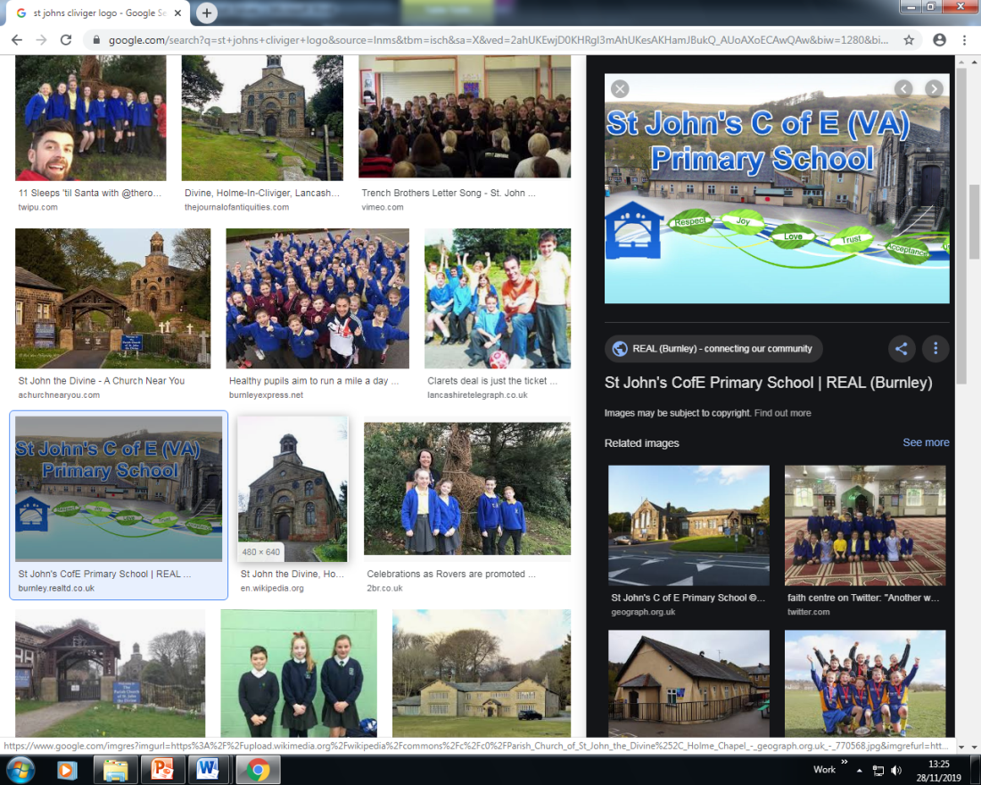 |  | Spiritual, Moral, Social & Cultural Audit Tool (SMSC)  SPIRITUAL DEVELOPMENT: Curriculum Subject - Religious Education
The SPIRITUAL development of pupils is shown by their: |  |  | Curriculum Provision | Evidence of Impact on Pupils’ SPIRITUAL  Development
■ ability to be reflective about their own beliefs, religious or otherwise, that inform their perspective on life and their interest in and respect for different people’s faiths, feelings and values |  |  | - Provision is made for studying Christianity and world faiths on a formal weekly basis.  - Blackburn Diocese Syllabus “Questful RE” supplemented by “Understanding Christianity”.  - Cross-curricular links used to develop Christian values. | - Children are able to articulate their views on different faiths and beliefs and responses and opinions are evidenced in RE books and worship journals.  - Through the delivery of Questful RE, children are given the opportunity to obtain a comprehensive understanding of Christianity.
■ sense of enjoyment and fascination in learning about themselves, others and the world around them |  |  | - Through a range of teaching and learning approaches including visits and visitors e.g. Bethany Children Gospel Choir, Blackburn Cathedral, Burnley Faith Centre.  - School Council  - Class Charities  - Ambassadors for each subject to build leadership qualities. | - Responses to visitors ie. Bethany Children, Bishop’s appeal, Burnley Faith Centre. Evidence in class journal.  - Children show understanding of the world around them and can use this in their lessons.  - Chn take care of their school environment and things in it.
■ use of imagination and creativity in their learning |  |  | - Adventurous Afternoons Curriculum.  - Nativity shows.  - Music in worship.  - Carols at the Cathedral  - Burnley Churches Together Carol Concert. | - Children use these areas for reflection and prayer.  - EYFS/KS1 children enjoy participating in nativity performances to parents and develop confidence.  - Children show enthusiasm and enjoyment when taking part in music in worship. They can discuss favourite pieces of music and give reasons for their choice.  - Children are involved in the wider community.
willingness to reflect on their experiences. |  |  | - Whole school journal to enable pupils to respond to worship.  - Class journals to record pupil voice and response.  - School Council. | - Children are confidence to share their experiences of worship.  - Children discuss their experiences and learning at home (evidenced in parent view obtained at RE Family Friday.

ECM Education- Spiritual, Moral, Social & Cultural Audit Tool (SMSC)

MORAL DEVELOPMENT: Curriculum Subject Religious Education
The MORAL development of pupils is shown by their: |  |  | Curriculum Provision | Evidence of Impact on Pupils’ MORAL  Development
■ ability to recognise the difference between right and wrong, readily apply this understanding in their own lives and, in so doing, respect the civil and criminal law of England |  |  | - 3 golden School Rules – safe, ready, respect.  - Behaviour policy is child centred.  - Rewards and praise in place for ‘Everyday is a new day’  - Exploring Christian values.  - Studying the Bible.  - Visits and visitors e.g. local Magistrates Court, firepersons and the Police. | - Children can articulate their awareness of the impact of the school behaviour policy e.g. recognition board.  - Children strive to achieve rewards by applying the 3 golden rules and Bible scripture in their own daily life.  - Children can talk about Bible stories and explain how these can provide message and teachings for them to apply in their own life.  - Children understand the rule of law.
■ understanding of the consequences of their behaviour and actions |  |  | - 3 golden School Rules – school Bible scripture.  - Rewards and praise in place.  - Visit from PCSO.  - Use of key role models in RE lessons. | - Children strive to achieve rewards by applying school behaviour policy in their own daily life.  - Children understand the rule of law.
interest in investigating and offering reasoned views about moral and ethical issues, and being able to understand and appreciate the viewpoints of others on these issues. |  |  | - Opportunities are provided for visitors of Christian and non-Christian faiths to explain to pupils their faith and beliefs.  - Visits and visitors.  - Faith friends. | - Children are confident to contribute to discussions and debates about moral and ethical issues.  - Children understand and appreciate the views of others and value different views from their own.  - Children are inquisitive and ask questions to find out more – understand that knowledge is key.

ECM Education- Spiritual, Moral, Social & Cultural Audit Tool (SMSC)

SOCIAL DEVELOPMENT: Curriculum Subject Religious Education
The SOCIAL development of pupils is shown by their: |  |  |  |  |  | Curriculum Provision | Evidence of Impact on Pupils’ SOCIAL  Development
■ use of a range of social skills in different contexts, including working and socialising with pupils from different religious, ethnic and socio-economic backgrounds |  |  |  |  |  | - Opportunities are provided for visitors of Christian and non-Christian faiths to explain to pupils their faith and beliefs.  - Lancashire Equality Badges  - Diversity Team. | - Children took part in inter-faith activities and are interested to learn about different faiths.  - Children are curious and interact with our Faith Friends respectfully.
■ willingness to participate in a variety of communities and social settings, including by volunteering, cooperating well with others and being able to resolve conflicts effectively |  |  |  |  |  | - Opportunities are provided for pupils to visit the local community and social settings including the links with local charities.  - Participation in community events held by the school e.g. Remembrance afternoon tea for the elders.  - Use of ‘Picture News’ resources to encourage discussion of topical issues.  - EYFS – role play opportunities.  - Other Key Stages involved in discussion and debating as part of the curriculum.  - Diversity Team.  - School Council Group.  - Family Fun Friday events.  - Class worships delivered to parents and friends.  - Participation in ‘Sing Together’ at Blackburn Cathedral | - Food was donated to the Burnley Food Bank Centre at harvest.  - Children participated in Burnley Churches Together Carol Concert with other schools.  - School Council representatives meet regularly.  - Family Fun Friday events provide opportunities for children and families to meet together.
acceptance and engagement with the fundamental British values of democracy, the rule of law, individual liberty and mutual respect and tolerance of those with different faiths |  |  |  |  |  | - Visits and visitors.  - Studying world faiths within RE lessons/units.  - Adventurous Afternoons curriculum has key roles models planned to show values in action.  - Diversity Team meetings.  - Picture news. | - Children develop a good knowledge and understanding of the beliefs and faiths of other individuals.  - Children demonstrate understanding and tolerance towards others.  - Children are able to respond to current issues and news items through the use of Picture News – evidence worship journal.  - Participation in class charity fundraising events.
 | and beliefs; the pupils develop and demonstrate skills and attitudes that will allow them to participate fully in and contribute positively to life in modern Britain.

ECM Education- Spiritual, Moral, Social & Cultural Audit Tool (SMSC)

CULTURAL DEVELOPMENT: Curriculum Subject - Religious Education
The CULTURAL development of pupils is shown by their: |  |  | Curriculum Provision | Evidence of Impact on Pupils’ CULTURAL  Development
■ understanding and appreciation of the wide range of cultural influences that have shaped their own heritage and that of others |  |  | - Study of Christianity and world faiths.  - Visits and visitors.  - Diversity Team  - Adventurous Afternoons curriculum has key roles models planned to show values in action.  - Awareness and celebration of individuals in our school family  - Lancashire Equality Badges – Race, Disability and Religion and Belief. | - Children develop a good knowledge and understanding of the beliefs and faiths of other individuals.  - Children demonstrate understanding and tolerance towards others.  - Worship badges – 2 faiths so feel included.
■ understanding and appreciation of the range of different cultures within school and further afield as an essential element of their preparation for life in modern Britain |  |  | - Lancashire Equality Badges – Race, Disability and Religion and Belief.  - Diversity Team  - Picture news.  - Visits and visitors.  - Provision for study of Christian values. | - Children are able to respond to current issues and news items through the use of Picture News – evidence in class worship journal.  - Children are aware of the Christian values and demonstrate an awareness of how to apply these in their own lives.
■ knowledge of Britain's democratic parliamentary system and its central role in shaping our history and values, and in continuing to develop Britain |  |  | - School Council.  - Visits by PCSO.  - Visit to places of worship e.g. Mosque and Gurdwara Temple. | - Children demonstrate an understanding of the democratic system during school council meetings and debates.  - Children are equipped with knowledge and understanding of the different places of worship and why they are important to communities in our area.
■ willingness to participate in and respond positively to artistic, sporting and cultural opportunities |  |  | - Participation in local school sporting competitions.  - Burnley Youth Theatre Projects  - Nativity shows.  - Music in worship.  - Carols at the Cathedral  - Burnley Churches Together Carol Concert. | - Children make links with other local schools whilst taking part in sporting events.  - Children can take part in drama and demonstrate  - All classes and demonstrated, displayed and performed in BYT projects e.g. Woven Through Time.
■ interest in exploring, improving understanding of and showing respect for different faiths and cultural diversity, and the extent to which they understand, accept, respect and celebrate diversity, as shown by their tolerance and attitudes towards different religious, ethnic and socio- economic groups in the local, national and global communities |  |  | - Visits to other schools and local enterprises to take part in activities.  - Visits and visitors.  - Burnley Together clothing and toy drop.  - Bishop’s Harvest Appeal.  - Class Charities  - Lancashire Equality Mark – socioeconomic badge. | - Children are keen to find out about different faiths and have requested more displays around school to reflect other faiths.  - Children have been able to experience diversity of other cultures whilst attending other schools as part of the SWAT project.  - Children are active participants to making a change e.g. supporting St Matthew’s.

ECM Education- British Values

British Values: Curriculum Subject - Religious Education
 | Understanding and knowledge expected of pupils as a result of schools promoting fundamental British values. |  |  |  | Curriculum Provision | Evidence of Impact on Pupils’ Understanding of  BRITISH VALUES
• an understanding of how citizens can influence decision-making through the democratic process; |  |  |  |  | - Pupil voice.  - Group discussions during teaching of RE.  - Diversity Team  - Promotion of speaking and listening skills during teaching of RE. | - Children play an effective role in groups within school I.e. school council, worship committee.  - Children are able to take part in debates during lessons e.g. taking on the role of Judas.
• an appreciation that living under the rule of law protects individual citizens and is essential for their wellbeing and safety; |  |  |  |  | - Visits and visitors.  - 3 golden school rules.  - Discussion opportunities. | - Children understand the concept of ‘right’ and ‘wrong’.  - Children can articulate the behaviour expected and explain why it is needed.
 | • an understanding that there is a separation of power between the executive and the judiciary, and that while some public bodies such as the police and the army can be held to account through Parliament, others such as the courts maintain independence; |  |  |  | - Visits to school by PCSO and fire persons. | - Children can ask relevant questions which demonstrate an understanding of the role of Police in society.

• | an understanding that the freedom to choose and hold other faiths and beliefs is protected in law; | - Study of Christianity and world faiths.  - Picture news.  - Burnley Faith Centre | - Children show respect for visitors of other faiths and are curious about their beliefs.  - Children are able to hold debates arising from issues raised in Picture News – evidence is recorded in worship journal.
• | an acceptance that other people having  different faiths or beliefs to oneself (or having none) should be accepted and tolerated, and should not be the cause of prejudicial or discriminatory behaviour; | - Study of Christianity and world faiths.  - Picture news.  - 3 golden school rules.  - Teachings of Christian values. | - Children learn about other faiths around the world.  - Children show respect for visitors of other faiths and are curious about their beliefs.  - Children are aware of current news issues and the situation with regard to refugees.
• | an understanding of the importance of identifying and combatting discrimination. | - School rules and taking responsibility for own actions.  - Visits and visitors.  - RE lessons.  - Lancashire Equality Mark/Badges | - Children can explain the times when they have observed discrimination in the media and can articulate why this is wrong.  - Children can talk about some Bible stories which identify times when discrimination has taken place.
NB: It is not necessary for schools or individuals to ‘promote’ teachings, beliefs or opinions that conflict with their own, but nor is it acceptable for schools to promote discrimination against people or groups on the basis of their belief, opinion or background.

