
Colour the box when you have completed the activity. Choose a different one each time.
Write a review of the book as if it was your job.  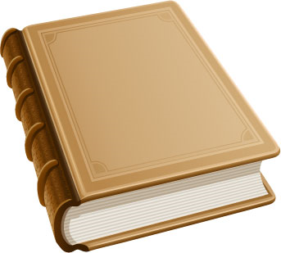 | Write about your favourite part of the book and say why you liked it. | 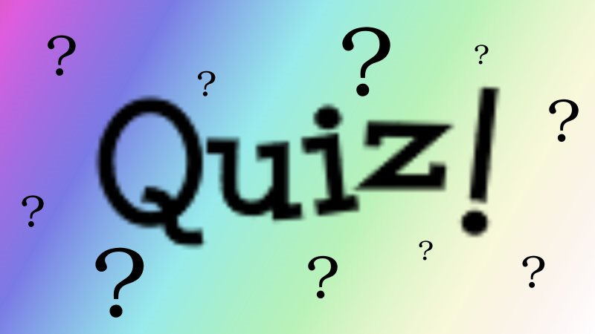  Create a quiz about this book and get other members of your group to complete it. |  | Create a PowerPoint presentation of the book for younger children. | Using ideas from the text, make a TRUE/FALSE quiz for a friend | Write about which part of the text is the most important and why.
Make a list of the facts you have learned from reading this book. | Choose one fact and find out more about it on the internet. | Design a  t-shirt for the main topic in the book. |  | 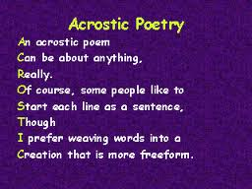  Write an ACROSTIC for the main topic. | Design a new cover for the book. | Draw an illustration for a section of the book.
Who is the author?  Find out more about them and make a list of other books they have written. Find one to compare. | Write a summary of the book in no more than 100 words. | Write your opinion of an issue in the book |  | Make a poster about the book. Include the title and author’s name. | Write a poem about an issue in the text. | Write a letter  to the author asking at least three questions about how they found their information.  ???

Pretend you are a  Colour the box when you have completed the activity. Choose a different one each time.  literary critic giving a  radio broadcast about  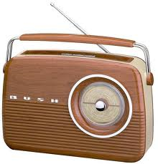  the book. How would you rate it? Would you advise children to read it? Why? | Draw a picture of your favourite part of the book and explain why you picked it | Pick 10 adjectives from the text and create a wordsearch!  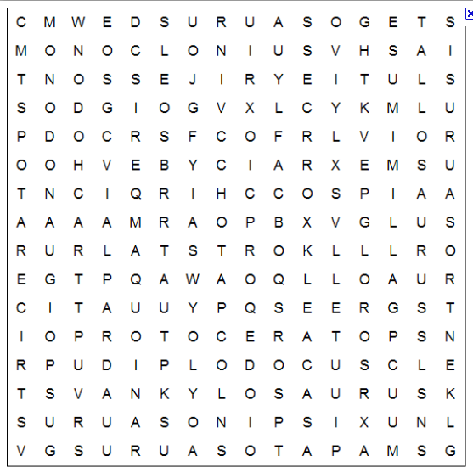 |  | Write about your favourite part of the book and say why you liked it. | Produce a mind map of the topics in the book to show how they are linked.  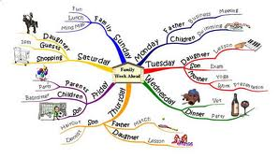 | Find features of the text which support the reader’s understanding of a non fiction text (e.g. sub-headings).
Make a poster to advertise the book you have read. Say why people should read it. | Make a list of five titles that would make a better title for your book. | Choose a section of the book and rewrite for a younger audience. |  | Find other books dealing with the same topic and list similarities and differences. | Find some phrases you like. Explain why you like them. | Turn information into a Flow Chart or set of instructions.
Make a bookmark about topics in your book.  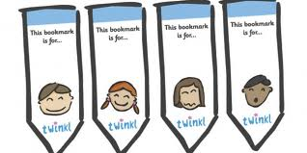 | Write the blurb for the book’s back cover.  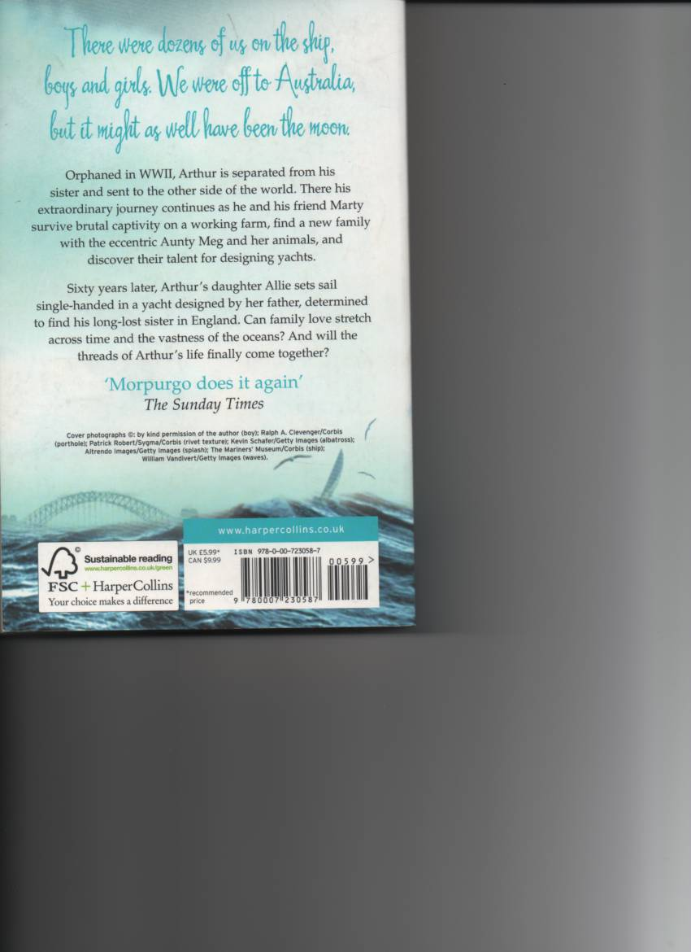 | Use program  www.wordle.net  to create a collage of words and/or  pictures to go with your book.  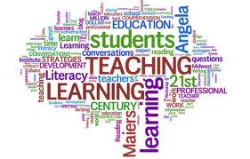 |  | Make an information page about a topic in your book. Include effective features of the text type. | Make a bank of effective paragraph openers and group them with sub-headings. | Write 5 questions to ask the rest of your group about the book.  ?????

