
Colour the box when you have completed the activity. Choose a different one each time.
How do you think a character was feeling when something happened in the story that they didn’t expect?  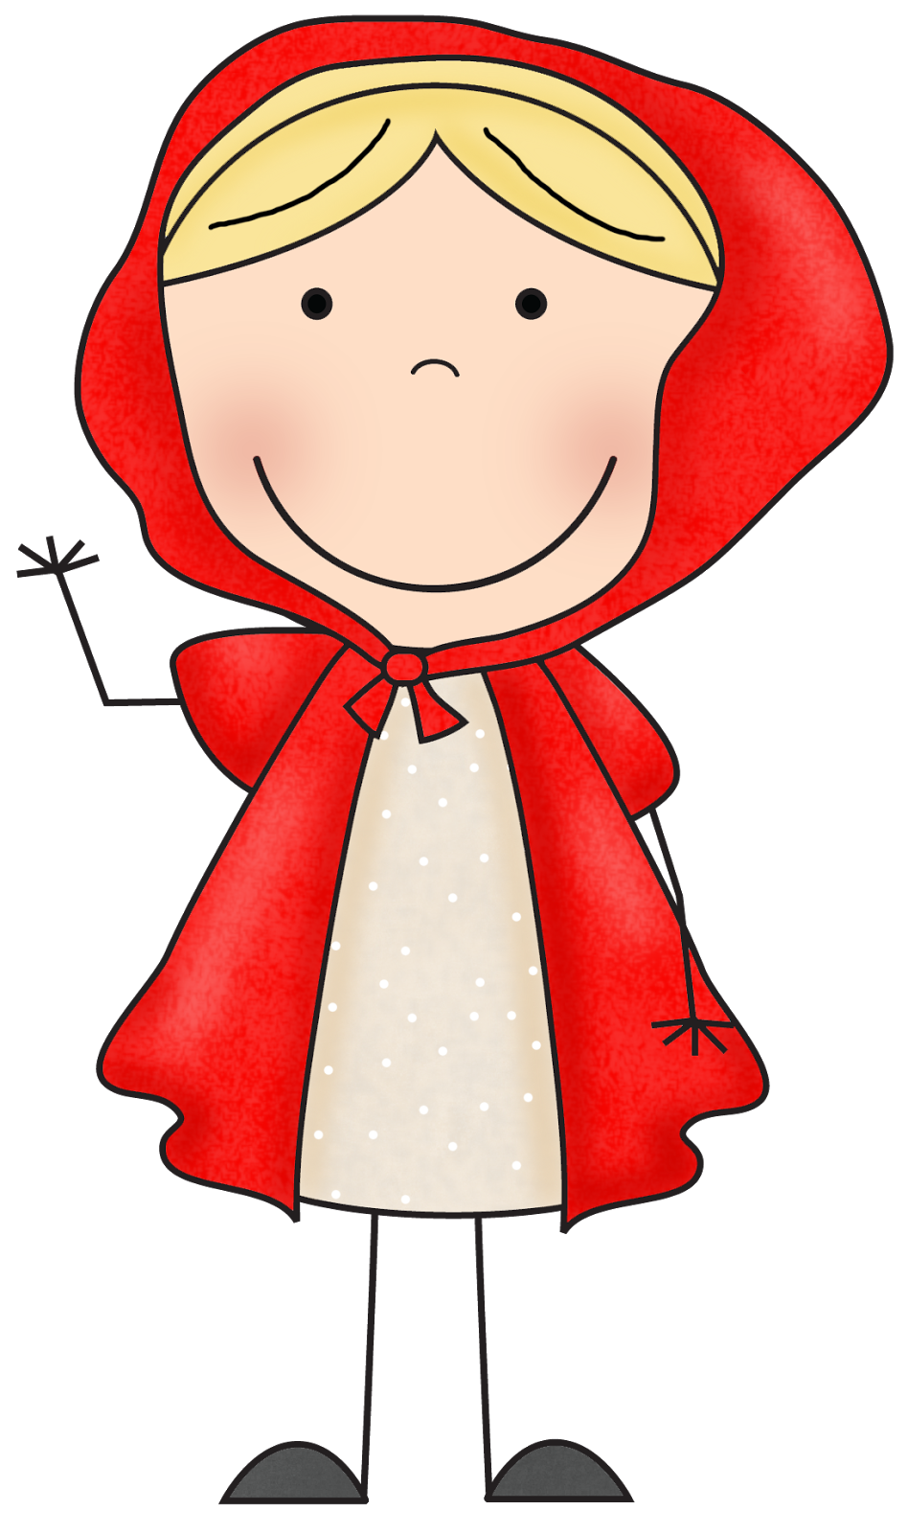  1d |   Look at the front cover. What do you think will happen in the story?  1e | List all the characters in the story.  1b  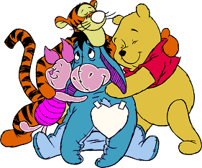 |  | Find 5 nouns in the story. Can you make them into plural nouns?  1a | Choose a character from the story. Make a list of what you think they would like and dislike.  1d  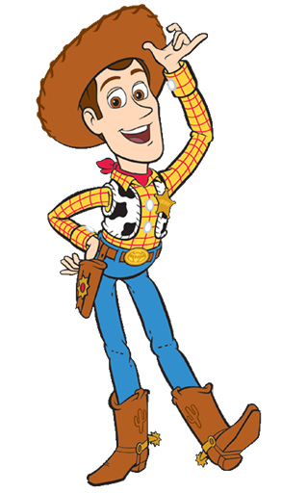 | Draw a story map to show the events in the story. 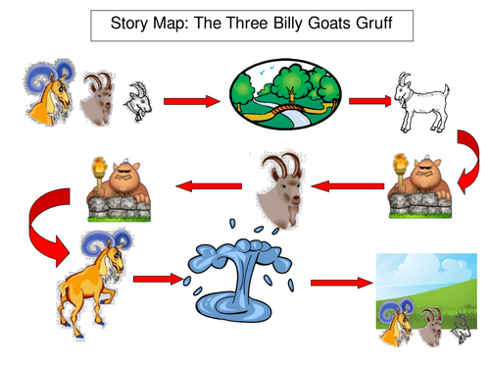  1c
Write down three questions you want to ask a character. Now try and write their answers.  ? ? ? | List the events in your story in the right order. | Choose a character from the story. Write down three things the author says about this character.  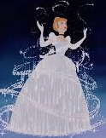 |  | Write a letter to the main character telling them what the other characters think of them and why.    1d | Draw and label a picture of a setting from the story. Copy words and phrases from the story to describe the setting.  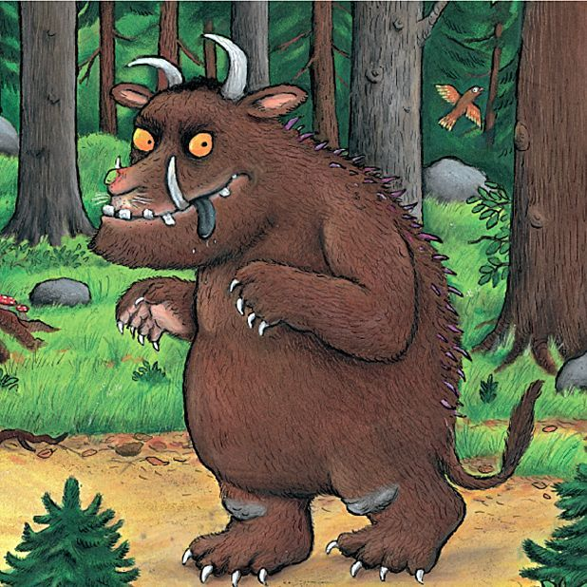  1d  1c  1b  1a  1d | Using speech bubbles, write a conversation between 2 characters in the story.
Make a fact sheet about things you have learned from the story.  1b | Pretend you are one of the characters. Write a diary entry for everything that happened on one day.  1b | Find 5 words hiding inside other words in the story.  1a  together  to get her |  | 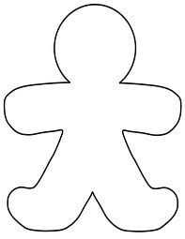  Draw an outline of a character. On the inside, choose words that tell the reader about their personality.  1d | Retell the story in your own words.  1c | Find 5 words with prefixes and use them in new sentences.  1a

Write a letter from one character to another. Explain where you got your evidence for  your ideas.  1b | Write three different titles for the book and explain why you have chosen these.  1d | Find 5 interesting words and use them in new sentences.  1a |  | Write about your favourite part of the story and say why you liked it.  1d | Produce a story mountain:  - opening  - build up  - dilemma  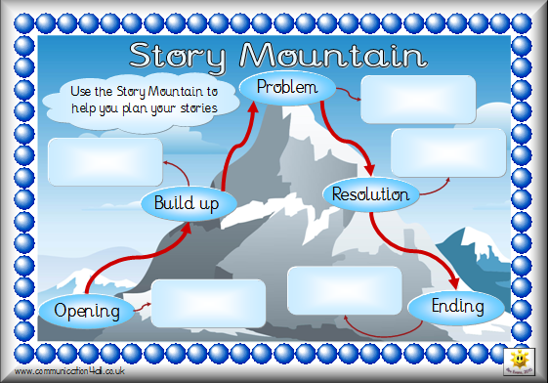  - resolution  1c | Create a list of key words from the text and write a glossary.  1a
Think of what might have happened before the story started and write down your ideas.  1e | Who are the main characters in the story?  1b  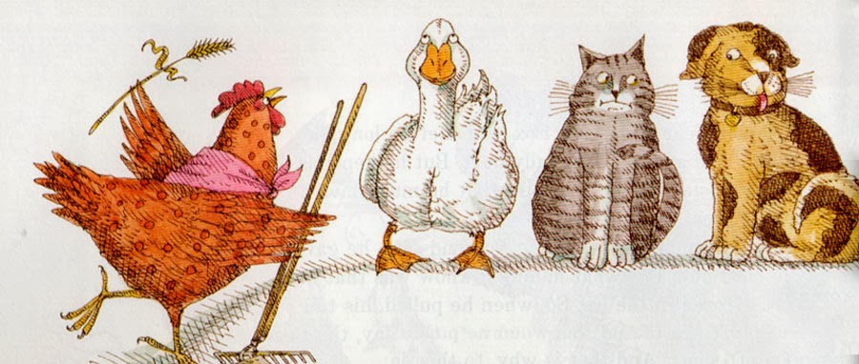 | Choose a section of the story and retell it to a friend.  1c |  | Find 5 words that are difficult to spell and highlight the tricky part of each word.  1a | Write down three things you have learned about a character. Justify your ideas with evidence from  the text.  1b | Imagine that a character is in the Hot Seat. Write questions you would want to ask.  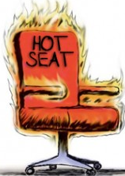  1b
Where is the story set?  1b  Draw and label a picture of a setting from the story. | Make two lists of good and bad characters from the story. Choose one and say more about them.  1d | Find words and phrases that create a picture of the character in your mind.  1a |  | Make a bookmark about events in your book in the order they happened.  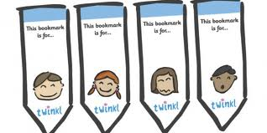  1b | Choose 5 words from the story ending in –ing or –ed and find the root word. What other words can you make?  1a | Create a True/ False quiz about the story and try it out on a friend.  1b

