
Find a key point in the story and consider how a character felt at that moment. Write down how you know.  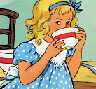  2d | 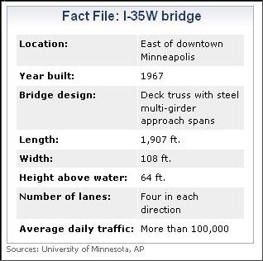  Make a fact file poster about a character.  2d | Draw a timeline of events in the story.  2b |  | Find words and phrases that effectively describe a setting.  2g |   Using ideas from the text, make a TRUE/FALSE quiz for a friend.  2f | Write a summary of the story in no more than 100 words.  2c
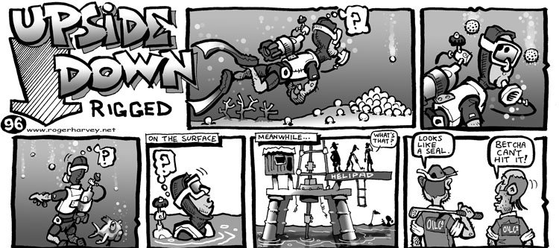  Make a cartoon strip showing the turning point in the story. |   Write a newspaper report of an event in your story. |   Compare 2 characters in your story.    How are they similar?  How are they different? |  | Write a letter to the main character telling them how they affect other characters in the story.    2d  2c  2b  2d  2a  2d | Find 5 adjectives from your text. Replace them with alternatives – do they still work? | Using speech bubbles, write a conversation between 2 characters in the story.
Write a new chapter for the story based on events so far.   | Retell an event in the story from the point of view of another character. | Find 10 words within words in your text. |  | Write a letter to another character asking at least three questions about something they have said or done.  2d | Find examples of dialogue in the story. How does the dialogue support your understanding of events or characters?  2e  2d  2a  2f  2a | Find 5 words with either prefixes or suffixes and identify the roots. Find 2 more examples for each root.

Pretend you are a  literary critic giving a  radio broadcast about    the story. How would you rate it? Would you advise children to read it? Why?  2g | Write a diary entry about an event from a character’s point of view. | pick 10 effective words from the story and create a wordsearch!  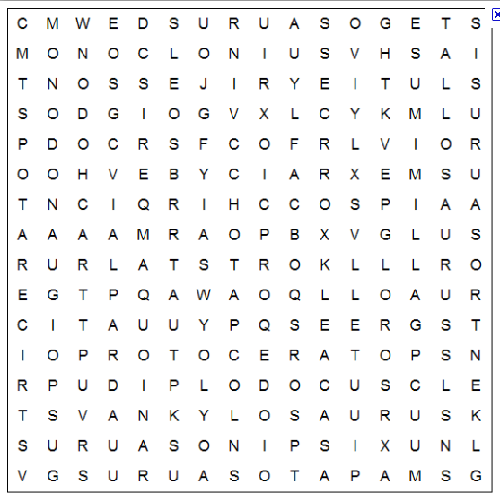 |  | Write about your favourite part of the story and say why you liked it.  2d | Produce a story mountain:  - opening  - build up  - dilemma  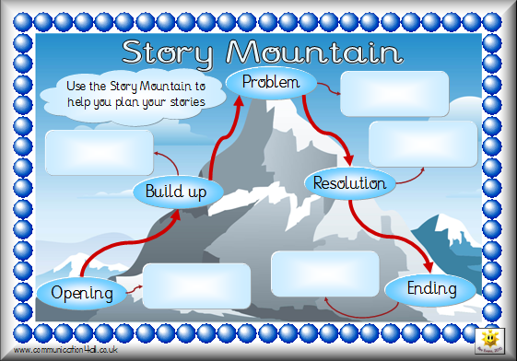  - resolution  2d  2a  2c |   Predict what will happen next in the story.  2e
Write a formal letter complaining about one of the characters in the story. | Identify where the author has created a setting. How effective is the description and why? | Choose a section of the story and rewrite for a younger audience. |  | Find 5 words with suffixes and list them. Write definitions for the meaning of the suffixes.  2d  2b  2d  2a | Write down three things you have learned about a character. Justify your ideas with evidence from  the text.  2b  2a | Create a list of key words from the text and produce a glossary.
Look at the different types and lengths of sentences used. How does this support the reader’s understanding? | write the blurb for the book’s back cover.  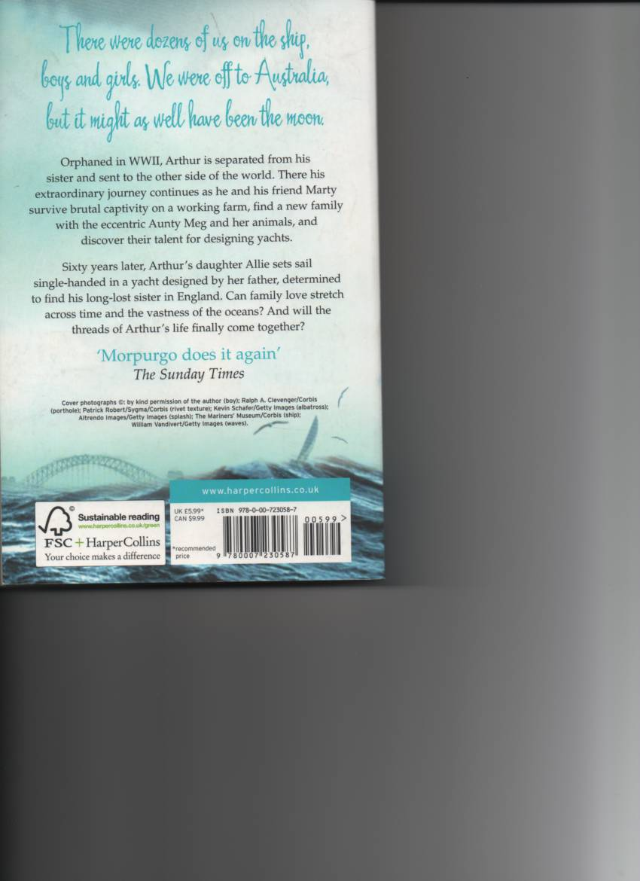 | Find words and phrases that effectively describe a character. |  | Make an information page about a character in your story. Include effective features of the text type.  2f  2c  2g  2bg | Write a back story of a minor character up to the point when they are introduced into  the story.  2d | Write 5 questions to ask the rest of your group about the book.  ?????  2b

Make a bookmark about events in your book in the order they happened.  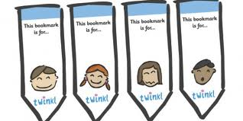 | Write a new ending for the book so that something else happens. | Use program  www.wordle.net  to create a collage of words and/or  pictures to go with your story.   |  | Imagine that a character is in the Hot Seat. Write questions you would want to ask.  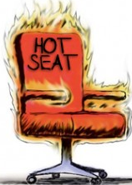  2b | Find an issue or dilemma in the story and make FOR and AGAINST lists.  2b  2d  2a  2d  2a | Find five verbs in the story then add adverbs to make them more interesting.
pick 10 effective words from the story and create a crossword!  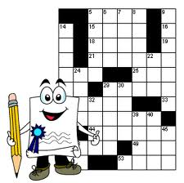  2a | Find  multi-clause sentences in your story and identify the main clause.  2f | Find a description of a setting. What impression is the author trying to create?  2g |  |   Label a Role on the Wall with words and phrases the author uses to describe a character.  2b | Find 5 words with prefixes and list them. Write definitions for the meaning of the prefixes.  2a | Write a school report for a character.  2d
  Make a list of words from the story and place them on a zone of relevance target.  2g | Produce a mind map of the characters in the story to show how they are linked.  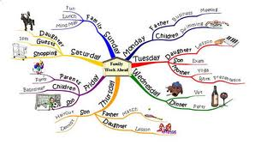  2b | Rewrite a section of the story from an alternative point of view.  2d |  | Rewrite a chapter in your own words.  2c | Write a letter from one character to another. Explain where you got your evidence for  your ideas.  2d | Predict what will happen next in the story.  2e

