 | 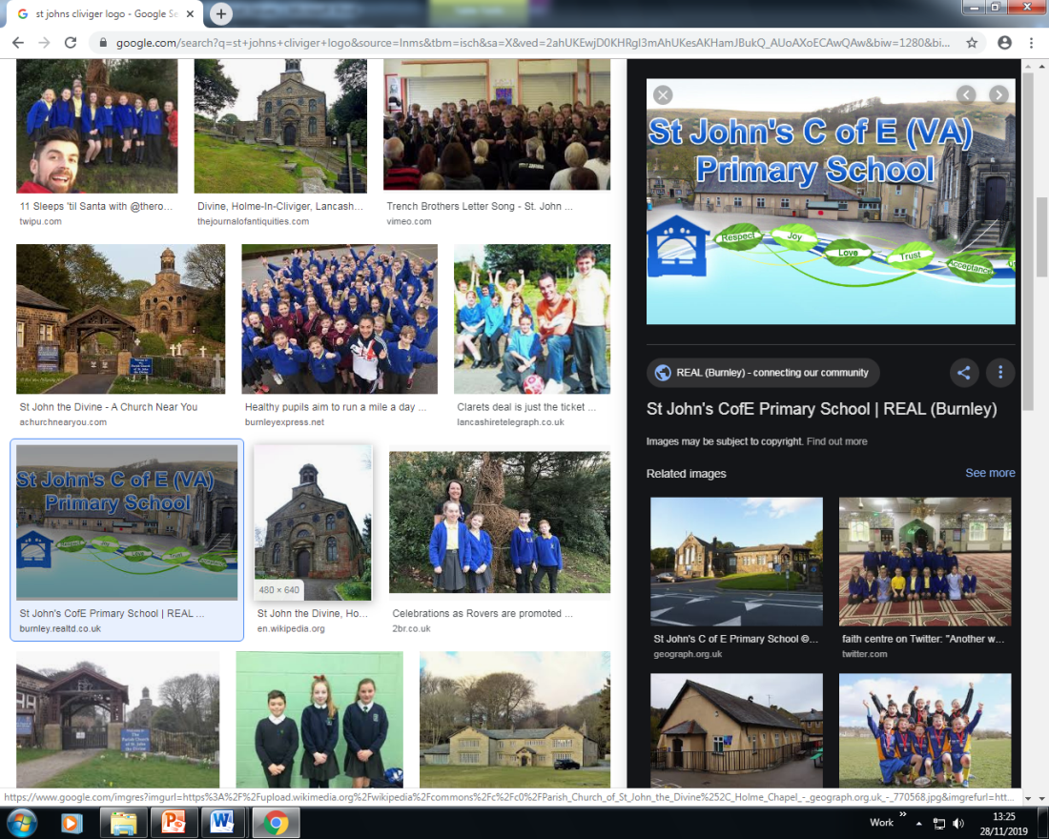 | ECM Education- Spiritual, Moral, Social & Cultural Audit Tool (SMSC)  SPIRITUAL DEVELOPMENT: Curriculum Subject - Science
The SPIRITUAL development of pupils is shown by their: |  |  | Curriculum Provision | Evidence of Impact on Pupils’ SPIRITUAL  Development
■ ability to be reflective about their own beliefs, religious or otherwise, that inform their perspective on life and their interest in and respect for different people’s faiths, feelings and values |  |  | - Encourages pupils to reflect on the natural world and to examine their response to nature i.e. awe and wonder.  - Encourages discussion on different opinions regarding creation. | - Y6 – oceans as habitats – their impact on the environment  - Y5 – earth and space – the relationship of science to religion  - Y4 – local and global food chains  - Scientific skills – presenting findings and research.
■ sense of enjoyment and fascination in learning about themselves, others and the world around them |  |  | - Encourages reflection of the natural world  - Compare and contrast similarities and differences in themselves and environments. | - Seasonal changes – y1  - Y2 – animals including humans – growing and staying healthy
■ use of imagination and creativity in their learning |  |  | - Comparison and discussion of different views regarding science and Christianity. | - 3 STEM challenges per year for each class. Use of creativity and independent application of skills.  - Exploration of science through outdoor learning.
willingness to reflect on their experiences. |  |  | - Compare and contrast opinions and experiences with peers. | - Scientific skills – presenting findings, research

ECM Education- Spiritual, Moral, Social & Cultural Audit Tool (SMSC)

MORAL DEVELOPMENT: Curriculum Subject _ Science
The MORAL development of pupils is shown by their: |  |  | Curriculum Provision | Evidence of Impact on Pupils’ MORAL  Development
■ ability to recognise the difference between right and wrong, readily apply this understanding in their own lives and, in so doing, respect the civil and criminal law of England |  |  | - Consideration of moral dilemmas that can result from scientific developments in medicine  - Encourages pupils to consider moral and social dilemmas i.e. recycling, global warming. | - Y6 oceans – pollution of oceans  - Y6 evolution – the changes in our environment over time
■ understanding of the consequences of their behaviour and actions |  |  | - Consideration of the implications of the impact of human activities and influences in the natural world. | - Y6 oceans – pollution of oceans  - Y6 evolution – the changes in our environment over time
interest in investigating and offering reasoned views about moral and ethical issues, and being able to understand and appreciate the viewpoints of others on these issues. |  |  | - Consideration of moral dilemmas that can result as a result of scientific developments | - Y6 oceans – pollution of oceans  - Y6 evolution – the changes in our environment over time  - STEM challenge – regreen the desert, beat the flood

ECM Education- Spiritual, Moral, Social & Cultural Audit Tool (SMSC)

SOCIAL DEVELOPMENT: Curriculum Subject Science _
The SOCIAL development of pupils is shown by their: |  |  |  |  | Curriculum Provision | Evidence of Impact on Pupils’ SOCIAL  Development
■ use of a range of social skills in different contexts, including working and socialising with pupils from different religious, ethnic and socio-economic backgrounds |  |  |  |  | - Working together when carrying out scientific investigations.  - Understanding and respecting the opinions and others. | - RAF engineering workshop  - STEM challenges – squashed tomatoes.  - Role model scientists from different cultures across the curriculum
■ willingness to participate in a variety of communities and social settings, including by volunteering, cooperating well with others and being able to resolve conflicts effectively |  |  |  |  | - Involvement in STEM project.  - Group work when planning and carrying out scientific investigation work. | - Y5 bulb planting at Towneley park
acceptance and engagement with the fundamental British values of democracy, the rule of law, individual liberty and mutual respect and tolerance of those with different faiths |  |  |  |  | - Respecting the views of others with regard to scientific matters i.e. creation, evolution, global matters. | - Scientific skills – presenting findings and research.  - Y6 – oceans as habitats  - Y6 – evolution
 | and beliefs; the pupils develop and demonstrate skills and attitudes that will allow them to participate fully in and contribute positively to life in modern Britain.

ECM Education- Spiritual, Moral, Social & Cultural Audit Tool (SMSC)

CULTURAL DEVELOPMENT: Curriculum Subject Science
The CULTURAL development of pupils is shown by their: |  |  | Curriculum Provision | Evidence of Impact on Pupils’ CULTURAL  Development
■ understanding and appreciation of the wide range of cultural influences that have shaped their own heritage and that of others |  |  | - Raising awareness that scientific developments are as a result of many different cultures. | - Role model scientists from different cultures across the curriculum
■ understanding and appreciation of the range of different cultures within school and further afield as an essential element of their preparation for life in modern Britain |  |  | - Involvement in STEM project. | - Role model scientists from different cultures across the curriculum
■ knowledge of Britain's democratic parliamentary system and its central role in shaping our history and values, and in continuing to develop Britain |  |  | - Parliamentary laws and opinions regarding current global matters with regard to global warming, pollution and other world issues. | - Y6 oceans – pollution of oceans  - Y6 evolution – the changes in our environment over time  - STEM challenge – regreen the desert, beat the flood
■ willingness to participate in and respond positively to artistic, sporting and cultural opportunities |  |  | - Involvement in environmental debates regarding local issues. | - STEM challenges  - Science week  - bulb planting at Towneley – Y5
■ interest in exploring, improving understanding of and showing respect for different faiths and cultural diversity, and the extent to which they understand, accept, respect and celebrate diversity, as shown by their tolerance and attitudes towards different religious, ethnic and socio- economic groups in the local, national and global communities |  |  | - Involvement in SWAT project involving other school communities.  - Visits to other schools and local enterprises to take part in science activities. | - Role model scientists from different cultures across the curriculum

ECM Education- British Values

British Values: Curriculum Subject - Science
 | Understanding and knowledge expected of pupils as a result of schools promoting fundamental British values. |  |  |  | Curriculum Provision | Evidence of Impact on Pupils’ Understanding of  BRITISH VALUES
• an understanding of how citizens can influence decision-making through the democratic process; |  |  |  |  | - Opportunities for debate regarding scientific issues in the local environment.  - The impact on the climate and environment. | - Y6 oceans – pollution of oceans  - Y6 evolution – the changes in our environment over time  - STEM challenge – regreen the desert, beat the flood  - Scientific skills – presenting findings, researching
• an appreciation that living under the rule of law protects individual citizens and is essential for their wellbeing and safety; |  |  |  |  | - The safe use of chemicals within chemistry.  - The spread of disease and infection and what causes this.  - The protection and preservation of our world. | - Y2 – Healthy humans  - Y3 – light and health and nutrition
 | • an understanding that there is a separation of power between the executive and the judiciary, and that while some public bodies such as the police and the army can be held to account through Parliament, others such as the courts maintain independence;

• | an understanding that the freedom to choose and hold other faiths and beliefs is protected in law; | - The combination of science and religion and how this can exist alongside each-other. | - Earth and space – y5
• | an acceptance that other people having  different faiths or beliefs to oneself (or having none) should be accepted and tolerated, and should not be the cause of prejudicial or discriminatory behaviour; | - Views in science do not always fit with all religions.  - experiments, discoveries and development of technologies can be accepted regardless of religious belief. | - Earth and space – y5
• | an understanding of the importance of identifying and combatting discrimination. | - Scientists of different heritages, religions and ethnicities are used throughout the scientific curriculum. t | - Evidence in books of the children's understanding and knowledge of the discoveries made form a variety of different scientists.
NB: It is not necessary for schools or individuals to ‘promote’ teachings, beliefs or opinions that conflict with their own, but nor is it acceptable for schools to promote discrimination against people or groups on the basis of their belief, opinion or background.

In addition, the ‘Promoting Fundamental British Values as Part of SMSC’ advice for schools suggests:

Through their provision of SMSC, schools should:
- enable students to develop their self-knowledge, self-esteem and self-confidence;

- enable students to distinguish right from wrong and to respect the civil and criminal law of England;

- encourage students to accept responsibility for their behaviour, show initiative, and to understand how they can contribute positively to the lives of those living and working in the locality of the school and to society more widely;

- enable students to acquire a broad general knowledge of and respect for public institutions and services in England;

- further tolerance and harmony between different cultural traditions by enabling students to acquire an appreciation of and respect for their own and other cultures;

- encourage respect for other people; and

- encourage respect for democracy and support for participation in the democratic processes, including respect for the basis on which the law is made and applied in England.

