I ‘m a star because…  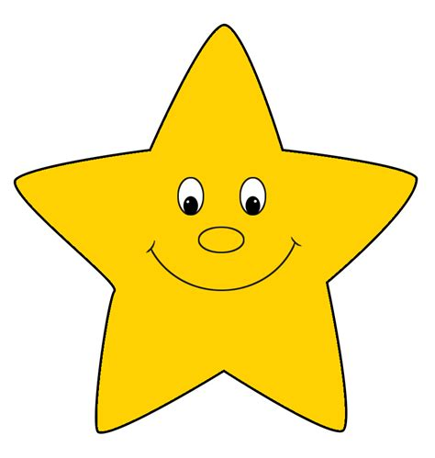 | I ‘m a star because…
I ‘m a star because… | I ‘m a star because…
I ‘m a star because… | I ‘m a star because…
I ‘m a star because… | I ‘m a star because…

