 **Disciplinary concept Substantive concept**

Year 1

History- Who were and are famous?

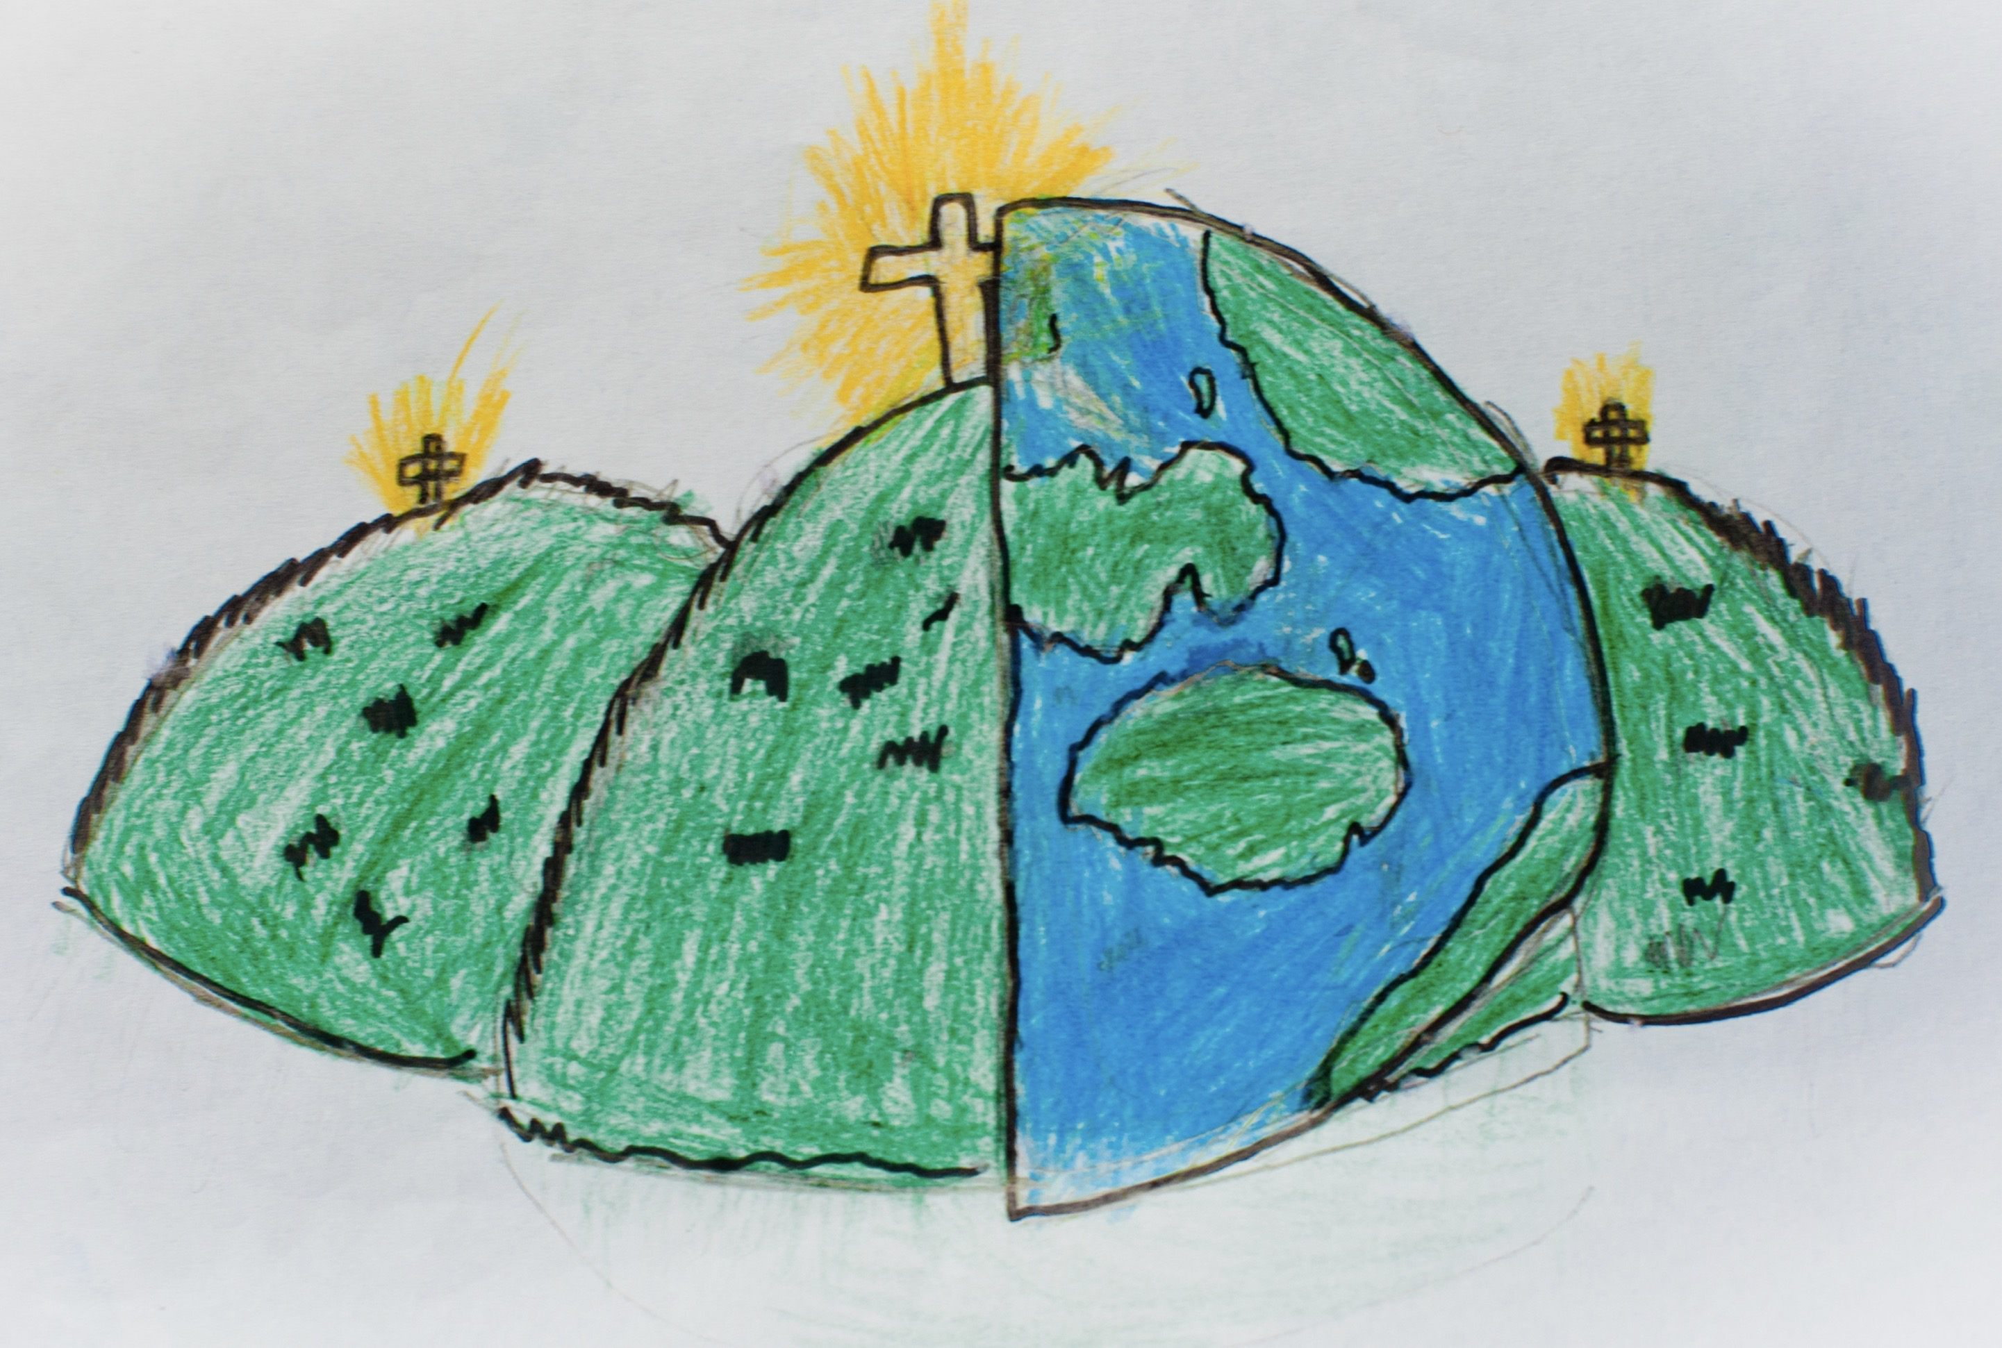

**Similarities and Impact.**

**differences.**

|  |  |  |
| --- | --- | --- |
| past  A time before now. | historical  Belonging to the past. | compare  Look for similarities and differences. |
| timeline | | famous  Known about by many people. |
| significant  Someone or something that is important. | suffragette  This is the name of the movement that fought for equal rights for women. | Important people from the past. |