**Disciplinary concept**   **Substantive concept**

Year 5

History- Who were the Anglo Saxons?

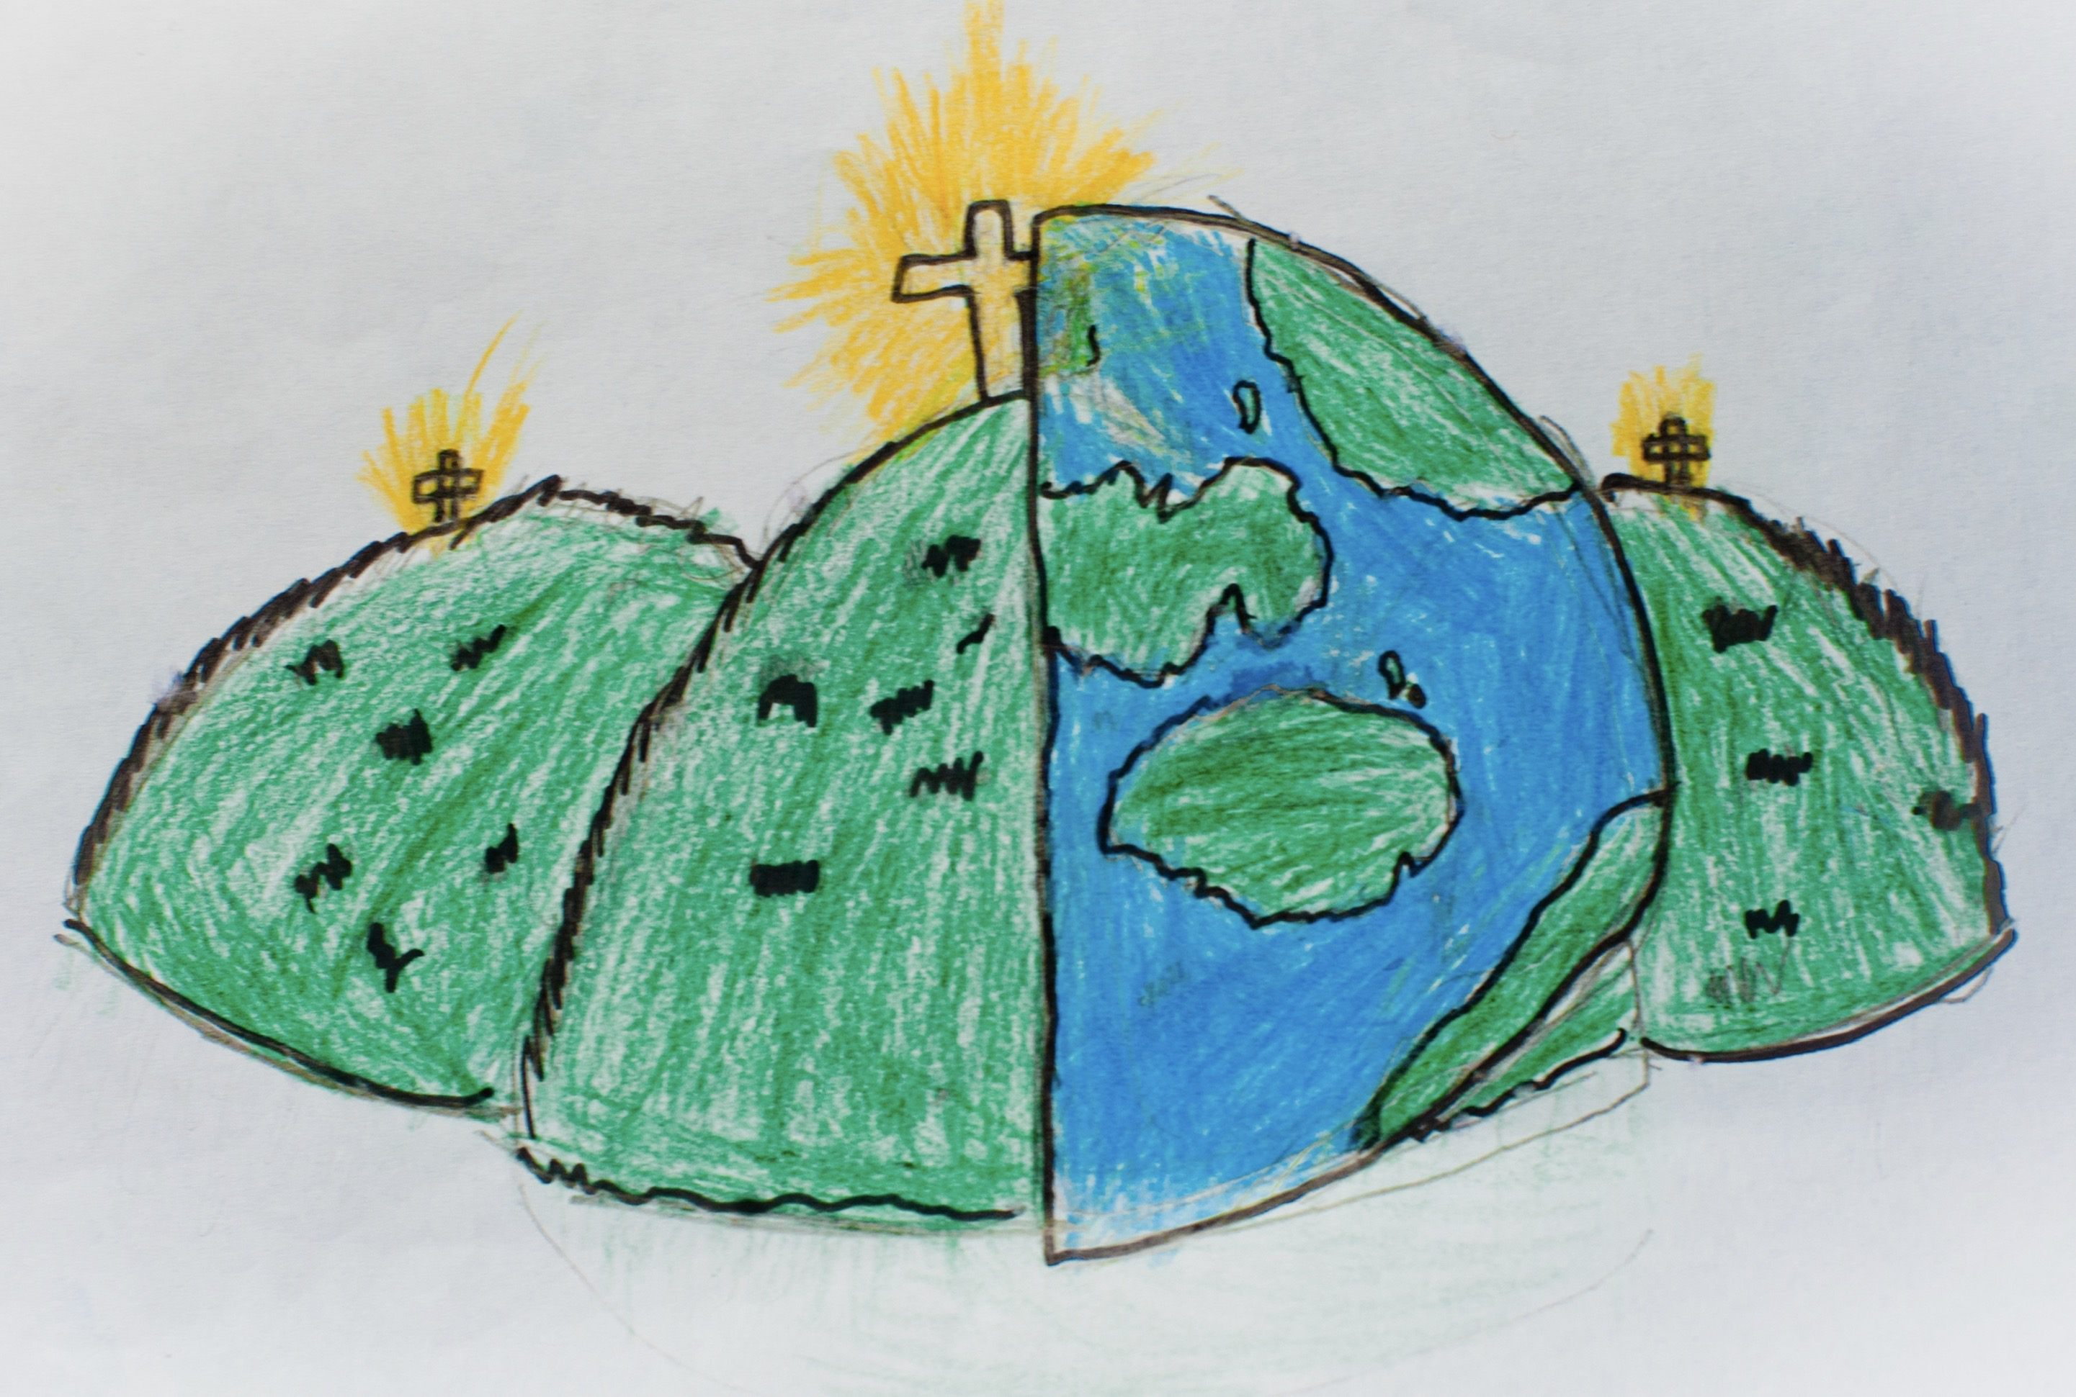

**Civilisation**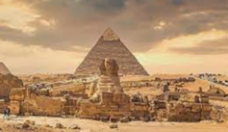

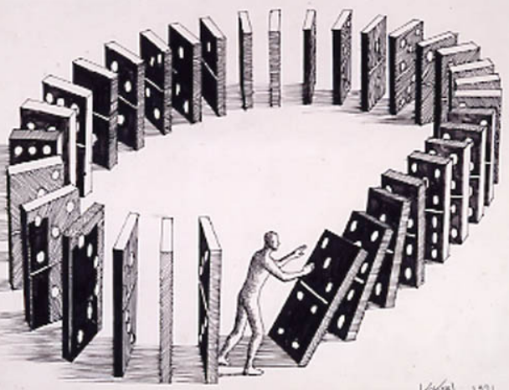**Cause & consequence Invasion**

|  |  |  |
| --- | --- | --- |
| Agriculture  Using the land to create produce | Perspective  To look at events in a certain context | Legacy  The impact of past events/civilisations on future generations |
| Hierarchy  A system of ordering people in terms of their status and importance | | Wereguild  A fine paid for damages caused to another – this was the most common punishment |
| Ceorls  Common people or peasants | Blood-feud  A long running fight for revenge | Settlement  staying in an area of land and developing it through agriculture and buildings. |
| How Anglo Saxon Britain was divided | An Anglo Saxon Bible | An example of Anglo Saxon craftsmanship | |