**Using Purple Mash at home**

1. Attached is a reminder of your child’s username and password. Purple Mash can be accessed via the icon on the school website homepage or via the web address: <https://www.purplemash.com/sch/stjohnsbb10>
2. Work will be set by the class teacher as a “2Do”, a list of set work can be found by clicking on the “2Dos” tab on the Purple Mash home screen.

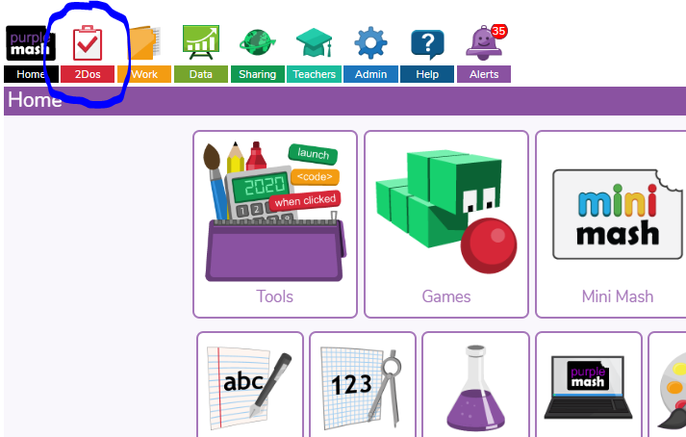

1. Work will be listed here and there are options to start a piece of work, to continue a piece of work or to hand a piece of work in.

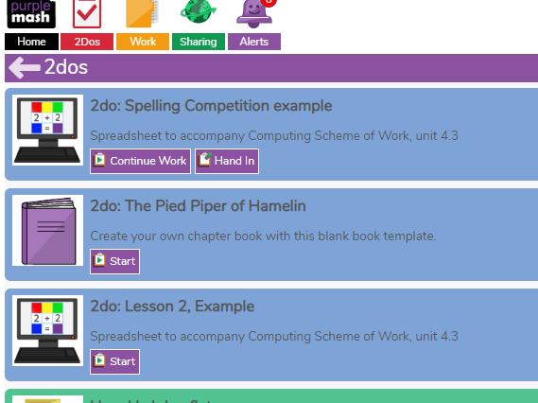

1. Once a piece of work is completed pupils should save and then hand in. They can then leave a comment if they want to.