Journey around the world!

Why not take advantage of having to stay indoors to explore the rest of the world? Although no real substitute for getting out to see it first-hand, the Internet can take you to some amazing places.

Here are some of our favourites. If you find others that are not on the list that you would recommend, please send

them to us. (All images are screenshots of the webcams live)

Animals

The Georgia Aquarium

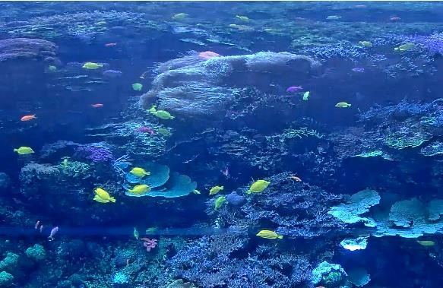

Currently closed to the public, this is an amazing world of aquatic animals from bottlenose dolphins, penguins and piranhas. You can watch the beluga whale live from the webcam as well as lots of other amazing animals. The jellyfish-cam is really mesmerising! The website also has lots of fun learning ideas and projects.

<https://www.georgiaaquarium.org/webcam/indo-pacific-barrier-reef/>

The Webcams at San Diego Zoo

From condors to polar bears – this zoo has it all, with webcams showing the activity of most of their animals. <https://animals.sandiegozoo.org/live-cams>

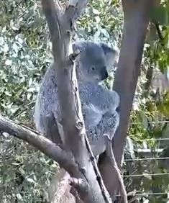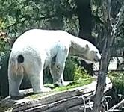

Edinburgh Zoo

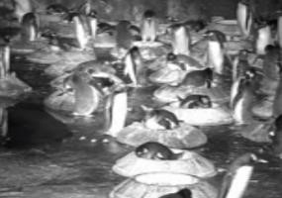

Lots of amazing things to see at Edinburgh zoo – including the UK’s only giant panda.

<https://www.edinburghzoo.org.uk/webcams> Lots of other animal webcams:



<https://www.earthcam.com/events/animalcams/>

Using this website, you can explore lots more of the world’s animal webcams from Botswana to Bali, Stirling to San Francisco.

Prefer to see animals in the wild?

This live cam provides another view of the watering hole and river at Mpala Research Centre in central Kenya. Watch as animals come to drink and swim, and keep an eye on the acadia trees lining the riverbank--they are home to vervet monkeys, olive baboons, and many birds.

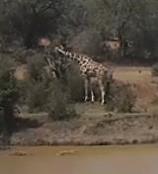

<https://explore.org/livecams/african-wildlife/african-safari-camera>

<https://explore.org/livecams/oceans/shark-meditation>

There is a surprisingly calming meditation video of a great white swimming through its natural habitat.

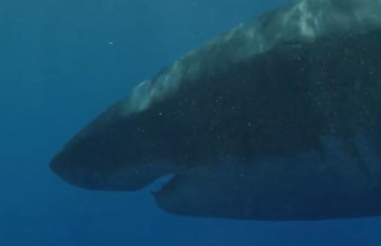

The Wildlife Trust have a wide range of fantastic webcams, where you can see the brilliant British wildlife caught on camera.

<https://www.wildlifetrusts.org/webcams>

<https://mymodernmet.com/best-wildlife-webcam-streams/>

Our World

March is a great time to see the Northern Lights in Canada. Tune in to the live webcam to watch the amazing Aurora

Borealis

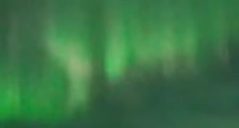

<https://explore.org/livecams/aurora-borealis-northern-lights/northern-lights-cam>

View volcanoes, lakes and more with this website dedicated to taking you far and wide to see the wonders of the natural world.

<https://www.skylinewebcams.com/en/live-cams-category/nature-mountain-cams.html>(contains adverts)

New York

This webcam gives you different views of NYC – unfortunately it’s not quite as busy as usual!

<https://www.earthcam.com/usa/newyork/timessquare/?cam=tstwo_hd>

National parks of America are also providing virtual tours of their most popular parks. Virtual visitors can travel through the trails of Yellowstone National Park, as well as the Yosemite National Park.

<https://www.virtualyosemite.org/virtual-tour/>

Museums and Art Galleries

Google Arts and Culture partnered with over 2,500 museums and galleries around the world to offer virtual tours of their spaces. Some of the options include New York’s Museum of Modern Art and Amsterdam’s Van Gogh Museum. The Louvre, based in Paris, is also offering its own virtual tour online for free.

The Natural History Museum, London

Find answers to your big nature questions. Delve into stories about the Museum's collections, scientists and research. Uncover the history of life on Earth, from the smallest insects to the largest mammals. <https://www.nhm.ac.uk/discover.html>

Take the virtual tour here: [https://artsandculture.google.com/streetview/the-natural-historymuseum/JQF3coVswSVUVw?sv_lng=-](https://artsandculture.google.com/streetview/the-natural-history-museum/JQF3coVswSVUVw?sv_lng=-0.1762865702767158&sv_lat=51.49612801030892&sv_h=250.51060300911368&sv_p=8.597618325247296&sv_pid=mFQI22sOR6Rg8H2wE7-mSA&sv_z=1)

[0.1762865702767158&sv_lat=51.49612801030892&sv_h=250.51060300911368&sv_p=8.597618325247296&sv_pid =mFQI22sOR6Rg8H2wE7-mSA&sv_z=1](https://artsandculture.google.com/streetview/the-natural-history-museum/JQF3coVswSVUVw?sv_lng=-0.1762865702767158&sv_lat=51.49612801030892&sv_h=250.51060300911368&sv_p=8.597618325247296&sv_pid=mFQI22sOR6Rg8H2wE7-mSA&sv_z=1)

The J Paul Getty Museum – LA

Explore the classic art of Rubens and Renoir, Van Gogh and Gauguin with the virtual tours at this iconic art gallery in Los Angeles.

[https://artsandculture.google.com/streetview/the-j-paul-getty-museum](https://artsandculture.google.com/streetview/the-j-paul-getty-museum/cwFdGYSXlaOg6w?hl=en&sv_lng=-118.4740649&sv_lat=34.0764513&sv_h=-126.22187211905162&sv_p=-21.19430687149854&sv_pid=Dx4_99dOiEpdu6LqdvxQbg&sv_z=1)

The National Gallery – London

See more amazing works of art from the comfort of your room. Which ones can you try to replicate?

<https://www.nationalgallery.org.uk/visiting/virtual-tours/google-virtual-tour>

Famous Monuments

Journey beyond Earth

Why not visit the NASA research centre in Langley, Virginia? Work your way around the centre, walk into the cock pit of the flight simulator and navigate where Apollo astronauts once trained.

<https://oh.larc.nasa.gov/oh/>

Walk on Mars

<https://www.nasa.gov/feature/jpl/take-a-walk-on-mars-in-your-own-living-room>- provides all the information about the project.

NASA teamed up with Google to bring this amazing experience: <https://accessmars.withgoogle.com/>

Other

Here are some other great web pages to help in the coming weeks. Most of these links will take you to further links – I think we would struggle to explore all of these, but there will be something that appeals to everyone here!

[https://chatterpack.net/blogs/blog/list-of-online-resources-for-anyone-who-is-isolated-athome?fbclid=IwAR2IlO2cFwclcSPet5PNdUk15jau9T47EV9xVN4XSydDQT_P9g_Di996b_k](https://chatterpack.net/blogs/blog/list-of-online-resources-for-anyone-who-is-isolated-at-home?fbclid=IwAR2IlO2cFwclcSPet5PNdUk15jau9T47EV9xVN4XSydDQT_P9g_Di996b_k)

Learn British Sign Language daily with Natasha Lamb on her Youtube channel:

<https://www.youtube.com/watch?v=rR2Zb7TbiOA>

Glasgow science centre are showing live science everyday at 10am on their Facebook, Twitter and Instagram pages. You can also catch their videos on their Youtube channel:

<https://www.youtube.com/user/scienceshowbob>

Steve Backshall is doing some home learning sessions via his Facebook page. And Youtube account: [https://www.youtube.com/channel/UCm-URP49TgSgyIU1rgh2m7A/?fbclid=IwAR33JpWj1k7sQ8tEfKeXzFu8o-](https://www.youtube.com/channel/UCm-URP49TgSgyIU1rgh2m7A/?fbclid=IwAR33JpWj1k7sQ8tEfKeXzFu8o-zZ_9d8FpBoXxxPbj0NPuKFOld8yxJZ_sc)

[zZ_9d8FpBoXxxPbj0NPuKFOld8yxJZ_sc](https://www.youtube.com/channel/UCm-URP49TgSgyIU1rgh2m7A/?fbclid=IwAR33JpWj1k7sQ8tEfKeXzFu8o-zZ_9d8FpBoXxxPbj0NPuKFOld8yxJZ_sc)

Don’t forget to let us know of any other amazing places you find!