Year 3

RE – Easter

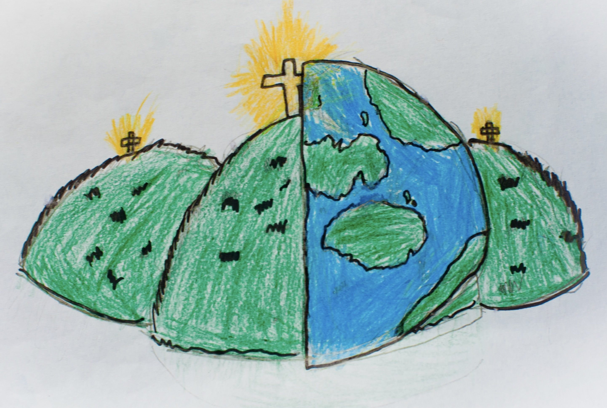

|  |  |  |
| --- | --- | --- |
| Jesus | Easter | disciple |
| Palm Sunday | temple | Last Supper |
| Gethsemane | Good Friday | crucified |
| Easter Sunday | resurrection | faith |
| sadness/joy | beginning/end | Holy Week |

|  |  |  |  |  |  |  |  |
| --- | --- | --- | --- | --- | --- | --- | --- |
|  |  |  |  |  |  |  |  |
| Creation | Fall | People of God | People of God | Incarnation | Gospel | **Salvation** | Kingdom of God |