Year 6 Geography

Investigating our town

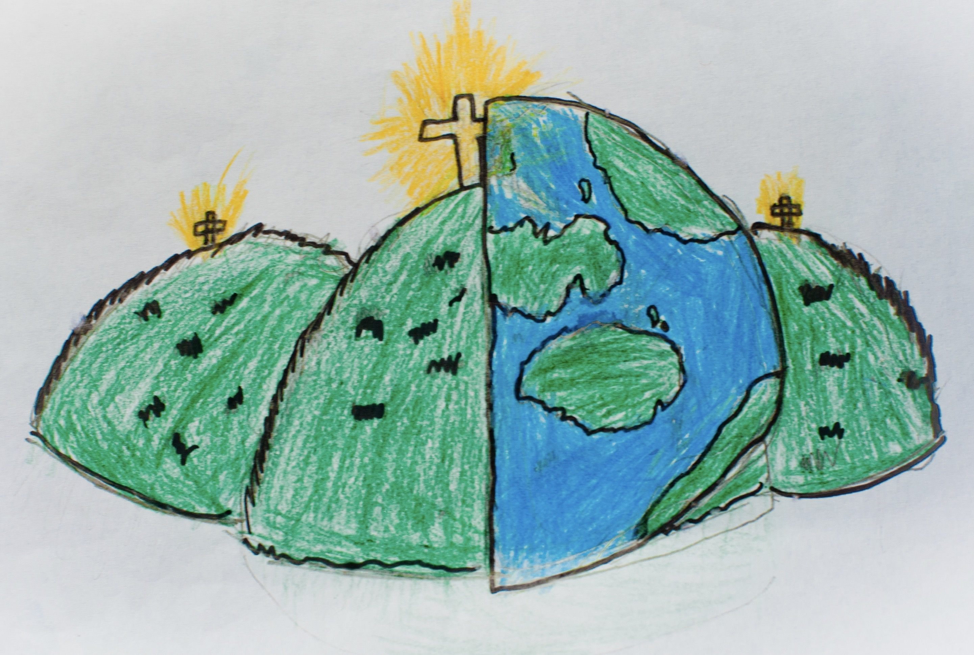

|  |  |  |
| --- | --- | --- |
| compass points – the points that show direction | environment – the surroundings or conditions in which a person, animal or plant lives or operates. | facilities – a place or amenity in an area. |
| impact – an effect or influence | land use – the management or modification of the environment | rural – the countryside |
| services – a system supporting public needs such as transport | settlements – a place where people establish a community | sustainability – avoidance of running out of natural resources |
| time zones – longitude where a common time is used | traffic congestion – where a lot of traffic is formed within a place | urban – a town or city |