Year 6 Geography

Brazil

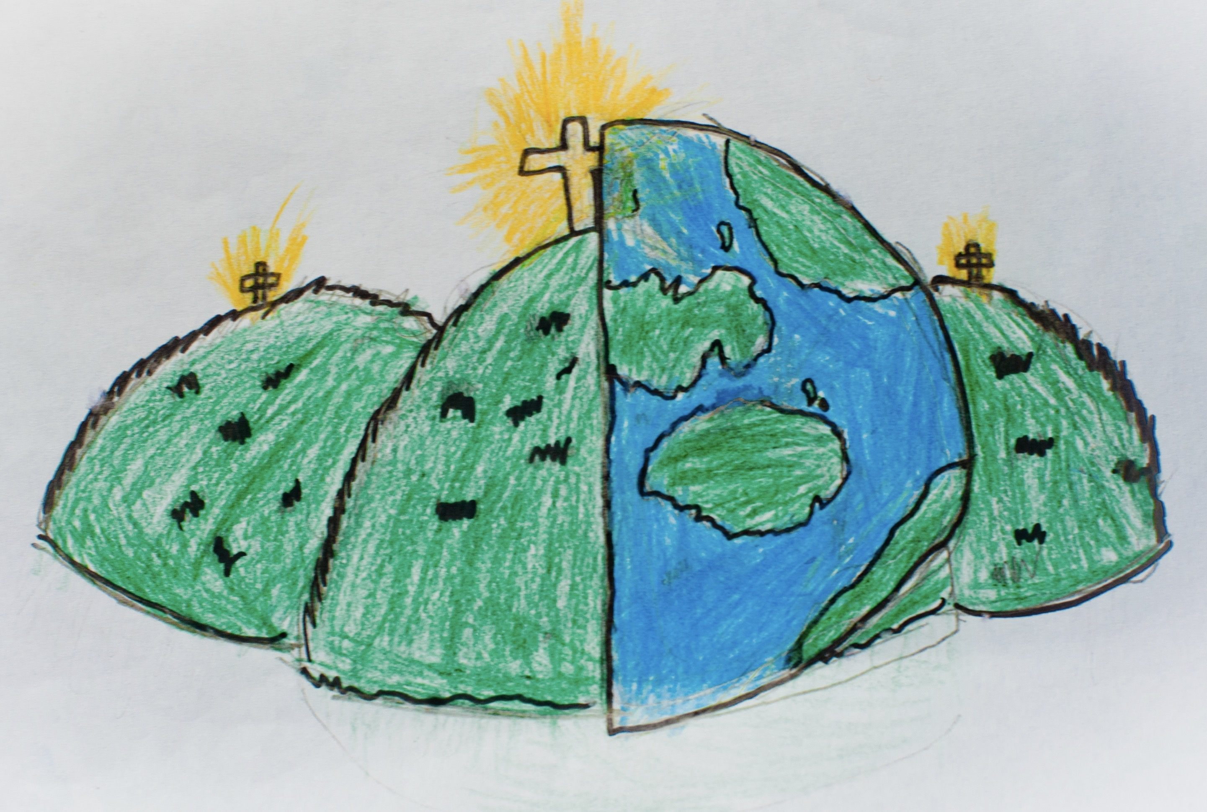

|  |  |  |
| --- | --- | --- |
| climate zone – an area of the world with a specific pattern of weather. | economy – the management of available resources | inequality – the difference in circumstances amongst the population. |
| human characteristics - features of a country that are man made or are influenced by the human population. | physical characteristics – features of the natural environment. | spatial variation – a difference or variation within the population e.g. wealth, land etc. |
| natural resources - different renewable or nonrenewable natural resources such as freshwater, fossil fuels, fertile soil, or timber based on their geographic location. |  | poverty - a state or condition in which a person or community lacks the financial resources and essentials for a minimum standard of living. |
| land locked – a country that is surrounded by other countries and does not have a coast line. | population – the amount and characteristics of the people living there. |