Disciplinary Concept – Historical Significance Substantive Concept – Civilisations

Year 6 History

The Mayas

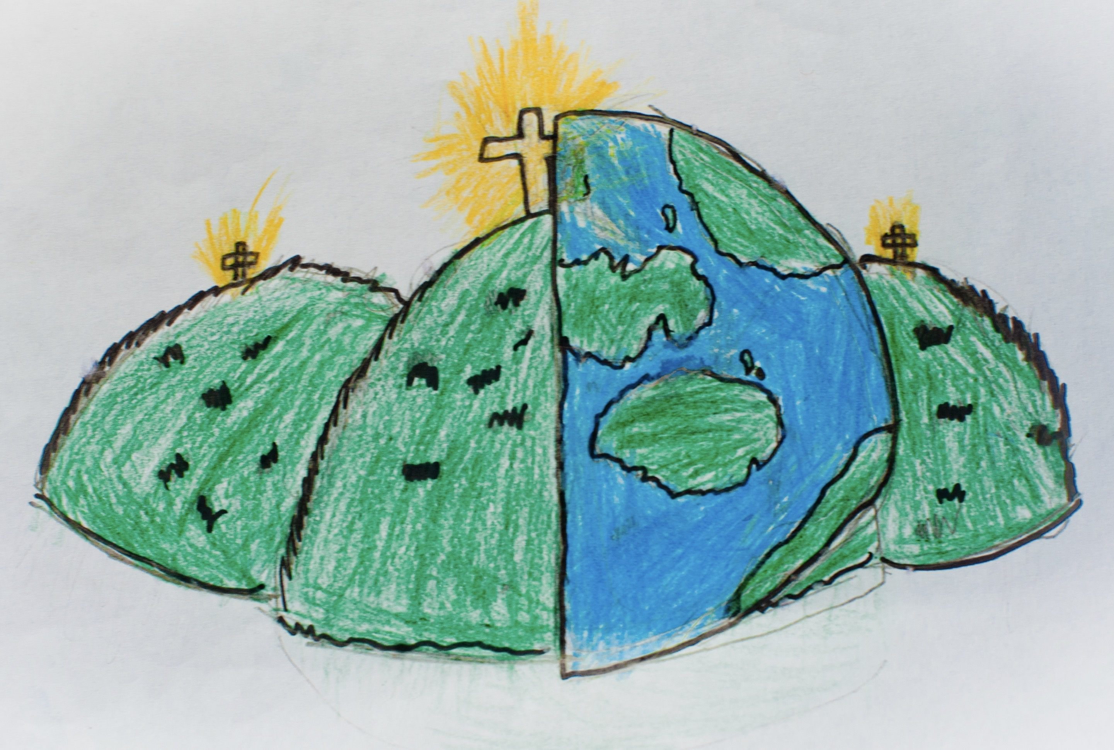

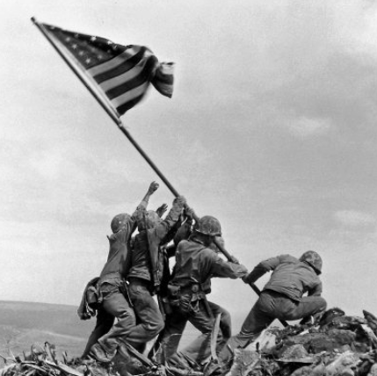 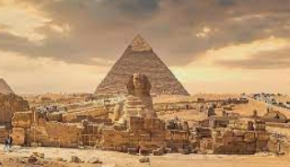

|  |  |  |
| --- | --- | --- |
| ahau or ahaw – the main king or lord of a maya city-state | btab – a lesser lord, usually ruling over a small town. | Why did the Maya civilization collapse? | Live Science |
| Chichen Itza – The Mayan’s most well-known pyramid. | civilisation – a stage in the development of society | codices – books, made of soft bark and folded like a fan created by the Mayans. |
| Itzamna – the main god of the Maya, Itzamna was the god of fire who created the earth. | Kukulcan – the serpent god of the Maya. One of the primary gods, e precisely to the Itza peoples of Chichen Itza. | Maya Geographical Location - Ancient Mayan Civilization |