Year 2

Music

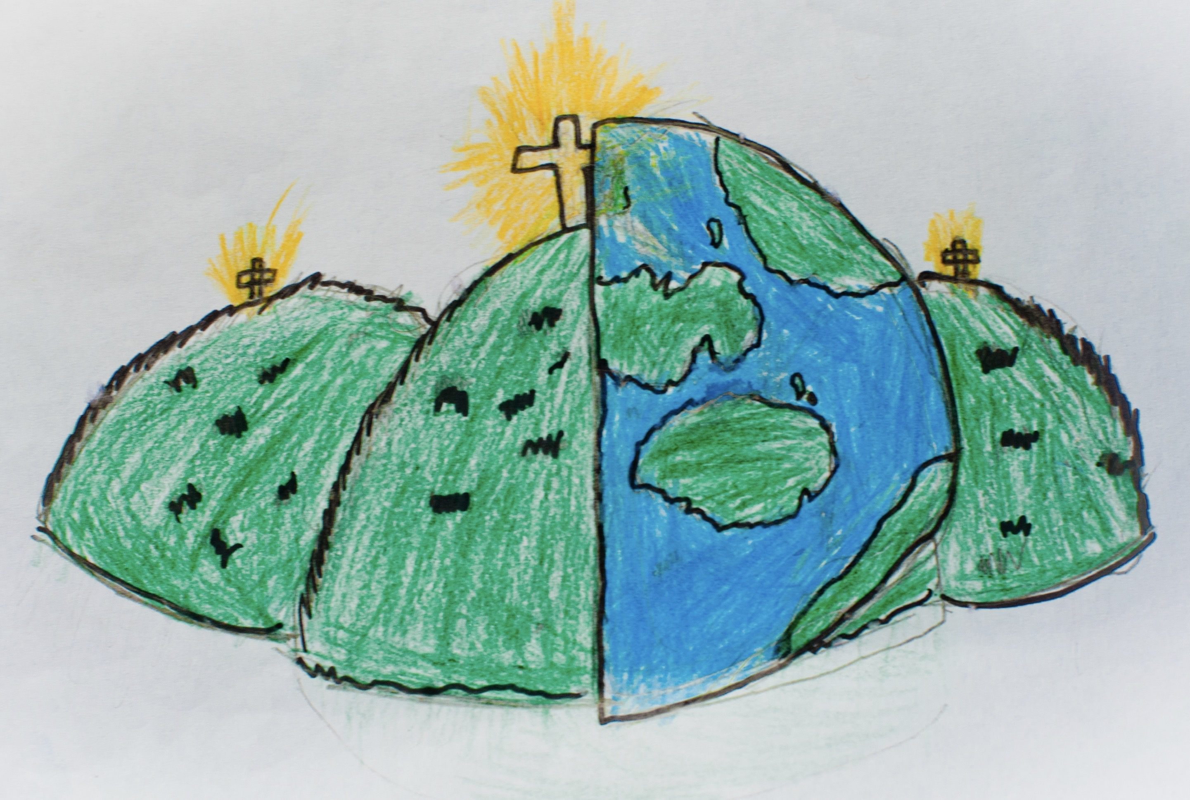

|  |  |  |
| --- | --- | --- |
| beat  Main rhythmic pattern.  steady beat  Rhythmic pattern stays the same throughout. | chord  A combination of notes. | compose  Write or create music. |
| duration  The length of a sound. | high/low  Highest or lowest sound in a piece of music. | loud/quiet  Strong sound or a soft sound. |
| percussion  An instrument that is played by being struck or scraped. | perform  When a musical show is listened to by an audience. | phrase  Like a musical sentence that makes sense on its own. |
| pitch  High and low sounds within a piece of music. | score  Writing down or recording the music that has been created or composed. | tempo  Speed of a piece of music – is is fast or slow? |
| tuned  A instrument with the correct pitch.  untuned  Pitch can’t be changed, like in percussion instruments. | volume  How loud or quiet a sound is. |  |