Year 5

Art – Self Portraits

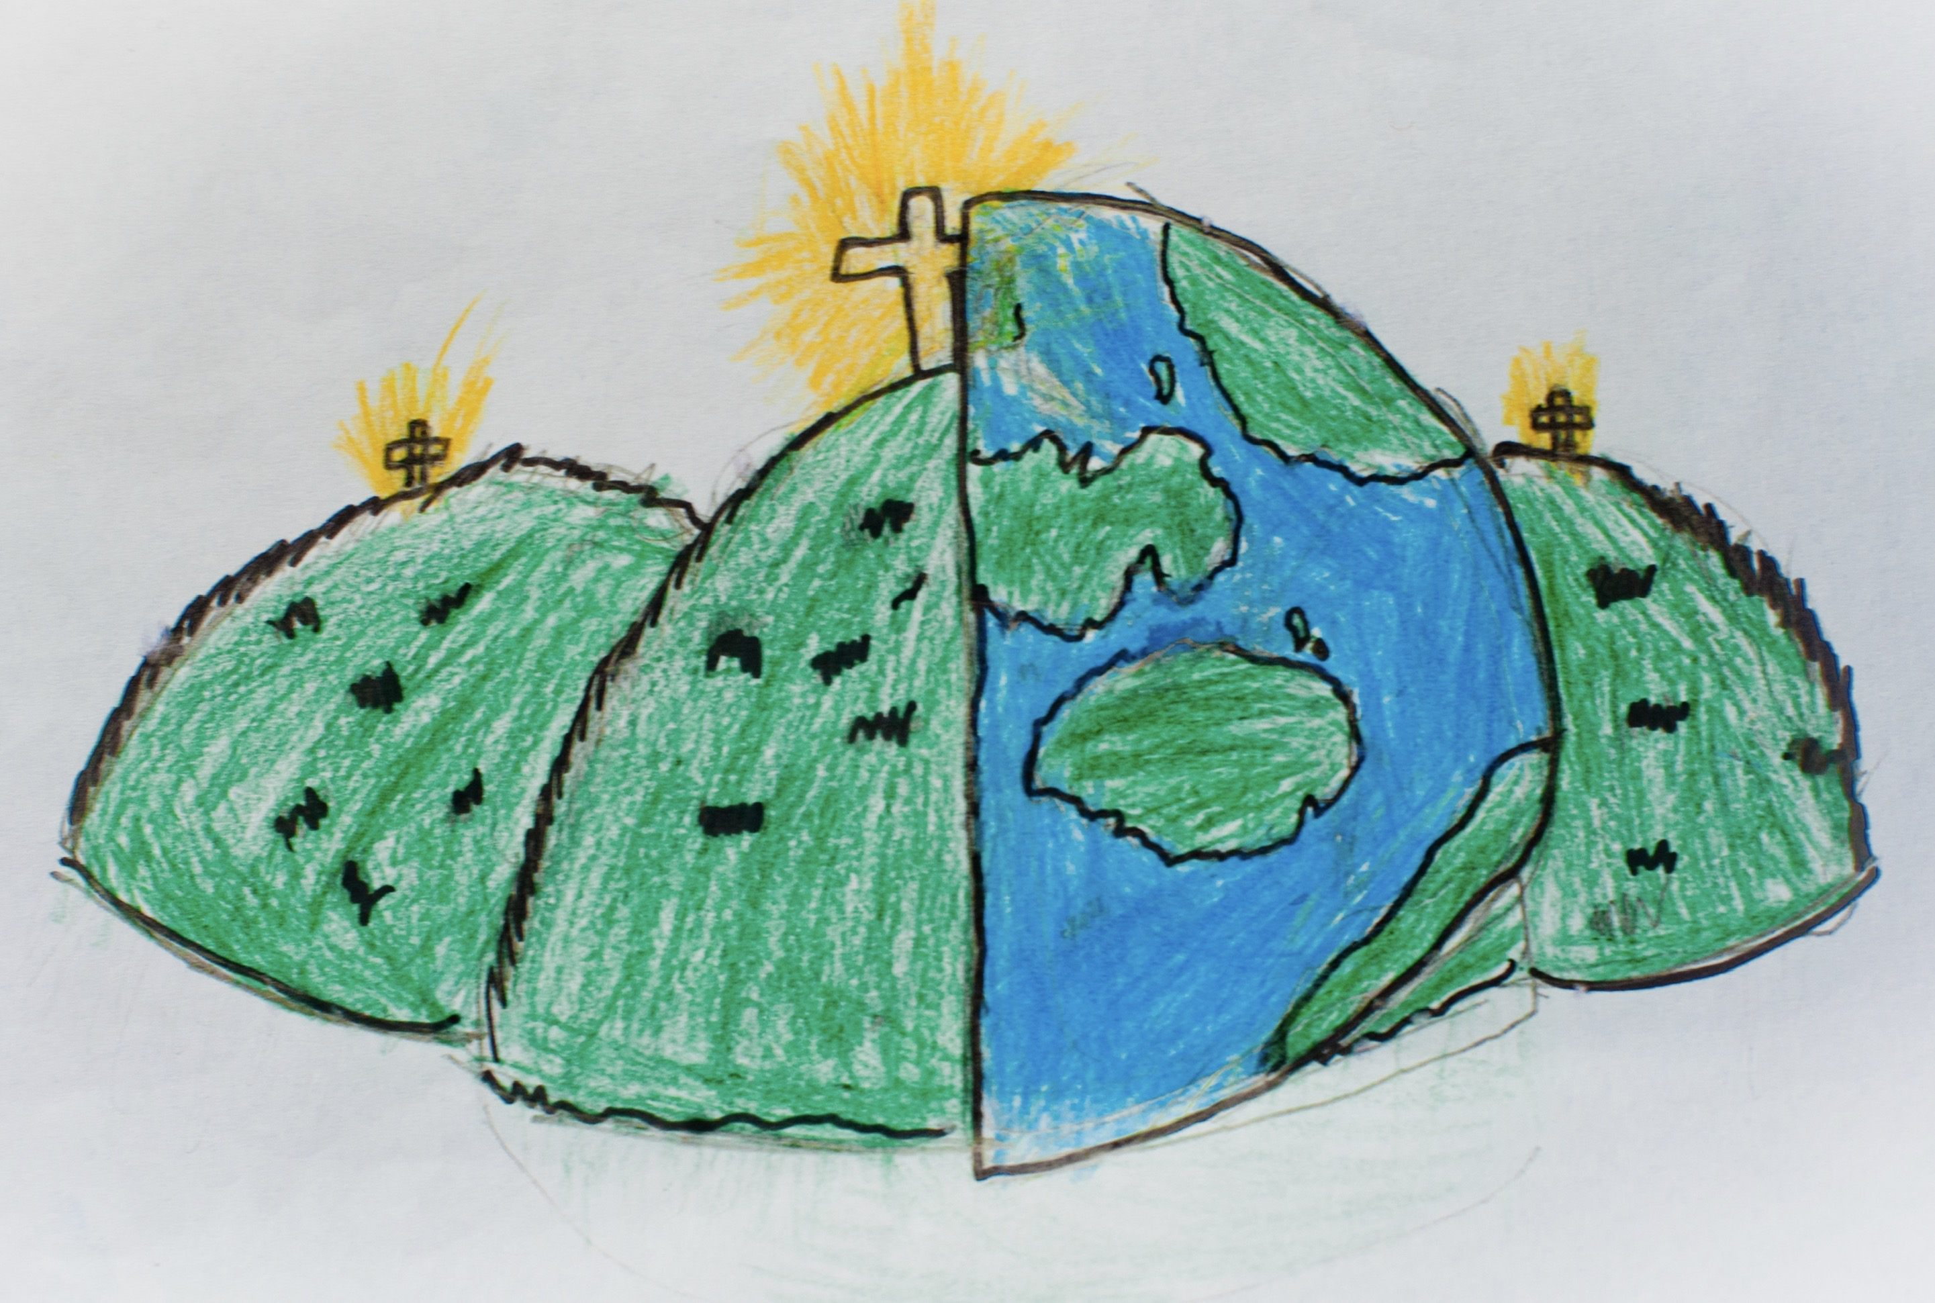

|  |  |  |
| --- | --- | --- |
| collage – cutting, arranging and sticking materials like fabric and paper to a background | identity – your qualities and beliefs that make you unique | mixed - media – art made from a combination of different materials |
| monoprint – a print that can only be made exactly the same way once | multi-media – artwork that includes audio or visual elements | photomontage – collage made from photgraphs |
| self-portrait – a portrait of the artist, by the artist |  |  |
|  |  |  |