Year 5 D.T.–

Textiles – Stuffed toys

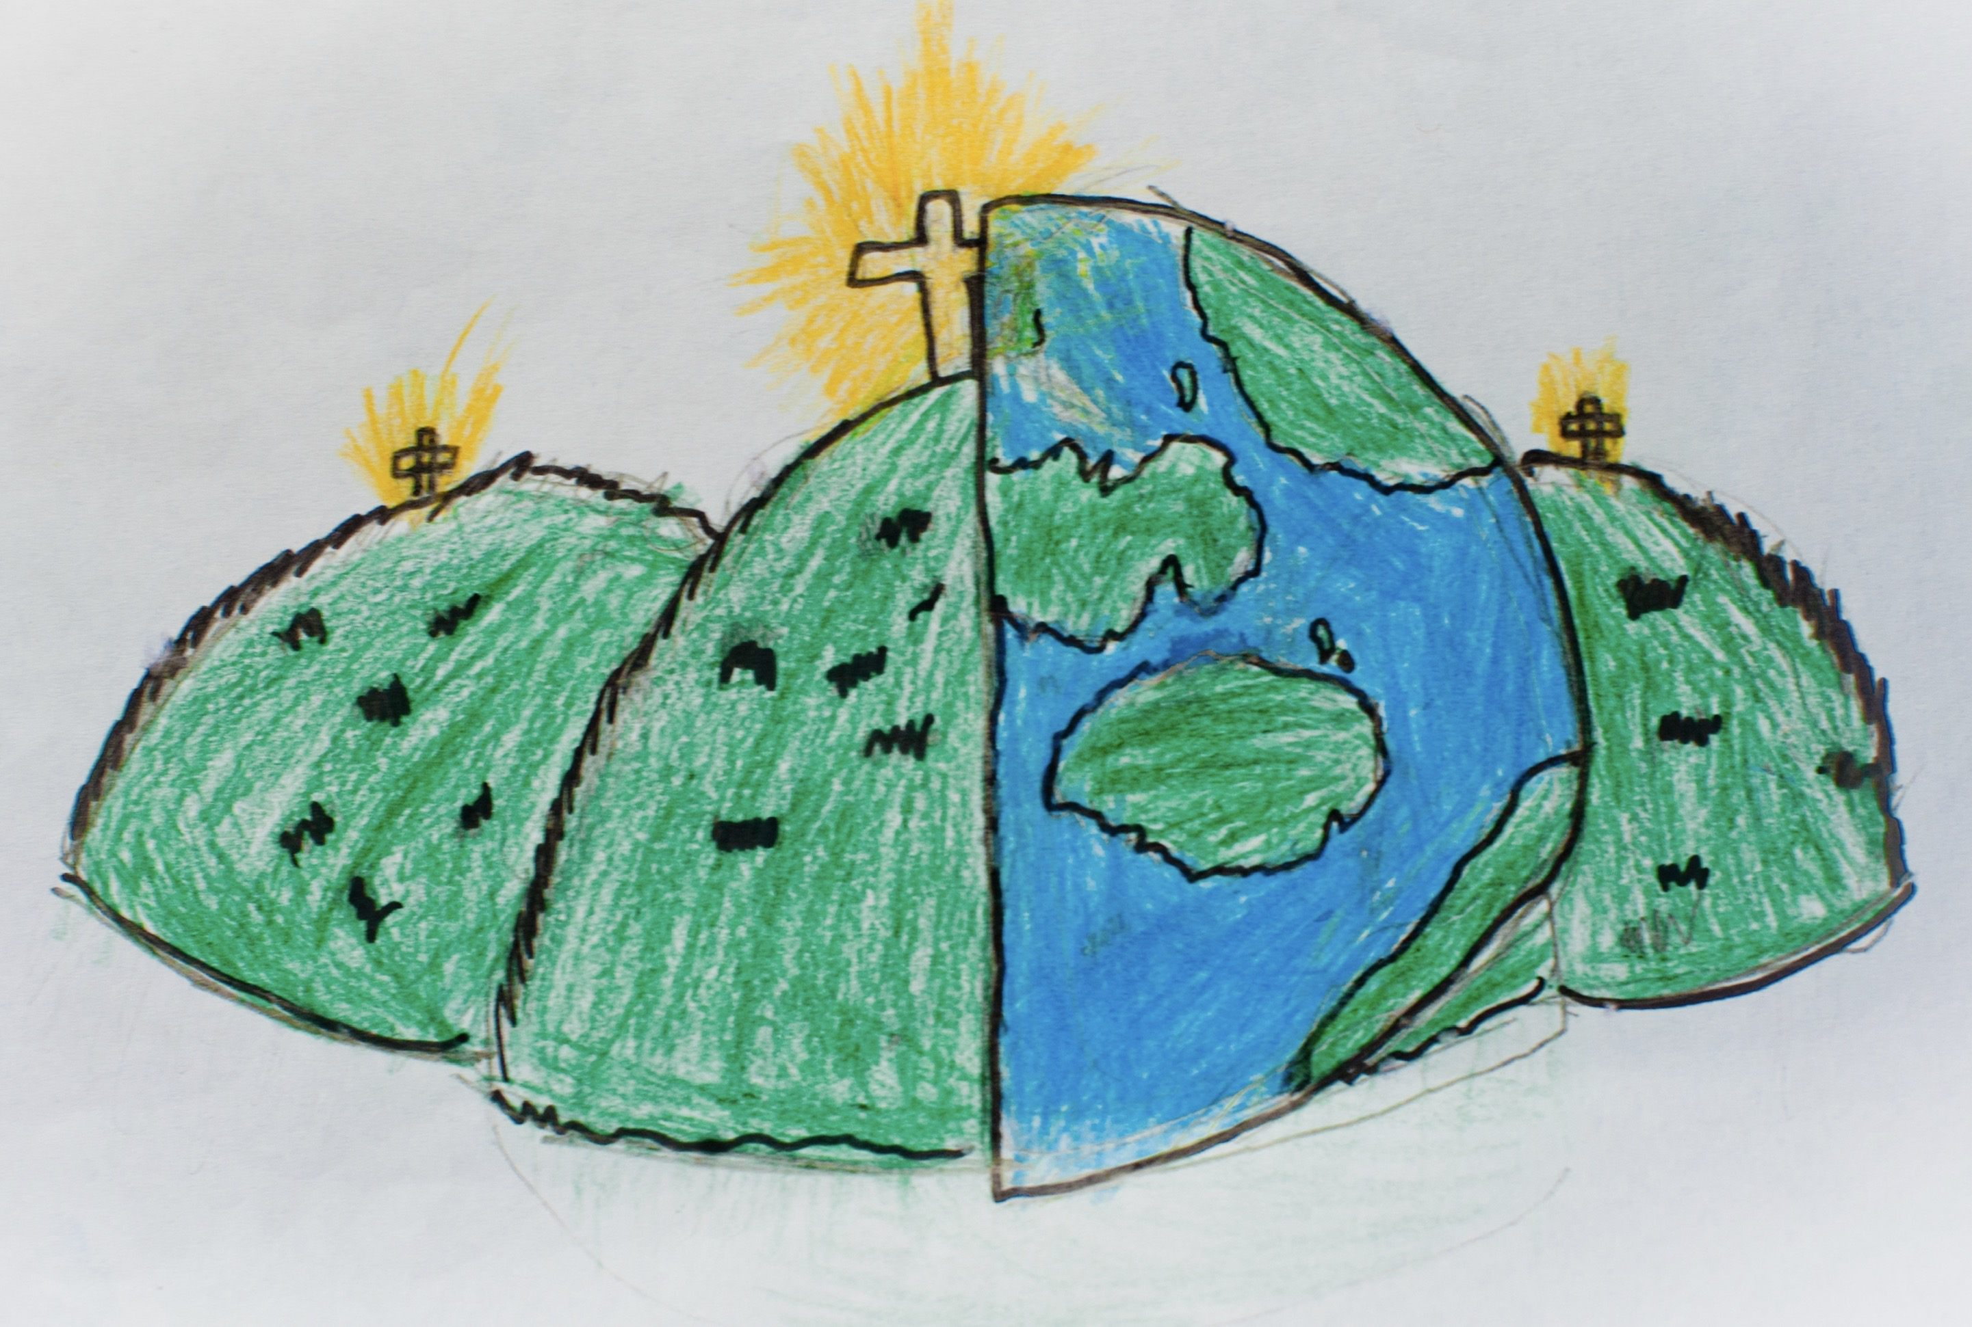

|  |  |  |
| --- | --- | --- |
| accurate – neat, correct shape, size and pattern with no mistakes. | annotate – to add notes to explain your plan or design | appendage – something attached to a larger more important thing |
| mark out – To measure and mark where a piece of material needs to be cut or shaped. | Design criteria – to help designers focus their ideas. And test the success of them | Detail – the small features of an object |
| Evaluation – when you look at the good and bad points and think about how it could be improved | Fabric -a natural or man-made woven or knitted material that is made from plant fibres, animal fur or synthetic material | Set Square or Try Square – A right-angle triangular plate, wood or metal tool used for drawing lines at 90, 45, 60 or 30 degrees. |
| Sew – to join or fasten by stitches using a needle and thread | Shape – the form of an object | Stuffing – soft material used to fill cushions and stuffed toys |
| Template – a stencil made of metal,plastic or paper used for making any copies of a shape or to help cut material accurately |  |  |