Year 5 Geography

Rainforests & Biomes

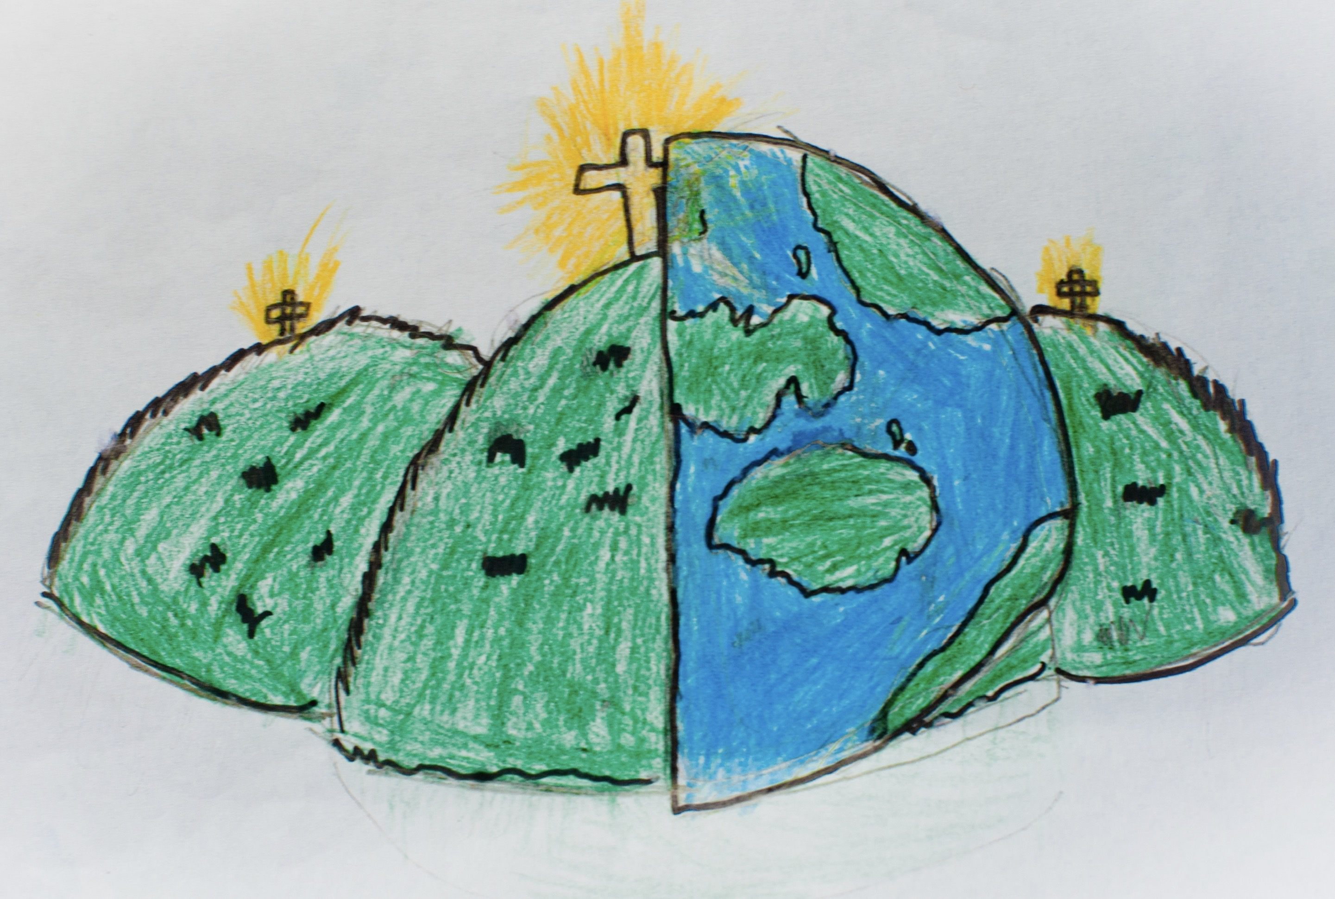

|  |  |  |
| --- | --- | --- |
| biome – a large naturally occurring community of flora and fauna occupying a major habitat eg: forest or tundra | Canopy layer – the layer underneath the emergent layer. Over 60% of life in the rainforest is in this layer. | climate zone – an area of the world with a specific pattern of weather. |
| deforestation – the action of clearing a wide area of trees. | Emergent layer – the top layer of the rainforest. Trees in this layer can be 230 feet high (70 metres). | Equator – an imaginary line exactly halfway between the North & South poles dividing the earth into the Northern hemisphere and the southern hemisphere. |
| fauna – a collective noun used to describe all the animal life in a particular region. | flora – a collective noun used to describe all the plants, trees, fungi and bacteria in a particular reason. | forest floor – the lowest layer in the rainforest. It is dark, damp and hot. |
| tropical rainforest – a hot, humid and dense forest, usually near the equator. They receive about 2 and a half metres of rain per year. | tundra – a large, flat treeless region of Arctic Europe, Asia and North America. | sustainable – able to be maintained at a certain rate or level. |
| Understorey layer – the layer above the forest floor containing shrubs and smaller trees under the Canopy layer. | Layers of the rainforest | Biomes |