Year 5 Science –

Properties & Changes of

Materials

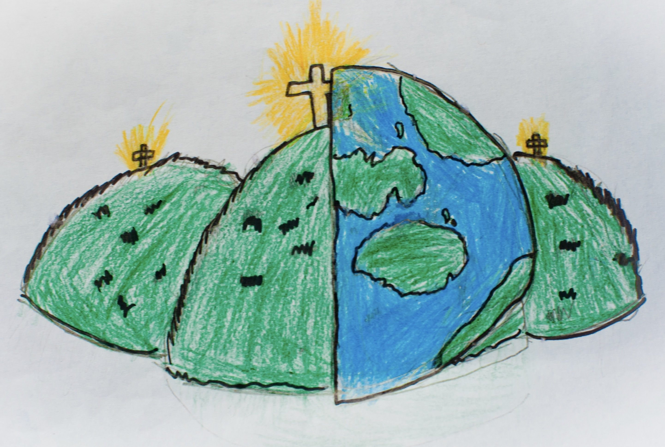

|  |  |  |
| --- | --- | --- |
| change of state – when something changes between a solid, liquid or gas. | dissolve – when particles spread out within a liquid and therefore dissolve in it. | electrical conductor – when electricity can move freely through a material. |
| electrical insulator – when electricity cannot pass through a material. | filter – a device which removes solid particles from a liquid or a gas. | insoluble – when something will not dissolve in a liquid. |
| mixture – a combination of liquids and/or gases. | irreversible change – when you **cannot** undo something or change it back. | reversible change – when you **can** undo something and change it back. |
| rusting – when metal comes into contact with air and water and turns a red/orange colour. | soluble – a solution which can’t be dissolved. | solution – a mixture of liquids. |
| Thermal conductor – a material that allows energy in the form of heat to be transferred within the material.  Thermal insulator – a material that does not allow energy in the form of heat to be transferred within the material. |  |  |