Year 5 Science –

Living things in their Habitat

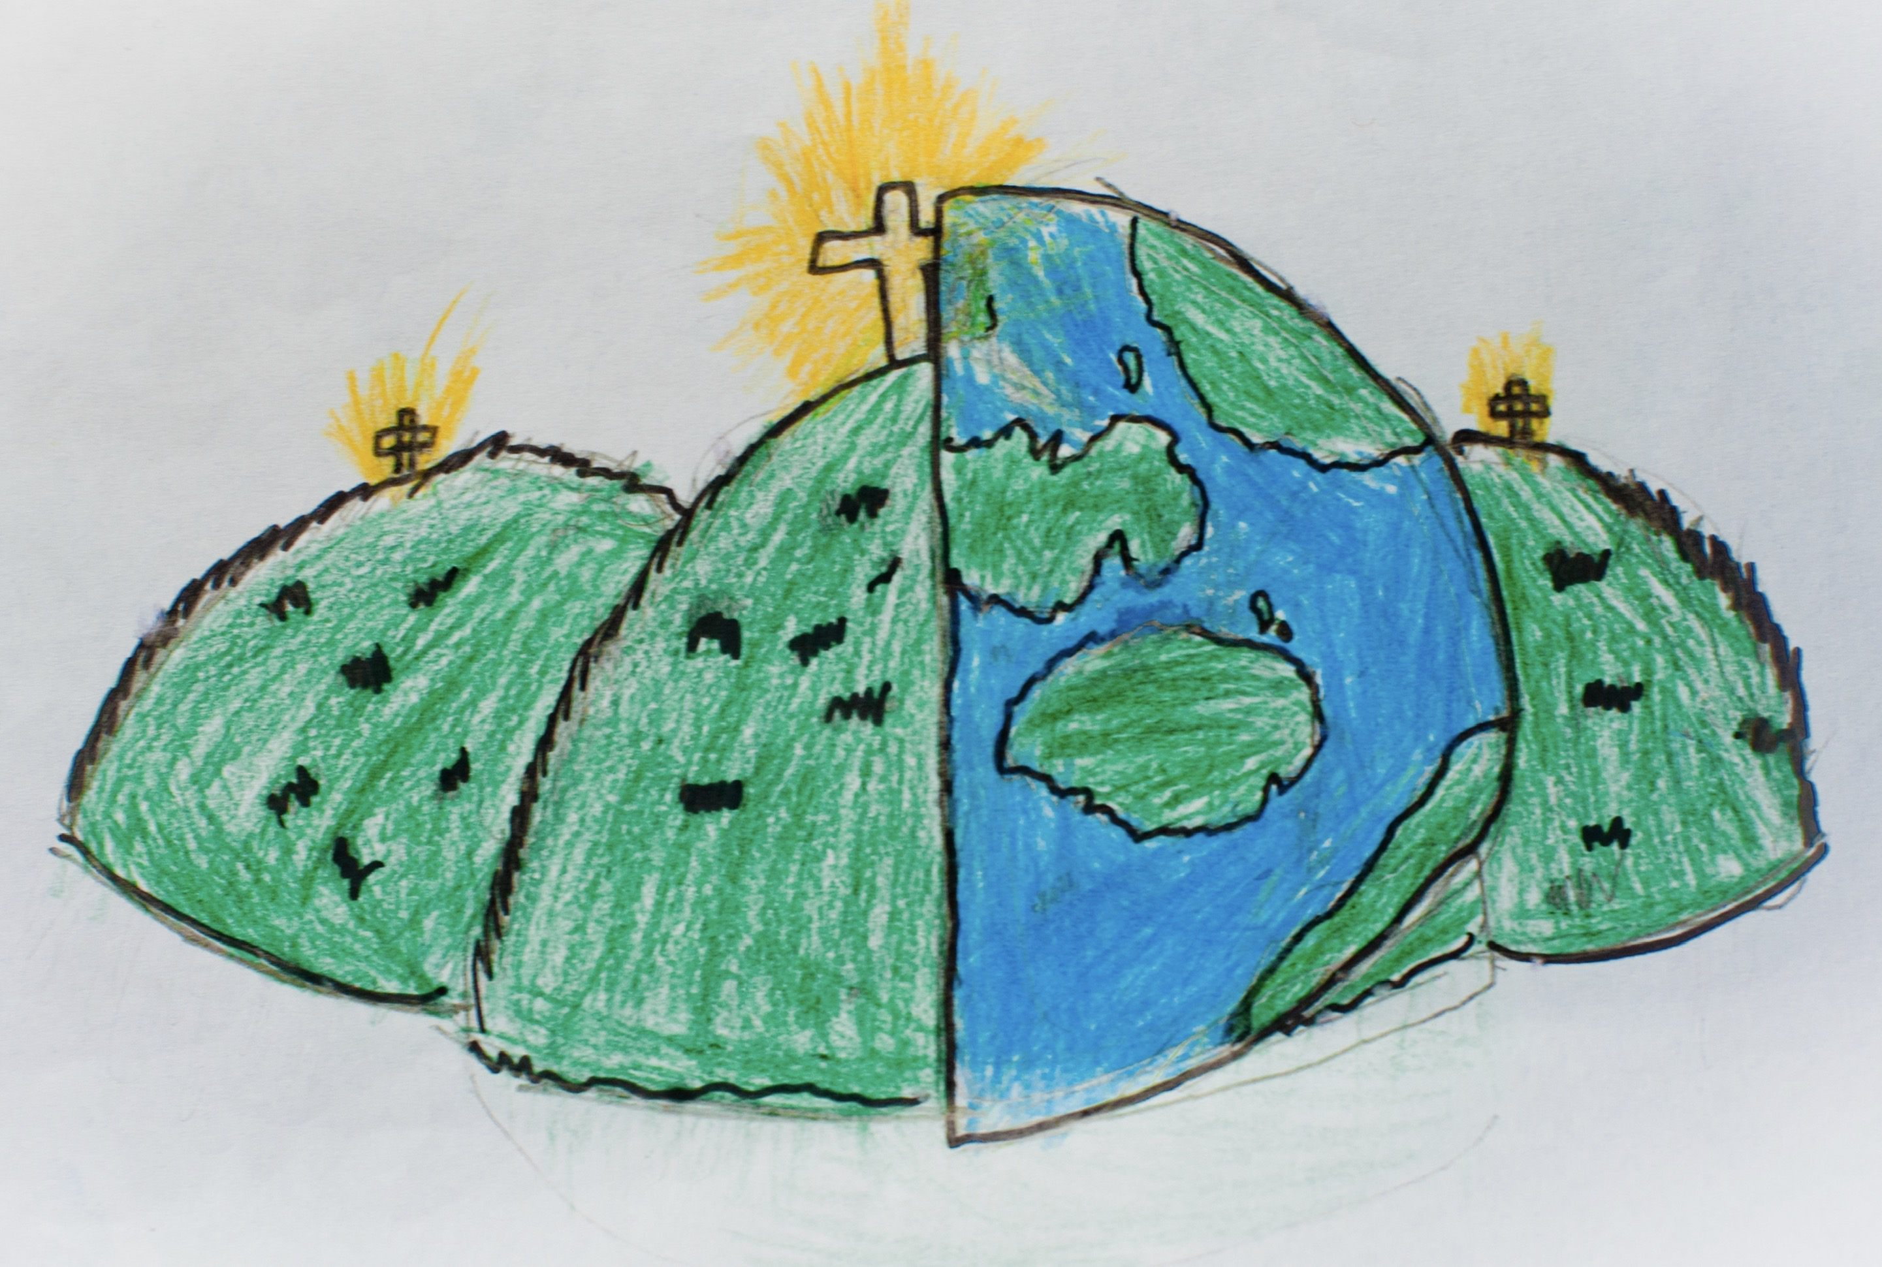

|  |  |  |
| --- | --- | --- |
| amphibian – a creature which can breathe on land and in water | bird – a winged creature with 2 legs, a beak and which lays eggs. | insect – an animal which has 3 parts to its body, an exoskeleton and six legs. |
| mammal – a creature which breathes air, has fur/hair, gives birth to live young and feeds them milk. | reproduction – the process of making more of something. | fertilise – when an egg receives the sperm in order that reproduction can happen. |
| life-cycle – the different stages a living thing goes through from birth to death. | asexually – the process of reproduction without a male and female. | metamorphosis – the process of physically changing in form and appearance. |
| gestation – the time taken for a baby to develop in its mother’s womb. | live young – a mother gives birth to a live baby, not one developed inside an egg. | fledgling – the name given to a young bird which has not developed its flight muscles. |
| Metamorphosis |  |  |