Year 6

Art – Painting and Mixed Media

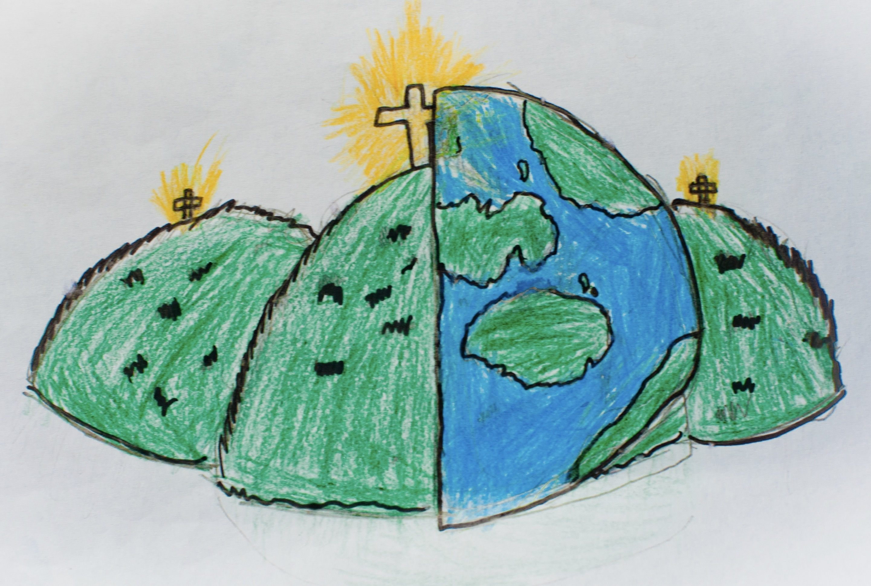

|  |  |  |
| --- | --- | --- |
| abstract – art that doesn’t necessarily look like it does in real-life – use shapes, colours and gestural marks. | analyse – to investigate in something in detail to understand it. | evaluate – to form an opinion about how good or useful something is. |
| interpret – to understand and explain the meaning of something. | medium – the materials used to make a piece of art. | mixed-media – art made from a combination of different materials. |
| narrative – is a story recalling events whether fictitious or true. | respond – to create ideas formed from experiencing art of others. | tableau – people recalling a scene from a story, painting in motionless poses. |
|  |  |  |